

**MINISTRY OF**

**EDUCATION AND TRAINING**

**FPT UNIVERSITY**

Capstone Project Document

**Accommodation Sharing**

|  |  |
| --- | --- |
| **GROUP 9** | |
| **Group members** | Nguyễn Quang Nhật - SE62245 (Leader)  Nguyễn Đỗ Minh Đức - SE61767  Vương Minh Thông - SE61739  Hồ Công Trình - SE61998 |
| **Supervisor** | Nguyễn Huy Hùng |
| **Ext. Supervisor** | N/A |
| **Capstone Project code** | ASP |

- Ho Chi Minh City, **September 11th*, 2018*** –

*This page is intentionally left blank*

# Table of Content

Table of Content 3

List of Table 8

List of Figure 9

Definitions, Acronyms, and Abbreviations 11

A. Introduction 11

1. Project Information 11

2. Introduction 11

3. Current Situation 12

4. Problem Definition 12

5. Proposed Solution 12

5.1 Feature functions 12

5.2 Advantages and Disadvantages 13

6. Functional Requirements 13

7. Role and Responsibility 14

B. Software Project Management Plan 14

1. Problem Definition 14

1.1 Name of this Capstone Project 14

1.2 Problem Abstract 14

1.3 Project Overview 14

1.3.1 Current Situation 14

1.3.2 The Proposed System 15

1.3.2.1 Mobile Application 15

1.3.2.2 Web Application 15

1.3.3 Boundaries of the System 15

1.3.4 Future Plan 16

1.3.5 Development Environment 16

1.3.5.1 Hardware requirements 16

1.3.5.2 Software requirements 16

2. Project Organization 17

2.1 Software Process Model 17

2.2 Roles and Responsibilities 17

2.3 Tools and Techniques 18

3. Project Management Plan 19

3.1 Product Backlog 19

3.2 Sprint Backlog 20

3.3 Meeting Minutes 20

4. Coding Convention 20

C. Software Requirement Specification 20

1. User Requirement Specification 20

1.1 Unauthorized User Requirement 20

1.2 Authorized User Requirement 21

1.3 House Owner Requirement 21

1.4 Room Master Requirement 21

1.5 Member Requirement 21

1.6 Admin Requirement 22

2. System Requirement Specification 22

2.1 External Interface Requirement 22

2.1.1 User Interface 22

2.1.2 Hardware Interface. 22

2.1.3 Software Interface 22

2.1.4 Communication Protocol 22

2.2 System Overview Use Case 22

2.3 List of Use Case 24

2.3.1 <Unauthorized User> Overview Use Case 24

2.3.1.1 <Unauthorized User> Register 24

2.3.1.2 <Unauthorized User> Login 26

2.3.2 <Authorized User> Overview Use 27

2.3.2.1 <Authorized User> Logout 28

2.3.2.2 <Authorized User>View Notification 29

2.3.2.3 <Authorized User> Edit Profile 30

2.3.3 <House Owner> Overview Use Case 32

2.3.3.1 <House Owner> Create Room 32

2.3.3.2 <House owner> Update Room 34

2.3.3.3 <House owner> Delete Room 36

2.3.3.4 <House owner> Add Member into Room 37

2.3.3.5 <House owner> Delete Member from Room 40

2.3.4 <Room Master> Overview Use Case 42

2.3.4.1 <Room Master> View Suggested Nearby Room Master 43

2.3.4.2 <Room Master> Create Finding Roommate Post 44

2.3.4.3 <Room Master> Update Finding Roommate Post 47

2.3.4.4 <Room Master> Delete Finding Roommate Post 49

2.3.4.5 <Room Master> View Post Detail 51

2.3.5 <Member> Overview Use Case 52

2.3.5.1 <Member> View Suggested Finding Roommate Post list 53

2.3.5.2 <Member> Create Finding Room Post 55

2.3.5.3 <Member> Update Finding Room Post 57

2.3.5.4 <Member> Delete Finding Room Post 59

2.3.5.5 <Member> Negotiate 60

2.3.6 <Admin> Overview Use Case 62

2.3.6.1 <Admin> Approve Room 62

2.3.6.2 <Admin> View Users 64

3. Software System Attribute 65

3.1 Usability 65

3.1.1 Graphic User Interface 65

3.1.2 Usability 65

3.2 Reliability 65

3.3 Availability 65

3.4 Security 65

3.5 Maintainability 65

3.6 Portability 65

3.7 Performance 66

4. Conceptual diagram 66

D. Software Design Description 67

1. Design Overview 67

2. System Architecture Design 67

2.1 System Architecture Design 67

3. Component Diagram 68

4. Detail Description 69

4.1.1 Class Diagram 69

4.2 Class Diagram Explanation 71

4.2.1 User 71

4.2.2 Room 71

4.2.3 Post 71

4.2.4 Role 72

4.2.5 Favourite 72

4.2.6 Utilities 72

4.2.7 Reference 72

4.2.8 District 72

4.2.9 City 72

4.2.10 Image 73

4.2.11 Type 73

4.2.12 Status 73

4.2.13 Room_Has_Utilities 73

4.2.14 Utilities_Reference 73

4.2.15 District_Reference 73

4.2.16 Room_Has_User 73

4.2.17 Post_Has_Utilities 74

4.2.18 Post_Has_District 74

4.2.19 Room_Rate 74

4.2.20 User_Rate 74

4.3 Interactive diagram 75

4.3.1 Sequence Diagram 75

4.3.1.1 Register 75

4.3.1.2 Login 75

4.3.1.3 Create Room 75

4.3.1.4 Update Room 76

4.3.1.5 Delete Room 76

4.3.1.6 View Single Room 77

4.3.1.7 Add Member into Room 77

4.3.1.8 Delete Member of Room 78

4.3.1.9 Create Finding Roommate Post 78

4.3.1.10 Delete Finding Roommate Post 78

4.3.1.11 Update Finding Roommate Post 79

4.3.1.12 View Suggest List Overview 79

4.3.1.13 <Suggest> Member/Room Master has reference and has no posts. 80

4.3.1.14 <Suggest> Room Master has posts 80

4.3.1.15 <Suggest>Member/Room Master has no reference but allow access current location 81

4.3.1.16 <Suggest> Member/Room Master has no reference and not allow access current location 81

4.3.1.17 Create Finding Room Post 82

4.3.1.18 Update Finding Room Post 82

4.3.1.19 Delete Finding Room Post 82

4.3.1.20 Filter 83

5. Interface 83

5.1 Admin Interface Design 83

5.1.1 Login 83

5.1.2 Manage User 84

5.1.3 Manage Room 85

5.1.4 Approve Room 86

5.2 Unauthorized User Interface Design 86

5.2.1 Launch Screen 86

5.2.2 Sign Up 88

5.2.2.1 <Member> Sign Up 88

5.2.2.2 <House Owner> Sign Up 89

5.2.3 Sign In 91

5.3 Authorized User Interface Design 93

5.3.1 View Setting 93

5.3.2 Update User Information 93

5.3.3 View Profile 93

5.3.3.1 <House Owner> View Profile 93

5.3.3.2 <Member/Room Master> View Profile 93

5.3.4 View Notification 93

5.3.5 View Bookmark 94

5.3.5.1 <Room Post> View Bookmark 94

5.3.5.2 <Roommate Post> View Bookmark 96

5.3.6 Request Location Popup Screen 98

5.3.7 View All 100

5.3.7.1 <Room Post> View All 100

5.3.7.2 <Roommate Post> View All 101

5.3.8 Filter 103

5.4 House owner Interface Design 105

5.4.1 Create Room 105

5.4.2 Update Room 107

5.4.3 View Room 110

5.4.4 Delete Room 112

5.4.5 Add member into Room 113

5.4.6 Delete member of Room 115

5.5 Room Master 116

5.5.1 View suggested room master list 116

5.5.2 Create Post 116

5.5.3 Update post 116

5.5.4 View Post 116

5.5.5 Delete Post 116

5.6 Member 116

5.6.1 View suggested room master list 116

5.6.2 Create Post 116

5.6.3 Update Post 116

5.6.4 Delete Post 116

5.6.5 View Post 116

6. Database Design 116

6.1 Entity relationship diagram (ERD) 116

6.2 Entity dictionary 116

7. Algorithms 117

7.1 Definition 117

7.2 Define Problem 117

7.3 Solution 117

E. System Implementation & Test 118

1. Introduction 118

1.1 Overview 118

1.2 Test approach 118

2. Database Relationship Diagram 119

2.1 Physical Diagram 119

2.2 Data dictionary 120

3. Performance Measure 124

3.1 Show list result of finding room post performance 124

3.2 Show list result of finding roommate post performance 124

3.3 Show list result of all post performance 124

3.4 Show list result of suggested post performance 124

3.5 Add new room performance 124

3.6 Update room performance 124

3.7 Add new post performance 125

3.8 Update post performance 125

4. Test Plan 125

4.1 Features to be tested 125

4.2 Features not to be tested 125

5. System Testing Test Case 125

5.1 Test case 125

5.1.1 <Unauthorized User> Login 125

5.1.2 <Unauthorized User> Register 126

5.1.3 <House Owner> Manage Room 128

5.1.4 <Room Master> Manage Finding Roommate Post 132

5.1.5 <Member> Manage Finding Room Post 133

5.1.6 <Member/Room Master> Suggestion 133

F. Software User’s Manual 134

1. Installation Guide 134

1.1 Setting up environment at server side 134

1.1.1 Hardware Requirement 134

1.1.2 Software Requirement 134

1.2 Deployment at server side 134

1.2.1 Check Environment 134

1.2.2 Import Database 134

1.2.3 Build Project 134

1.2.4 Deploy Project to IIS 134

2. User Manual 134

2.1 Unauthorized User 134

2.1.1 Login 134

2.2 Authorized User 134

2.3 Admin 134

2.4 House Owner 134

2.5 Room Master 134

2.3 Member 134

G. Appendix 134

1. A nautical mile 134

2. Spherical law of cosines 135

# List of Table

Table 1: Roles and Responsibilities 14

Table 2: Hardware Requirements for Server 16

Table 3: Hardware Requirement for Mobile 16

Table 4: Software Requirements 17

Table 5: Roles and Responsibilities 18

Table 6: Tools and Techniques 18

Table 7: Product Backlog 20

Table 8: <Unauthorized User> Register specification 26

Table 9: <Unauthorized User> Login specification 27

Table 10: <Authorized User> Logout specification 29

Table 11: <Authorized User> View Notification specification 30

Table 12: <Authorized User> Update Information specification 32

Table 13: <House Owner> Create Room specification 34

Table 14: <House owner> Update Room specification 36

Table 15: <House owner> Delete Room specification 37

Table 16: <House owner> Add Member into Room specification 40

Table 17: <House owner> Delete Member from Room specification 42

Table 18: <Room Master> View Suggested Nearby Room Master Post Specification 44

Table 19: <Room Master> Create Finding Roommate Post specification 47

Table 20: <Room Master> Update Finding Roommate Post specification 49

Table 21: <Room Master> Delete Finding Roommate Post specification 51

Table 22: <Room Master> View Post Detail Specification 52

Table 23: <Member> View Suggested Finding Roommate Posts List Specification 55

Table 24: <Member> Create Finding Room Post specification 57

Table 25: <Member> Update Finding Room Post specification 59

Table 26: <Member> Delete Finding Room Post specification 60

Table 27: <Member> Negotiate specification 62

Table 28: <Admin> Approve room specification 64

Table 29: <Admin> View User specification 65

Table 30: Conceptual Entity dictionary 67

Table 31: Component Diagram Explanation 69

Table 32: Class Diagram Explanation 71

Table 33: User Attributes 71

Table 34: Room Attributes 71

Table 35: Post Attributes 72

Table 36: Role Attributes 72

Table 37: Favourite Attributes 72

Table 38: Utility Attributes 72

Table 39: Reference Attributes 72

Table 40: District Attributes 72

Table 41: City Attributes 73

Table 42: Image Attributes 73

Table 43: Type Attributes 73

Table 44: Status Attributes 73

Table 45: Room Has Utilities Attributes 73

Table 46: Utilities Reference Attributes 73

Table 47: District Reference Attributes 73

Table 48: Room Has User Attributes 74

Table 49: Post Has Utilities 74

Table 50: Post Has Districts 74

Table 51: Room Rate 74

Table 52: User Rate 74

Table 53: Admin login - Field, Buttons 84

Table 54: Admin Manage User - Field, Buttons, Hyperlinks 85

Table 55: Admin Manage Room - Field, Buttons, Hyperlinks 86

Table 56: Admin Approve Room - Field, Buttons, Hyperlinks 86

Table 57: Launch Screen - Buttons 88

Table 58:<Member> Sign Up – Buttons, Field 89

Table 59: <House Owner> Sign Up – Buttons, Field 91

Table 60: Sign In - Field, Buttons 93

Table 61: View Setting - Field, Buttons, Hyperlinks 93

Table 62: Update User Information - Field, Buttons, Hyperlinks 93

Table 63: View Profile - Field, Buttons, Hyperlinks 93

Table 64: View Profile - Field, Buttons, Hyperlinks 93

Table 65: View Notification - Field 94

Table 66: View Bookmark - Field, Buttons, Hyperlinks 96

Table 67: View Bookmark - Field, Buttons, Hyperlinks 98

Table 68: Request Location - Fields 100

Table 69: <Room Post> View All- Fields, Buttons 101

Table 70: <Roommate Post> View All- Fields, Buttons 103

Table 71: <Authorized User> Filter - Fields, Buttons 105

Table 72: Create Room - Field, Buttons, Hyperlinks 107

Table 73: Update Room - Field, Buttons, Hyperlinks 110

Table 74: View Room - Field, Buttons, Hyperlinks 112

Table 75: Delete Room - Field, Buttons, Hyperlinks 113

Table 76: Add member into Room - Field, Buttons, Hyperlinks 115

Table 77: Delete member of Room - Field, Buttons, Hyperlinks 116

Table 78: Entity Data dictionary 117

Table 79: Data dictionary 121

Table 80: Data Table Description 124

Table 81: Test case <Unauthorized User> Login 126

Table 82: Test case <Unauthorized User> Register 128

Table 83: Test case <House Owner > Manage Room 132

Table 84: Test case <Room Master> Manage Finding Roommate Post 133

Table 85: Test case <Member> Manage Finding Room Post 133

Table 86: Test case <Member/Room Master> Suggest 134

# List of Figure

Figure 1: Scrum Methodology 17

Figure 2: System Overview Use Case (1) 23

Figure 3: System Overview Use Case (2) 24

Figure 4: <Unauthorized User> Overview Use Case 24

Figure 5: <Unauthorized User> Register Use Case 25

Figure 6: <Unauthorized User> Login Use Case 26

Figure 7: <Authorized User> Overview Use Case 28

Figure 8: <Authorized User> Logout Use Case 28

Figure 9: <Authorized User> View Notification Use Case 29

Figure 10: <Authorized User> Update Information Use Case 30

Figure 11: <House Owner> Overview Use Case 32

Figure 12: <House Owner> Create Room Use Case 32

Figure 13: <House owner> Update Room Use Case 34

Figure 14: <House owner> Delete Room Use Case 36

Figure 15: <House owner> Add Member into Room Use Case 38

Figure 16: <House owner> Delete Member from Room Use Case 40

Figure 17: <Room Master> Overview Use Case 42

Figure 18: <Room Master> View Suggested Nearby Room Master Post Use Case 43

Figure 19: <Room Master> Create Finding Roommate Post Use Case 45

Figure 20: <Room Master> Update Finding Roommate Post Use Case 47

Figure 21: <Room Master> Delete Finding Roommate Post Use Case 50

Figure 22: <Room Master> View Post Detail Use Case 51

Figure 23: <Member> Overview Use Case 53

Figure 24: <Member> View Suggested Finding Roommate Posts List Use Case 54

Figure 25:< Member> Create Finding Room Post Use Case 55

Figure 26:< Member> Update Finding Room Post Use Case 57

Figure 27: <Member> Delete Finding Room Post Use Case 59

Figure 28: <Member> Negotiate Use Case 61

Figure 29: <Admin> Overview Use Case 62

Figure 30: <Admin> Approve Room Use Case 63

Figure 31: <Admin> View User Use Case 64

Figure 32: Conceptual Diagram 66

Figure 33: System Architecture Design (MVC) 68

Figure 34: Component Diagram 69

Figure 35: Class Diagram 70

Figure 36: Sequence Diagram - <Unauthorized> Register 75

Figure 37: Sequence Diagram - <Unauthorized> Login 75

Figure 38: Sequence Diagram - <House owner> Create Room 76

Figure 39: Sequence Diagram - <House owner> Update Room 76

Figure 40: Sequence Diagram - <House owner> Delete Room 77

Figure 41: Sequence Diagram - <House owner> View Single Room 77

Figure 42: Sequence Diagram - <House owner> Add Member into Room 78

Figure 43: Sequence Diagram - <House owner> Delete Members of Room 78

Figure 44: Sequence Diagram - <Room Master> Create Finding Roommate Post 78

Figure 45: Sequence Diagram - <Room Master> Delete Finding Roommate Post 79

Figure 46: Sequence Diagram - <Room Master> Update Finding Roommate Post 79

Figure 47: Sequence Diagram - <Member/Room Master> View Suggest List 80

Figure 48: Sequence Diagram - <Member/Room Master> Has reference and has no posts. 80

Figure 49: Sequence Diagram - <Room Master> Room Master has posts 81

Figure 50: Sequence Diagram - <Member/Room Master> Member/Room Master has no reference but allow access current location. 81

Figure 51: Sequence Diagram - <Member/Room Master> Member/Room Master has no reference and not allow access current location. 82

Figure 52: Sequence Diagram - <Member> Create Finding Room Post 82

Figure 53: Sequence Diagram - <Member> Update Finding Room Post 82

Figure 54: Sequence Diagram - <Member> Delete Finding Room Post 83

Figure 55: Sequence Diagram - <Authorized User> Filter 83

Figure 56: <Admin> Login Interface 83

Figure 57: <Admin> Manage User Interface 84

Figure 58: <Admin> Manage Room Interface 85

Figure 59: <Admin> Approve Room Interface 86

Figure 60: <Unauthorized User> Launch Screen Interface 87

Figure 61: <Member >Sign Up Interface 88

Figure 62: <House Owner > Sign Up Interface 90

Figure 63: <Unauthorized User> Sign In Interface 92

Figure 64: <Authorized User> View Setting Interface 93

Figure 65: <Authorized User> Update Information Interface 93

Figure 66: <Authorized User> View Profile Interface 93

Figure 67: <Authorized User> View Profile Interface 93

Figure 68: <Authorized User> View Notification Interface 94

Figure 69: <Room Post> View Bookmark 95

Figure 70: <Roommate Post > View Bookmark 98

Figure 71: <Authorized User> Request Location Interface 99

Figure 72: <Room Post> View All 100

Figure 73: <Roommate Post> View All 102

Figure 74: <Authorized User> Filter 104

Figure 75: <House owner> Create Room Interface 106

Figure 76: < House owner > Update Room Interface 109

Figure 77: < House owner > View Room Interface 112

Figure 78: < House owner > Delete Room Interface 113

Figure 79: < House owner > Add member into Room Interface 114

Figure 80: < House owner > Delete member of Room Interface 115

Figure 81: Entity Relationship diagram 116

Figure 82: Physical diagram 120

# Definitions, Acronyms, and Abbreviations

|  |  |
| --- | --- |
| Name | Definition |
| ASP | Accommodation Sharing |

# A. Introduction

## Project Information

* Project Name: **Accommodation Sharing Platform**
* Project Code: **ASP**
* Project Type: **Mobile Application**
* Start Date: **September 11th, 2018**
* End Date: **N/A**

## Introduction

Nowadays, finding an accommodation is really a difficult and exhausting process, especially for province people who are working in the city recently. Searching for an accommodation information is so difficult, choosing a good and safe accommodation at reasonable cost is more difficult, not to mention scams, and other bad situations. When searching for an accommodation around the internet, the informations are not usually accurately. As a matter of fact, the Accommodation Sharing Platform with a simple interface, easy to use, users do not have to spend much time to post or search for an accommodation.

## Current Situation

Currently there are many mobile applications that help people to find an accommodation. However, they only show places that are match with users. When users who have already rented an accommodation, looking for roommates, they have to search for all the users who requested for room/house to stay, but not the ones who are also in the same situation, so that they can discuss to move in together.

## Problem Definition

We have research on some current mobile applications and websites in Vietnam such as: Ohana, phongtro123.com, thuephongtro.com… Some of them have some limits:

* Not support suggesting for Room Master (people who are looking for roommates) in the same area move in together.
* Not support finding nearby Room Master.
* Not support suggesting best match for those who looking for a room/house to stay.

## Proposed Solution

Our proposed solution is to build a system named “ASP”. User can add information about their requests in system. The system processes the requests and matches the Room Master with the Member appropriately. Besides that, 2 Room Master can be suggested to move in if they are in the same area.

ASP system includes a mobile application for Room Master and Member and a web application for administrator and householder.

### Feature functions

* Mobile application
* User can register a new account to find an accommodation or post for shared room.
* User can manage their own information.
* House owner can create room and manage members in room.
* Room Master can create and manage their own post.
* System matching Room Master with utilities and suggest appropriate room for member.
* Member can view information of room master’s post.
* Room Master and member can negotiate with feature to send text or call.
* House owner can rate for member in their room.
* Member can rate their current room.
* Web application (for admin)
* Manage users.
* Manage rooms.

### Advantages and Disadvantages

* Advantages:
* Members can easily find the place they want.
* Accommodation will be verified by staff.
* House-owner can manage their room.
* Room master can get suggested nearby other room master to move in if they are in the same area.
* Member can get suggested nearby their current location.
* Disadvantages:
* Trust issues is top priority problem.

## Functional Requirements

Function requirement of the system are listed at below:

* Mobile application (for unauthorized user)
* Login form.
* Register.
* Mobile application (for authorized user)
* Negotiate.
* View and manage information.
* Get notification.
* Logout.
* Mobile application (for House Owner)
* Manage rooms.
* Manage members of room.
* Mobile application (for Room Master)
* View suggested nearby other room master’s posts.
* Manage post.
* View finding room post.
* View finding roommate post.
* Manage references.
* Mobile application (for Member)
* View suggest finding roommate posts base one current reference.
* View suggest finding roommate posts base one current location.
* Manage information.
* Manage references.
* Web application (for admin)
* View and manage user.
* View and manage rooms.

## Role and Responsibility

|  |  |  |  |  |
| --- | --- | --- | --- | --- |
| **No** | **Full name** | **Role** | **Position** | **Contact** |
| 1 | Nguyễn Huy Hùng | Project Manager | Supervisor | Hungnh@fpt.edu.vn |
| 2 | Nguyễn Quang Nhật | Scrum Master | Leader | [Nhatnqse62245@fpt.edu.vn](mailto:Nhatnqse62245@fpt.edu.vn) |
| 3 | Nguyễn Đỗ Minh Đức | Developer | Member | Ducndmse61767@fpt.edu.vn |
| 4 | Vương Minh Thông | Developer | Member | Thongvmse61739@fpt.edu.vn |
| 5 | Hồ Công Trình | Developer | Member | Trinhhcse61998@fpt.edu.vn |

Table 1: Roles and Responsibilities

# B. Software Project Management Plan

## Problem Definition

### Name of this Capstone Project

* Official name: Accommodation Sharing
* Vietnamese name: Ứng dụng hỗ trợ tìm người ở ghép
* Abbreviation: ASP

### Problem Abstract

First, Vietnam is currently in the integration and development process, so developed countries are always focus on this potential market. Foreign companies invest a lot in Vietnam and it always have number of employee working onsite.

Second, young generation used to move on to the big city to study and work. Besides that, traveling is one of the most popular in their mind right now, so that we providing the best accommodation for living, short term travelling and studying.

From above, we have thought about an idea of an application that can help those who travel, live and study in Vietnam have the opportunity to easily find suitable accommodation.

### Project Overview

#### Current Situation

Below are some problems that we encountered in this project:

* **Business logic:** Some scopes of this project are not clear in early stage of development. For example, room master and member share the same interface because users can be different roles in different situations.
* **Scheduler of team members:** Team members can have conflicts in meeting schedule because of sick, study and work schedule, etc.
* **Framework study:** Team members have a problem when applying the play framework into project. The team needs an amount of time to get familiar new techniques.
* **Lack of UI and UX design skill:** Our team members all study IS major, and no one has studied UI, UX design. Therefore, that some UI may misunderstand or hard to use with normal user.

#### The Proposed System

The system contains a web application for admin and a mobile application for room master, member, house owner.

##### Mobile Application

**- House-owner:**

* House-owner can create rooms and system can upload their room for room master create a post if they want.
* House-owner can add room master and other members to their room.

**- Room Master:**

* Room Master can create new post for member to know which one they should contact.
* Room Master can manage their own information, post they have made and negotiate with member.

**- Member:**

* Member can create utilities and system can match their utilities with location room master to make a suggestion.
* Member can manage their own information, their utilities.

##### Web Application

**- Admin:**

* Admin manages user informations, rooms.

#### Boundaries of the System

This section supposes that users of the system have stable internet connection while using.

Language of application is Vietnamese.

* **The system can:**
* Allow room master search for partner.
* Allow member search for rom master.
* Matching post and utilities then suggest to member.
* Matching 2 accommodation if in the same area.
* Send notification to users.
* **The system cannot:**
* The application can not run in another platform except IOS.

#### Future Plan

The current system only support for IOS, we recommend some features for future plan:

* Mobile application will be available on Android OS.

#### Development Environment

##### Hardware requirements

**For Server**

|  |  |  |
| --- | --- | --- |
| Windows | Minimum Requirements | Recommend Requirements |
| OS | Window Server 2008 | Window Server 2012 |
| Internet Connection | Cable, Wifi (8 Mbps) | Cable, Wifi (16 Mbps) |
| Processor | Intel® Xeon ® 1.4GHz | Intel® Xeon ® Quad-Core (12M Cache, 2.50 GHz) |
| RAM | 1GB | 2GB |
| I/O Speed | 120MB/s | 350MB/s |

Table 2: Hardware Requirements for Server

**For Mobile**

|  |  |  |
| --- | --- | --- |
| Mobile | Minimum Requirements | Recommend Requirements |
| OS | IOS 10.2 | IOS 11.4 |
| Internet Connection | 2 Mbps | 4 Mbps |
| Memory | N/A | N/A |

Table 3: Hardware Requirement for Mobile

##### Software requirements

|  |  |  |
| --- | --- | --- |
| Software | Name/Version | Description |
| Environment | Windows 7 or above | Window 10 |
| Modeling Tool | StarUML v2.0 |  |
| IDE | Intellij Idea, X-Code 9.0 |  |
| DBMS | Microsoft SQL Server 2014 |  |
| Source Control | Github |  |
| Web Browser | Chrome |  |

Table 4: Software Requirements

## Project Organization

### Software Process Model

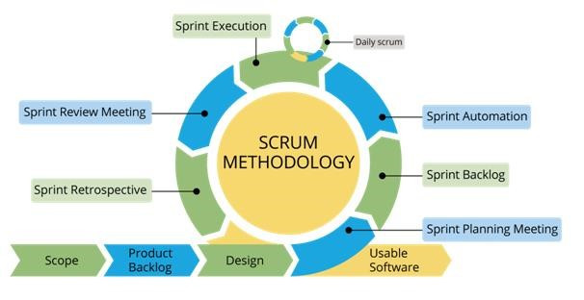

Figure 1: Scrum Methodology

For more information: https://www.belatrixsf.com/

This project is developed under Scrum model. We apply Scrum model to capable with current situation of our team. We choose this model due to following reasons:

* **Greater flexibility:** Though traditional methodologies require the customer to provide detail idea requirements, scrum software developers are more flexible because of their iterative style of work.
* **Quick responding to changing needs:** Since scrum software development goes through multiple rollout cycles, it has a better chance of providing exactly what the customers need at any given point in time. These cycles are designed not only to add new features but also to make adjustments to what has already been deployed.
* **Continuous feedback and easy to track:** It allow continuous feedbacks in bill to shape the final design.

### Roles and Responsibilities

|  |  |  |  |
| --- | --- | --- | --- |
| **No** | **Full name** | **Role** | **Responsibilities** |
| 1 | Nguyễn Huy Hùng | Project Manager | - Specify user requirement  - Control development process  - Give out technique and business analysis support  - Review document and product |
| 2 | Nguyễn Quang Nhật | Team Leader, BA, Developer | - Managing process  - Planning project  - Distribute tasks  - Designing database  - Clarifying requirements  - Prepare document  - Create test plan  - Coding  - Testing  - Deploy product |
| 3 | Nguyễn Đỗ Minh Đức | Team Member, BA, Developer, Tester | - Designing database  - Clarifying requirements  - Prepare document  - Create test plan  - Coding  - Testing |
| 4 | Vương Minh Thông | Team Member, BA, Developer, Tester | - Designing database  - Clarifying requirements  - Prepare document  - GUI design  - Create test plan  - Coding  - Testing |
| 5 | Hồ Công Trình | Team Member, BA, Developer, Tester | Designing database  - Clarifying requirements  - Prepare document  - GUI design  - Create test plan  - Coding  - Testing |

Table 5: Roles and Responsibilities

### Tools and Techniques

|  |  |  |
| --- | --- | --- |
|  | **Tools** | **Techniques** |
| Front-end | Sketch, X-Code 9.0 | Swift 3 |
| Back-end | Intellij |  |
| Web server |  |  |
| Application | X-Code 9.0 |  |
| DBMS | MYSQL Workbench 6.3 |  |
| Source control | Github |  |
| Modeling tool | StarUML v2.0 |  |
| Document tool | Microsoft Word 2013 |  |

Table 6: Tools and Techniques

## Project Management Plan

### Product Backlog

|  |  |  |
| --- | --- | --- |
| **ID** | **Features** | **User Story** |
| 1 | Register | Registering to become member |
| 2 | Login/Logout | Accessing the account to use their features |
| 3 | View all rooms | Admin want to view all rooms |
| 4 | Approve room | Admin want to remove room which changed house owner or not used |
| 5 | Remove room | Admin want to remove a room |
| 6 | View all users | Admin want to view all users |
| 7 | Approve house owner | Admin want to promote member to house owner |
| 8 | Remove user | Admin want to remove an user |
| 9 | Create room | House Owner want to add new room |
| 10 | Update account information | House Owner want to update informations |
| 11 | Update room information | House Owner want to update their room's informations |
| 12 | Remove room | House Owner want to delete room |
| 13 | Assign room master | House Owner want to assign room master for room |
| 14 | Add room's member | House Owner want to add room's members |
| 15 | View all room's information | House Owner want to view all room's informations |
| 16 | Remove room's member | House Owner want to remove member of room |
| 17 | Update account information | Room master want to update account information |
| 18 | Create finding roommate post | Room master want to create finding roommate post |
| 19 | Update finding roommate post | Room master want to update finding roommate post |
| 20 | Remove finding roommate post | Room master want to remove finding roommate post |
| 21 | Get notification about verified post | Room master want to get notified about verified post |
| 22 | Get notification about declined post | Room master want to get notified about declined post |
| 23 | Suggested member | Room master want to get suggested member |
| 24 | Suggested nearby room master | Room master want to get suggested nearby room master |
| 25 | Search for roommate | Room master want to search for roommate |
| 26 | Suggested room master | Member want to get suggested nearby rooms |
| 27 | Suggested by utilities | Member want to get suggested rooms by utilities |
| 28 | Search for room master | Member want to search rooms by address or utilities |
| 29 | Bookmark room | Member want to add bookmark |
| 30 | View all available room | Member want to view all available rooms |
| 31 | Filter room by utilities | Member want to filter room by utilities |
| 32 | Update account information | Member want to update account information |

Table 7: Product Backlog

### Sprint Backlog

Refer to “Sprint Backlog” folder.

### Meeting Minutes

Refer to “Meeting Minutes” folder.

## Coding Convention

We use followings naming convention from the reference to capable with the current situation in our team:

* Naming Convention:
* Follows camelcase syntax for naming the class, interface, method and variable.
* Method names should be verbs.
* Class names should be nouns, in mixed case with first letter of each internal word capitalized.
* Constant names should be all uppercase with words separated by underscore.
* Comment:
* Using /* */ for block comments.
* Using // for line comments.
* Follow Field Naming Conventions
* Other fields start with a lowercase letter.
* Public static final fields (constants) are ALL_CAPS_WITH_UNDERSCORES.

Using Java coding convention from:

<http://www.oracle.com/technetwork/java/codeconvtoc-136057.html>

# C. Software Requirement Specification

## User Requirement Specification

### Unauthorized User Requirement

Unauthorized user is a person who does not access to the system. Unauthorized user can use some functions in the system, to use all functions, they must login. These are functions that they can use:

* Register
* Login

### Authorized User Requirement

Authorized user is a person who logins in the system and will be separated into House owner, Room master, Member depend on what they want to do in the application. Authorized user can do the following functions, such as:

* Manage profile
* Search
* Negotiate
* View notification
* Logout

### House Owner Requirement

House owner is an authorized user who want to upload their room so that room master can create a post about that room in order to find roommates.

House owner can do the following functions:

* Create room
* Update room
* View room
* Delete room
* Add room members
* Remove room members

### Room Master Requirement

Room master is an authorized user who is looking for roommate.

Room master can do the following functions:

* Create finding roommate post
* Update finding roommate post
* View finding roommate post
* Delete finding roommate post
* View suggested nearby room master’s posts.

### Member Requirement

Member is an authorized user who is looking for a room

Member can do the following functions:

* Create finding room post
* Update finding room post
* View finding room post
* Delete finding room post
* View posts list
* View suggested posts list

### Admin Requirement

Admin is a completely different role form the others. Admin can manage information and tracking if the system work efficiently or not. Admin can do following functions.

* Manage room
* Manage user
* Approve room
* Logout

## System Requirement Specification

### External Interface Requirement

#### User Interface

* The user interface use Vietnamese.
* Use the consistent palette of colors between the text and the background.
* General requirement for graphical user interface of application on the mobile device is that the GUI should be simple, reminiscent.

#### Hardware Interface.

* Smartphone.

#### Software Interface

* Mobile application: IOS operating system (IOS 10 or above).

#### Communication Protocol

* Using Http protocol.

### System Overview Use Case

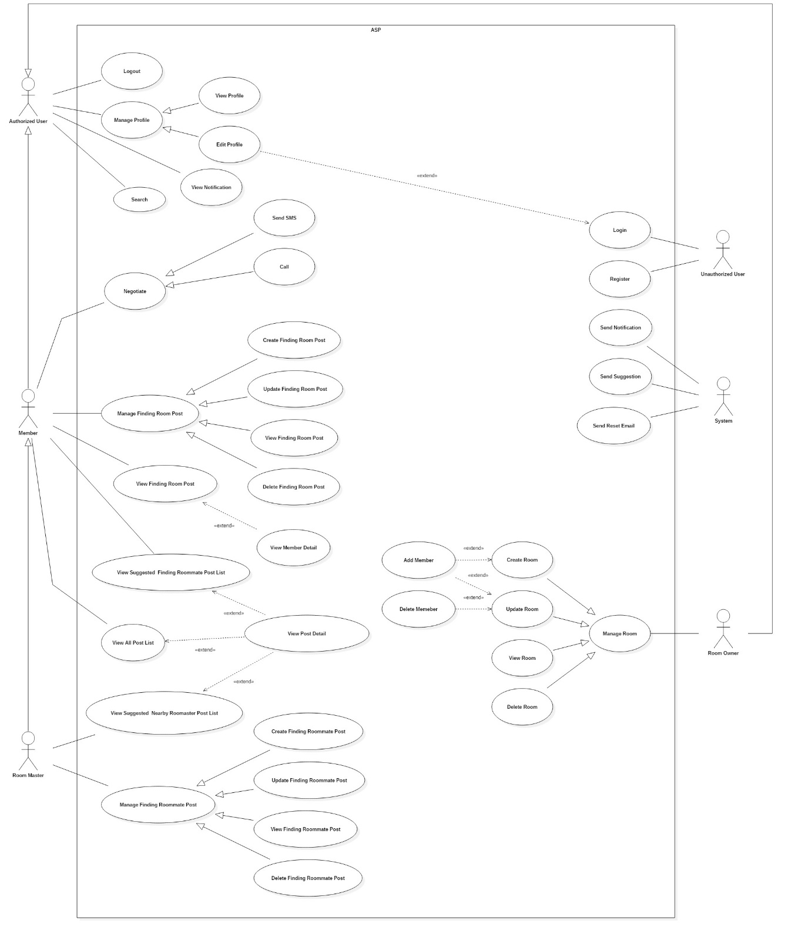

Figure 2: System Overview Use Case (1)

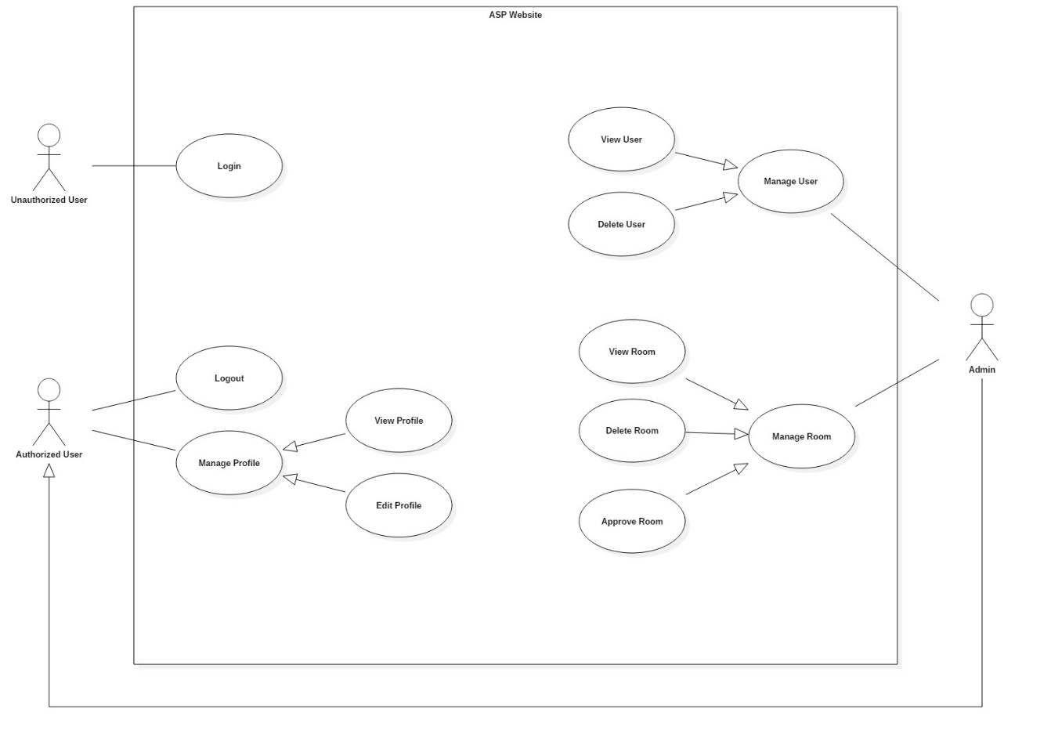

Figure 3: System Overview Use Case (2)

### List of Use Case

#### <Unauthorized User> Overview Use Case

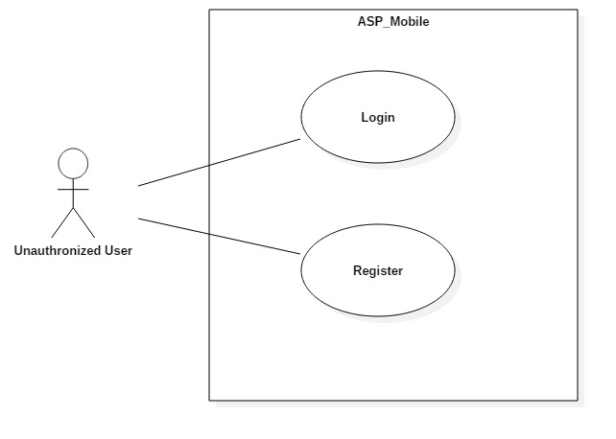

Figure 4: <Unauthorized User> Overview Use Case

##### <Unauthorized User> Register

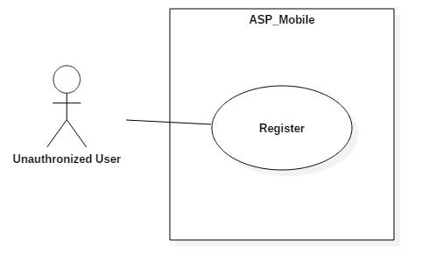

Figure 5: <Unauthorized User> Register Use Case

|  |  |  |  |
| --- | --- | --- | --- |
| **USE CASE – UC_ ASP_1** | | | |
| **Use Case No.** | UC_ ASP_1 | **Use Case Version** | 0.2 |
| **Use Case Name** | Register | | |
| **Author** | Nguyễn Đỗ Minh Đức | | |
| **Date** | 17/10/2018 | **Priority** | High |
| **Actor:**   * Unauthorized User   **Summary:**   * This use case allows unauthorized user to create account.   **Goal:**   * Create account then login to the system.   **Triggers:**   * Unauthorized click on “Đăng ký” button in first launch screen.   **Preconditions:**   * User have not logged in to system.   **Post conditions:**   * Success: Actor creates an account successfully. * Fail: System shows error messages.   **Main Success Scenario:**   |  |  |  | | --- | --- | --- | | **Step** | **Actor Action** | **System Response** | | 1 | Actor accesses to register screen | System requires information:   * “Tài khoản”: Text input * “Mật khẩu”: Text input * “Email”: Text input * “Giới tính”: Radio button * “Số điện thoại”: Text input * “Ngày sinh”: Date time picker * “Ảnh đại diện”: Image upload * “Đăng ký”button. | | 2 | Actor inputs information | [Exception no.1] |   **Alternative Scenario:** N/A  **Exceptions:**   |  |  |  | | --- | --- | --- | | **No** | **Cause** | **System Response** | | 1 | Actor input wrong information. | System shows message:“Thông tin bạn nhập không hợp lệ” |   **Relationships:** N/A  **Business Rules:**   * Username must be in range of 6-35 characters * Password must be in range of 4-30 characters. * Password must be encrypted before being sent to server. * User can choose role (House owner/member). * Each role have different register form. * User have not logged in to system. * After users registered, redirect them to home screen. | | | |

Table 8: <Unauthorized User> Register specification

##### <Unauthorized User> Login

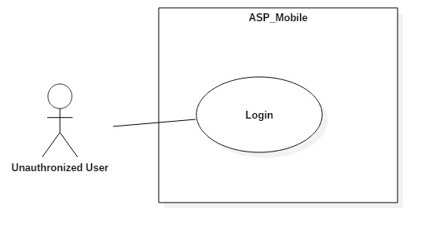

Figure 6: <Unauthorized User> Login Use Case

|  |  |  |  |
| --- | --- | --- | --- |
| **USE CASE – UC_ ASP_2** | | | |
| **Use Case No.** | UC_ ASP_2 | **Use Case Version** | 0.2 |
| **Use Case Name** | Login | | |
| **Author** | Nguyễn Đỗ Minh Đức | | |
| **Date** | 17/10/2018 | **Priority** | High |
| **Actor:**   * Unauthorized User   **Summary:**   * This use case allows unauthorized user to login to system with username and password.   **Goal:**   * To login to the system.   **Triggers:**   * Actor press on “Đăng nhập” button in first launch screen.   **Preconditions:**   * User have not logged in to system.   **Post conditions:**   * Success: Actor accesses to system successfully. * Fail: System shows error messages.   **Main Success Scenario:**   |  |  |  | | --- | --- | --- | | **Step** | **Actor Action** | **System Response** | | 1 | Actor accesses to login screen | System requires information:   * “Tài khoản”: Text input * “Mật khẩu”: Text input * “Đăng nhập” button. | | 2 | Actor inputs information  (username and password) | [Exception no.1] | | 3 | Actor sends command to login  (Press “Login” button after input login form). | [Exception no.2]  System navigates to login screen. |   **Alternative Scenario:** N/A  **Exceptions:**   |  |  |  | | --- | --- | --- | | **No** | **Cause** | **System Response** | | 1 | Actorinput wrong information. | System shows message:“Thông tin đăng nhập không hợp lệ” | | 2 | Actor left blank to required fields | System shows message: “Vui lòng điền đầy đủ thông tin”. |   **Relationships:** N/A  **Business Rules:**   * Username must be in range of 5-35 characters * Password must be in range of 4-30 characters. * User have not logged in to system. | | | |

Table 9: <Unauthorized User> Login specification

#### <Authorized User> Overview Use

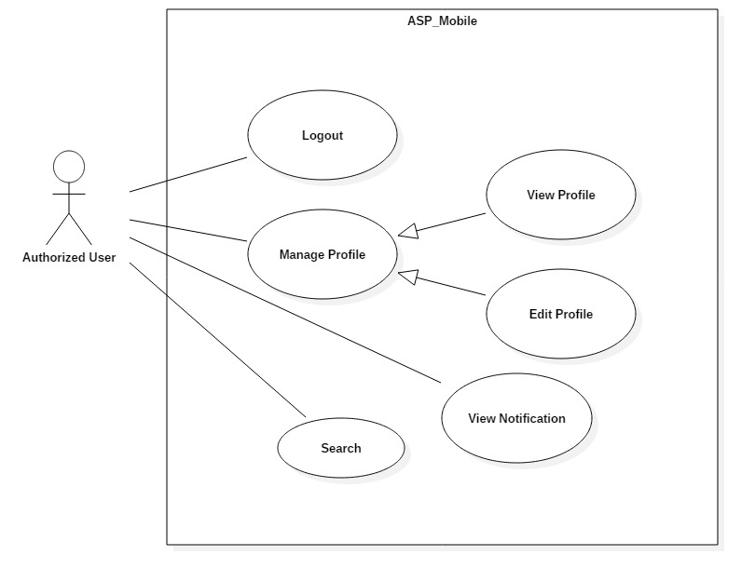

Figure 7: <Authorized User> Overview Use Case

##### <Authorized User> Logout

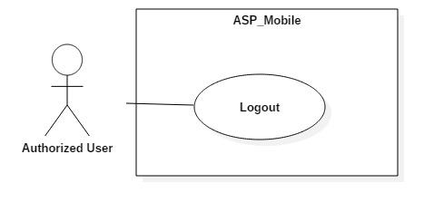

Figure 8: <Authorized User> Logout Use Case

|  |  |  |  |
| --- | --- | --- | --- |
| **USE CASE – UC_ ASP_3** | | | |
| **Use Case No.** | UC_ ASP_3 | **Use Case Version** | 0.2 |
| **Use Case Name** | Logout | | |
| **Author** | Vương Minh Thông | | |
| **Date** | 17/10/2018 | **Priority** | High |
| **Actor:**   * Authorized User   **Summary:**   * This use case allows authorized user signs out from the system.   **Goal:**   * Authenticated user stops accessing to the system. * User’s session is removed from the system.   **Triggers:**   * Press “Tài khoản” button in home screen. * Press “Đăng Xuất” button.   **Preconditions:**   * User logged in the system.   **Post conditions:**   * Success: User session is removed, and system displays login screen. * Fail: System displays error messages.   **Main Success Scenario:**   |  |  |  | | --- | --- | --- | | **Step** | **Actor Action** | **System Response** | | 1 | Actor presses account button. | User navigated to setting screen | | 2 | Actor presses logout button. | User session is removed,  System displays login screen. |   **Alternative Scenario:**N/A  **Exceptions:** N/A  **Relationships:** N/A  **Business Rules:**   * Actor has already accessed to the system. * After signing out, Authorized User will become “Unauthorized User”. | | | |

Table 10: <Authorized User> Logout specification

##### <Authorized User>View Notification

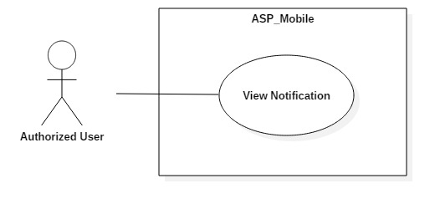

Figure 9: <Authorized User> View Notification Use Case

|  |  |  |  |
| --- | --- | --- | --- |
| **USE CASE – UC_ ASP_4** | | | |
| **Use Case No.** | UC_ ASP_4 | **Use Case Version** | 0.2 |
| **Use Case Name** | View Notification | | |
| **Author** | Hồ Công Trình | | |
| **Date** | 17/10/2018 | **Priority** | Medium |
| **Actor:**   * Authorized User   **Summary:**   * This use case allows user to view notification.   **Goal:**   * Get notification.   **Triggers:**   * From home screen, press on notification button in navigator bar.   **Preconditions:**   * User logged in the system.   **Post conditions:**   * Success: User get list of notifications. * Fail: System displays error messages.   **Main Success Scenario:**   |  |  |  | | --- | --- | --- | | **Step** | **Actor Action** | **System Response** | | 1 | Actor presses on notification button. | System navigates to notification screen with list of notifications. |   **Alternative Scenario:**N/A  **Exceptions:** N/A  **Relationships:** UC_ ASP_24, UC_ ASP_9, UC_ ASP_10  **Business Rules:**   * User has already accessed to the system. * User can be any role to get notified. * If there is no notification, display “Hiện tại bạn chưa có thông báo mới”. * If house owner’s room approved by admin, display “Phòng của bạn đã được xác thực.” * If members are added into room, display “Bạn đã được thêm vào phòng.” * If members are removed out of room, display “Bạn đã bị xóa ra khỏi phòng.” | | | |

Table 11: <Authorized User> View Notification specification

##### <Authorized User> Edit Profile

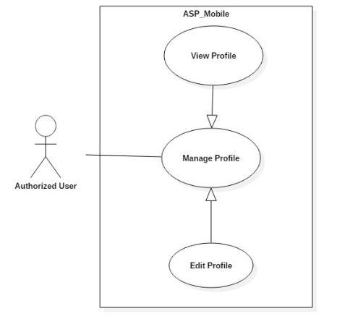

Figure 10: <Authorized User> Update Information Use Case

|  |  |  |  |
| --- | --- | --- | --- |
| **USE CASE – UC_ ASP_5** | | | |
| **Use Case No.** | UC_ ASP_5 | **Use Case Version** | 0.2 |
| **Use Case Name** | Edit Profile | | |
| **Author** | Nguyễn Đỗ Minh Đức | | |
| **Date** | 17/10/2018 | **Priority** | High |
| **Actor:**   * Authorized User   **Summary:**   * This use case allows authorized user to update their own information.   **Goal:**   * To update user’s information.   **Triggers:**   * Actor presses on edit profile button.   **Preconditions:**   * User logged in the system.   **Post conditions:**   * Success: System navigates back to user information screen and displays new information of the current user. * Fail: System displays error messages.   **Main Success Scenario:**   |  |  |  | | --- | --- | --- | | **Step** | **Actor Action** | **System Response** | | 1 | Actor presses on edit profile button. | System displays profile screen with:   * “Ảnh đại diện”: Image Upload * “Họ và tên”: Text input * “Email”: Text input * “Số điện thoại”: Text input * “Địa chỉ”: Text input * “Giới thiệu bản thân”: Text input * “Tiện ích”: Checkmark * “Lưu” button | | 2 | Fill form and press save button. | [Exception no.1]  [Exception no.2]  User info is updated successfully and system refreshes the profile screen with new information. |   **Alternative Scenario:***N/A*  **Exceptions:**   |  |  |  | | --- | --- | --- | | **No** | **Cause** | **System Response** | | 1 | User does not input required fields. | System notices that user need to input all these field:  - “Email”: System displays warning message: “Email không được để trống”. | | 2 | User input wrong information in some fields. | System notices that user need to re-input all these field:  - “Họ và tên”: System displays warning message: “Không được sử dụng ký tự đặc biệt !@#$%^&*()-=_+...”.  - “Email”: System displays warning message: “Sai định dạng, thiếu @”  - “Số điện thoại”: System displays warning message: “Không được sử dụng chữ hoặc ký tự đặc biệt !@#$%^&*()-=_+...”. |   **Relationships:** N/A  **Business Rules:**   * Actor has already accessed to the system. * Information are updated must not be in wrong format. * Email should not be empty. * Phone number is 10 digits. | | | |

Table 12: <Authorized User> Update Information specification

#### <House Owner> Overview Use Case

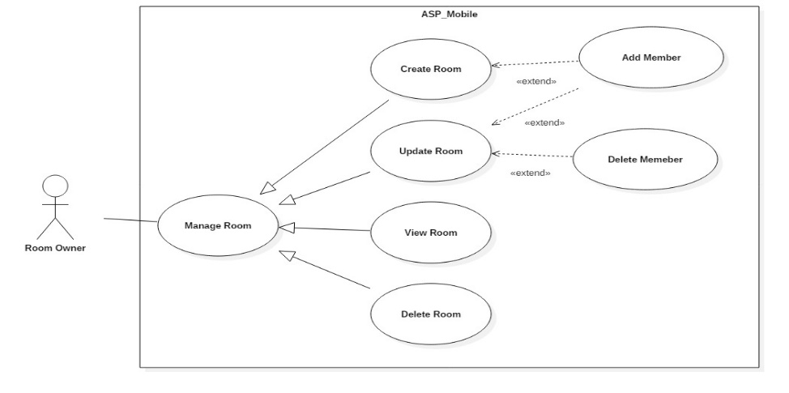

Figure 11: <House Owner> Overview Use Case

##### <House Owner> Create Room

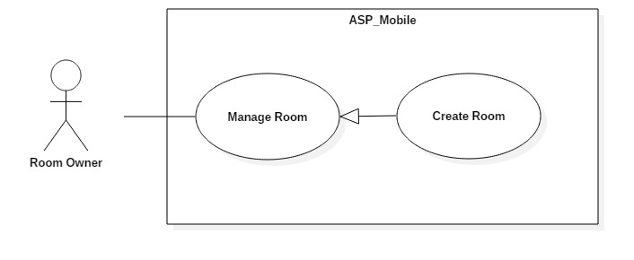

Figure 12: <House Owner> Create Room Use Case

|  |  |  |  |
| --- | --- | --- | --- |
| **USE CASE – UC_ ASP_6** | | | |
| **Use Case No.** | UC_ ASP_6 | **Use Case Version** | 0.2 |
| **Use Case Name** | Create Room | | |
| **Author** | Vương Minh Thông | | |
| **Date** | 17/10/2018 | **Priority** | High |
| **Actor:**   * House Owner   **Summary:**   * This use case allows house owner to create new room.   **Goal:**   * To create new room.   **Triggers:**   * Press create room button in home screen.   **Preconditions:**   * User is house owner.   **Post conditions:**   * Success: User can create new room. * Fail: System shows error messages.   **Main Success Scenario:**   |  |  |  | | --- | --- | --- | | **Step** | **Actor Action** | **System Response** | | 1 | Actor presses on create room button. | System displays create room screen with:  - “Tên Phòng”: Text input.  - “Thành phố”: Dropdown list.  - “Quận”: Dropdown list.  - “Giá”: Text input.  - “Diện tích”: Text input.  - “Địa chỉ”: Text input.  - “Số khách tối đa”: Text input.  - “Mô tả”: Text input.  - “Tiện ích”: Checkmark.  - “Hình ảnh”: Image upload.  - “Thêm thành viên vào phòng” : Button  - “Tạo phòng” : Button | | 2 | Actor fills form and presses on save button. | [Exception no.1]  System creates room successfully and navigate user back to home screen.  System will display latest information. |   **Alternative Scenario:** N/A  **Exceptions:**   |  |  |  | | --- | --- | --- | | **No** | **Cause** | **System Response** | | 1 | User does not input required fields. | System notices that user need to input all these field:  - “Tên phòng”: System displays warning message: “Tên phòng không được để trống”.  - “Giá”: System displays warning message: “Giá không được để trống”.  - “Địa chỉ”: System displays warning message: “Địa chỉ không được để trống”. |   **Relationships:** N/A  **Business Rules:**   * User already logged in the system. * Room name must not be empty. * Room price must not be empty. * Address must not be empty. * User must be house owner role to create room. * After house owner create room, redirect to home screen. | | | |

Table 13: <House Owner> Create Room specification

##### <House owner> Update Room

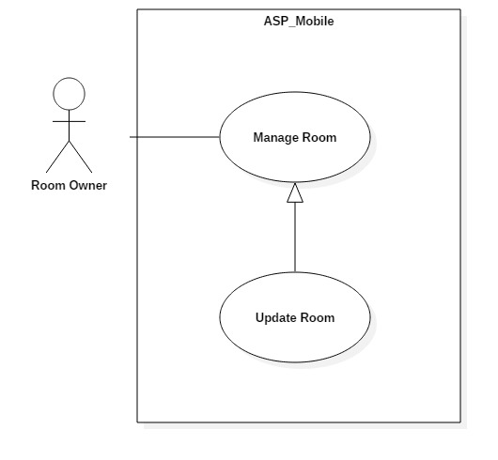

Figure 13: <House owner> Update Room Use Case

|  |  |  |  |
| --- | --- | --- | --- |
| **USE CASE – UC_ ASP_7** | | | |
| **Use Case No.** | UC_ ASP_7 | **Use Case Version** | 0.2 |
| **Use Case Name** | Update Room | | |
| **Author** | Vương Minh Thông | | |
| **Date** | 17/10/2018 | **Priority** | High |
| **Actor:**   * House owner   **Summary:**   * This use case allows House owner update room.   **Goal:**   * To update room.   **Triggers:**   * Actor press on update room button.   **Preconditions:**   * User logged in the system. * Room have been uploaded.   **Post conditions:**   * Success: User can update new information to room. * Fail: System shows error messages.   **Main Success Scenario:**   |  |  |  | | --- | --- | --- | | **Step** | **Actor Action** | **System Response** | | 1 | Actor presses on update room button. | Systems navigate to update room screen.  System displays update screen with:  - “Tên Phòng”: Text input.  - “Thành phố”: Dropdown list.  - “Quận”: Dropdown list.  - “Giá”: Text input.  - “Diện tích”: Text input.  - “Địa chỉ”: Text input.  - “Số khách tối đa”: Text input.  - “Mô tả”: Text input.  - “Tiện ích”: Checkmark.  - “Hình ảnh”: Image upload.  - “Thành viên trong phòng” table  - “Thêm thành viên vào phòng” button  - “Lưu” button | | 2 | Actor fills form presses on save button. | [Exception no.1]  Room info is updated successfully and system refreshes the current screen with new information. |   **Alternative Scenario:** N/A  **Exceptions:**   |  |  |  | | --- | --- | --- | | **No** | **Cause** | **System Response** | | 1 | User does not input required fields. | System notices that user need to re-input all these fields:  - “Tên phòng”: System displays warning message: “Tên phòng không được để trống”.  - “Giá”: System displays warning message: “Giá không được để trống”.  - “Địa chỉ”: System displays warning message: “Địa chỉ không được để trống”. |   **Relationships:** N/A  **Business Rules:**   * User already logged in the system. * User must have role as House Owner to update room. * Room’s information is updated must be matched the defined room’s information structure. * Room name must not be empty. * Room price must not be empty. * Room address must not be empty. | | | |

Table 14: <House owner> Update Room specification

##### <House owner> Delete Room

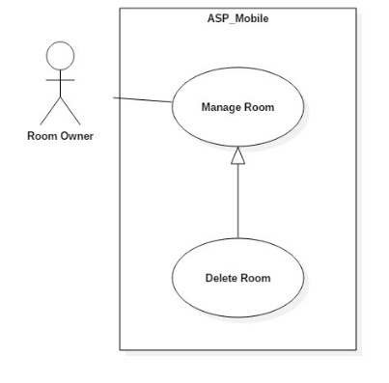

Figure 14: <House owner> Delete Room Use Case

|  |  |  |  |
| --- | --- | --- | --- |
| **USE CASE – UC_ ASP_8** | | | |
| **Use Case No.** | UC_ ASP_8 | **Use Case Version** | 0.2 |
| **Use Case Name** | Delete Room | | |
| **Author** | Vương Minh Thông | | |
| **Date** | 17/10/2018 | **Priority** | High |
| **Actor:**   * House owner   **Summary:**   * This use case allows House owner delete room.   **Goal:**   * To delete room.   **Triggers:**   * Actor press on certain room in account screen. * Press delete room button.   **Preconditions:**   * User logged in the system. * Rooms have been uploaded.   **Post conditions:**   * Success: User can delete room. * Fail: System shows error messages.   **Main Success Scenario:**   |  |  |  | | --- | --- | --- | | **Step** | **Actor Action** | **System Response** | | 1 | Actor presses on certain room. | System will navigate to this room screen with common detail.  - “Hình ảnh”  - “Tên phòng”  - “Giá phòng”  - “Diện tích”  - “Địa chỉ”  - “Mô tả”  - “Ngày đăng bài”  - “Tiện ích”  - “Thành viên trong phòng” table  - “Chỉnh sửa” button  - “Xóa” button | | 2 | Actor presses on delete button. | Room is deleted successfully and system refreshes the “Đã đăng” screen with new information. |   **Alternative Scenario:**N/A  **Relationships:** N/A  **Business Rules:**   * User already logged in the system. * Room already uploaded to the system. * User must be house owner. | | | |

Table 15: <House owner> Delete Room specification

##### <House owner> Add Member into Room

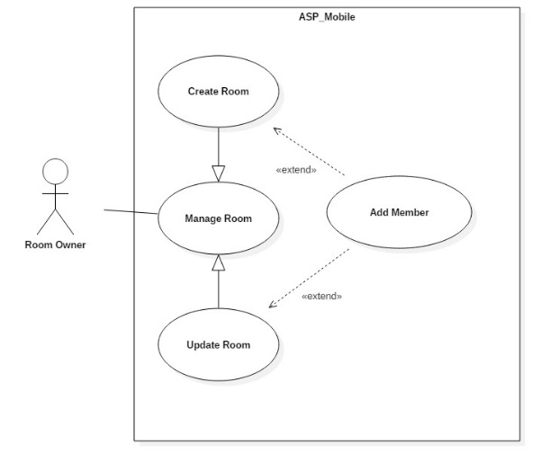

Figure 15: <House owner> Add Member into Room Use Case

|  |  |  |  |
| --- | --- | --- | --- |
| **USE CASE – UC_ ASP_9** | | | |
| **Use Case No.** | UC_ ASP_9 | **Use Case Version** | 0.2 |
| **Use Case Name** | Add Member into Room | | |
| **Author** | Hồ Công Trình | | |
| **Date** | 17/10/2018 | **Priority** | High |
| **Actor:**   * House owner   **Summary:**   * This use case allows house owner add member into Room.   **Goal:**   * To add member into room.   **Triggers:**   * Actor press on certain room in account screen. * Actor press add member button.   **Preconditions:**   * User logged in the system. * Room have been uploaded.   **Post conditions:**   * Success: House owner can add member into Room. * Fail: System shows error messages.   **Main Success Scenario:**   |  |  |  | | --- | --- | --- | | **Step** | **Actor Action** | **System Response** | | 1 | Actor presses on certain room. | System will navigate to this room screen with common detail.  - “Hình ảnh”  - “Tên phòng”  - “Giá phòng”  - “Diện tích”  - “Địa chỉ”  - “Ngày đăng bài”  - “Mô tả”  - “Chỉnh sửa” button  - “Xóa” button | | 2 | Actor presses on edit member button. | Systems navigate to add member into room screen.  System displays add member into room screen with:  - “Tài khoản”: Text input  - “Thêm” button. | | 3 | Actor presses on add button. | [Exception no.1]  [Exception no.2]  Room info is updated successfully and system refreshes the “Thêm thành viên vào phòng” screen with new information. |   **Alternative Scenario:** N/A  **Exceptions:**   |  |  |  | | --- | --- | --- | | **No** | **Cause** | **System Response** | | 1 | User does not input required fields. | System notices that user need to re-input all these fields:  - “Tài khoản”: System displays warning message: “Tài khoản không được để trống”. | | 2 | User inputs wrong information in some fields. | System notices that user need to re-input all these fields:  - “Tài khoản”: System displays warning message: “Tài khoản không tồn tại hoặc bị trùng”. |   **Relationships:** Extend Create/Update room  **Business Rules:**   * User already logged in the system. * User must be house owner role. * Username must have been in system. * Date in must be later than date create room. * House owner enter username of member then press add button. * House owner must choose one room master before submit. | | | |

Table 16: <House owner> Add Member into Room specification

##### <House owner> Delete Member from Room

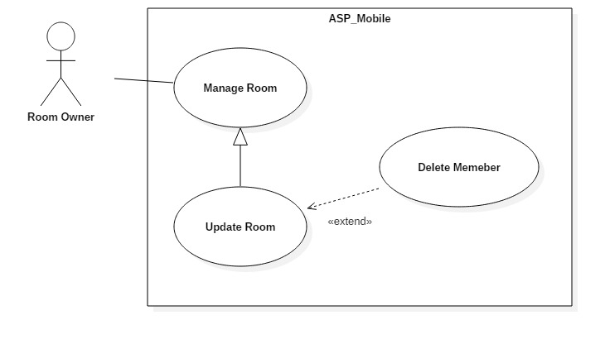

Figure 16: <House owner> Delete Member from Room Use Case

|  |  |  |  |
| --- | --- | --- | --- |
| **USE CASE – UC_ ASP_10** | | | |
| **Use Case No.** | UC_ ASP_10 | **Use Case Version** | 0.2 |
| **Use Case Name** | Delete Member from Room | | |
| **Author** | Hồ Công Trình | | |
| **Date** | 17/10/2018 | **Priority** | High |
| **Actor:**   * House owner   **Summary:**   * This use case allows house owner delete member from room.   **Goal:**   * To delete member from room.   **Triggers:**   * Actor presses on certain room in account screen. * Actor presses delete member button.   **Preconditions:**   * User logged in the system. * Member already added into room.   **Post conditions:**   * Success: House owner can delete member of room. * Fail: System shows error messages.   **Main Success Scenario:**   |  |  |  | | --- | --- | --- | | **Step** | **Actor Action** | **System Response** | | 1 | Actor presses on certain room. | System will navigate to this room screen with common detail.  - “Hình ảnh”  - “Tên phòng”  - “Giá”  - “Diện tích”  - “Địa chỉ”  - “Ngày đăng bài”  - “Mô tả”  - “Chỉnh sửa” button  - “Xóa” button | | 2 | Actor chooses 1 member of room and press delete button | Systems display popup “Xoá thành công”.  System displays the rest of members of the room. | | 3 | Actor presses on save button. | Room info is updated successfully and system refreshes the update room screen with new information. |   **Alternative Scenario:** N/A  **Relationships:** Extend Update room  **Business Rules:**   * User already logged in the system. * Member already added into room. * User must be house owner role. * If Room Master was removed, system will promote the next member to room master automatically. | | | |

Table 17: <House owner> Delete Member from Room specification

#### <Room Master> Overview Use Case

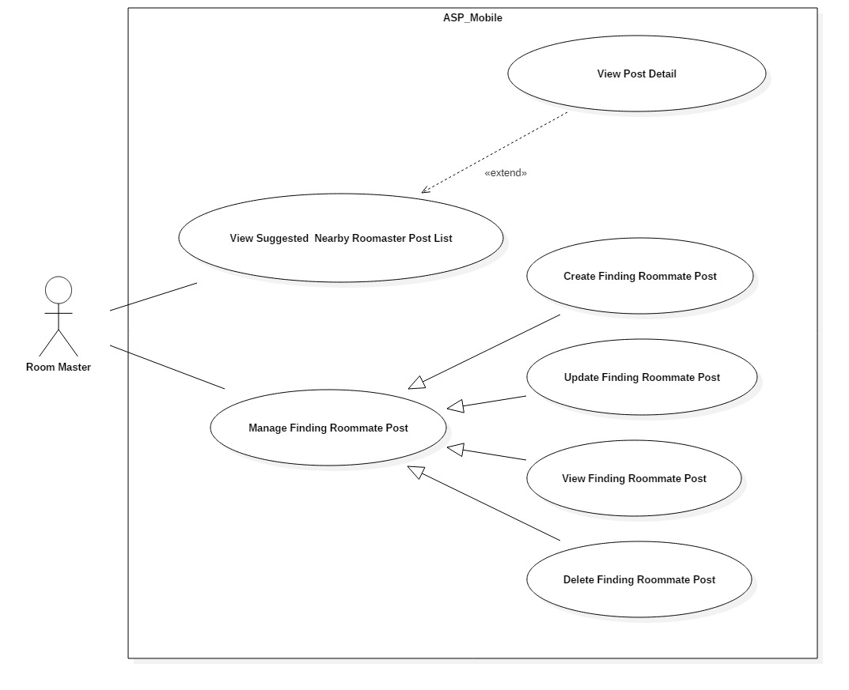

Figure 17: <Room Master> Overview Use Case

##### <Room Master> View Suggested Nearby Room Master

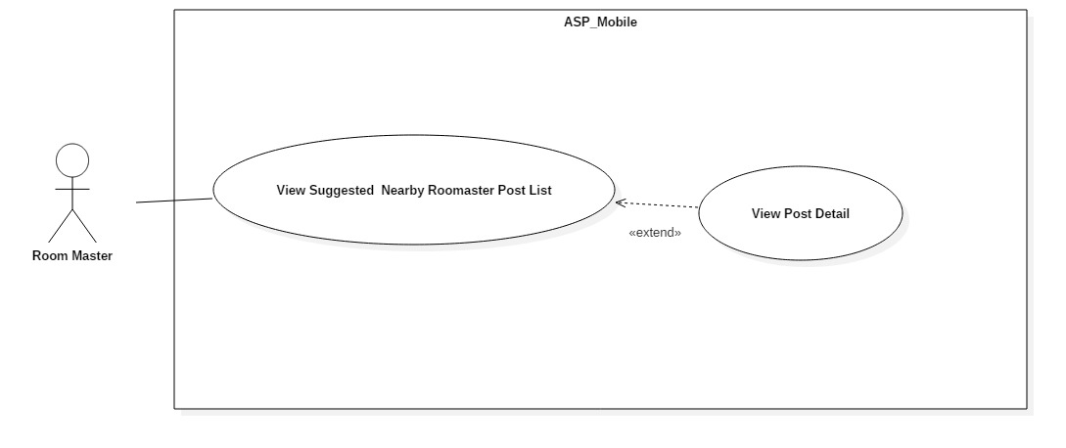

Figure 18: <Room Master> View Suggested Nearby Room Master Post Use Case

|  |  |  |  |
| --- | --- | --- | --- |
| **USE CASE – UC_ ASP_11** | | | |
| **Use Case No.** | UC_ ASP_11 | **Use Case Version** | 0.2 |
| **Use Case Name** | View Suggested Nearby Room master Post | | |
| **Author** | Nguyễn Đỗ Minh Đức | | |
| **Date** | 17/10/2018 | **Priority** | High |
| **Actor:**   * Room Master   **Summary:**   * This use case allows room master to view suggested nearby room master posts.   **Goal:**   * To get suggested nearby room master posts.   **Triggers:**   * Actor logged into system and goes to home screen.   **Preconditions:**   * User logged in the system.   **Post conditions:**   * Success: User can view suggested finding nearby room master posts. * Fail: System shows error messages.   **Main Success Scenario:**   |  |  |  | | --- | --- | --- | | **Step** | **Actor Action** | **System Response** | | 1 | Actor access application. | System displays home screen with:  - “Những bài gần bạn”: Horizontal scroll view. |   **Alternative Scenario:** N/A  **Exceptions:** N/A  **Relationships:** N/A  **Business Rules:**   * User already logged in the system. * System get all posts which are in the same city as room master’s current finding roommate post. * System calculate distance between them based on their longitude and latitude which stored in database. * System then shows nearby finding roommate posts. | | | |

Table 18: <Room Master> View Suggested Nearby Room Master Post Specification

##### <Room Master> Create Finding Roommate Post

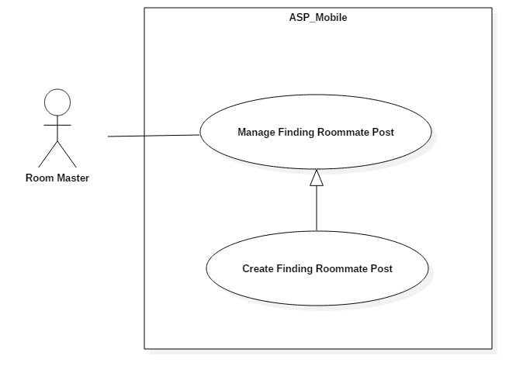

Figure 19: <Room Master> Create Finding Roommate Post Use Case

|  |  |  |  |
| --- | --- | --- | --- |
| **USE CASE – UC_ ASP_12** | | | |
| **Use Case No.** | UC_ ASP_12 | **Use Case Version** | 0.2 |
| **Use Case Name** | Create Finding Roommate Post | | |
| **Author** | Nguyễn Quang Nhật | | |
| **Date** | 17/10/2018 | **Priority** | High |
| **Actor:**   * Room Master   **Summary:**   * This use case allows room master to create new finding roommate post.   **Goal:**   * To create new post.   **Triggers:**   * Actor press on create post button in home screen.   **Preconditions:**   * User logged in the system. * The first member was added into room by house owner.   **Post conditions:**   * Success: User can create new post. * Fail: System shows error messages.   **Main Success Scenario:**   |  |  |  | | --- | --- | --- | | **Step** | **Actor Action** | **System Response** | | 1 | Actor press on create post button. | System displays create post screen with:  - “Tên bài”: Text input.  - “Giá”: Text input.  - “Số điện thoại”: Text input  - “Diện tích”  - “Địa chỉ”  - “Số bạn ở ghép”: Text input  - “Mô tả”: Text input.  - “Giới tính”: Radio button  - “Đăng bài”: Button | | 3 | Fill form and press on submit button. | [Exception no.1]  [Exception no.2]  System creates post successfully and navigate user back to home screen.  System displays latest information. |   **Alternative Scenario:** N/A  **Exceptions:**   |  |  |  | | --- | --- | --- | | **No** | **Cause** | **System Response** | | 1 | User does not input required fields. | System notices that user need to input all these field:  - “Giá”: System displays warning message: “Giá không được để trống”.  - “Số bạn ở ghép”: System displays warning message: ““Số bạn ở ghép không được để trống”. | | 2 | User input wrong information in some fields. | System notices that user need to re-input all these field:  - “Giá”: System displays warning message: “Không được sử dụng chữ hoặc ký tự đặc biệt !@#$%^&*()-=_+...”.  - “Số bạn ở ghép”: System displays warning message: “Không được sử dụng chữ hoặc ký tự đặc biệt !@#$%^&*()-=_+... Và phải ít hơn số thành viên tối đa của phòng”. |   **Relationships:** N/A  **Business Rules:**   * User already logged in the system. * Number of partner must not be empty. * Price must not be empty. * User must be room master. * User must be added into room. | | | |

Table 19: <Room Master> Create Finding Roommate Post specification

##### <Room Master> Update Finding Roommate Post

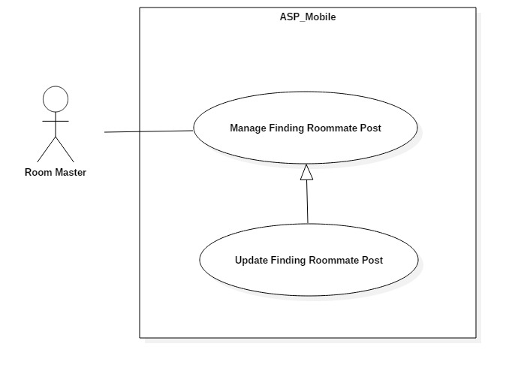

Figure 20: <Room Master> Update Finding Roommate Post Use Case

|  |  |  |  |
| --- | --- | --- | --- |
| **USE CASE – UC_ ASP_13** | | | |
| **Use Case No.** | UC_ ASP_13 | **Use Case Version** | 0.2 |
| **Use Case Name** | Update Finding Roommate Post | | |
| **Author** | Nguyễn Quang Nhật | | |
| **Date** | 17/10/2018 | **Priority** | High |
| **Actor:**   * Room Master   **Summary:**   * This use case allows room master to update finding roommate post.   **Goal:**   * To update post.   **Triggers:**   * Actor press on edit post button.   **Preconditions:**   * User logged in the system. * Post have been uploaded.   **Post conditions:**   * Success: User can update post. * Fail: System shows error messages.   **Main Success Scenario:**   |  |  |  | | --- | --- | --- | | **Step** | **Actor Action** | **System Response** | | 1 | Actor presses on edit post button. | Systems navigate to update room screen.  System displays update screen with:  - “Hình ảnh”  - “Tên phòng” ”: Text input  - “Số điện thoại”: Text input  - “Giá phòng” ”: Text input  - “Diện tích”  - “Địa chỉ”  - “Ngày đăng bài”  - “Mô tả” ”: Text input  - “Lưu” button | | 2 | Actor fills form and presses on save button. | [Exception no.1]  [Exception no.2]  Room info is updated successfully and system refreshes the “Đã đăng” screen with new information. |   **Alternative Scenario:** N/A  **Exceptions:**   |  |  |  | | --- | --- | --- | | **No** | **Cause** | **System Response** | | 1 | User does not input required fields. | System notices that user need to input all these field:  - “Giá”: System displays warning message: “Giá không được để trống”.  - “Số bạn ở ghép”: System displays warning message: ““Số bạn ở ghép không được để trống”. | | 2 | User input wrong information in some fields. | System notices that user need to re-input all these field:  - “Giá”: System displays warning message: “Không được sử dụng chữ hoặc ký tự đặc biệt !@#$%^&*()-=_+...”.  - “Số bạn ở ghép”: System displays warning message: “Không được sử dụng chữ hoặc ký tự đặc biệt !@#$%^&*()-=_+... Và phải ít hơn số thành viên phòng tối đa”. |   **Relationships:** N/A  **Business Rules:**   * User already logged in the system. * Post number of partner is not null. * Post price is not null. * User must be room master role. * Information are updated must not be in wrong format. | | | |

Table 20: <Room Master> Update Finding Roommate Post specification

##### <Room Master> Delete Finding Roommate Post

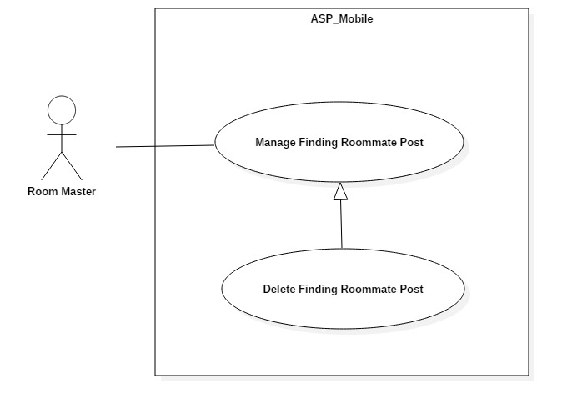

Figure 21: <Room Master> Delete Finding Roommate Post Use Case

|  |  |  |  |
| --- | --- | --- | --- |
| **USE CASE – UC_ ASP_14** | | | |
| **Use Case No.** | UC_ ASP_14 | **Use Case Version** | 0.2 |
| **Use Case Name** | Delete Finding Roommate Post | | |
| **Author** | Nguyễn Quang Nhật | | |
| **Date** | 17/10/2018 | **Priority** | High |
| **Actor:**   * Room Master   **Summary:**   * This use case allows room master to delete finding roommate post.   **Goal:**   * To delete post.   **Triggers:**   * Actor press on delete post button.   **Preconditions:**   * User logged in the system. * Post have been uploaded.   **Post conditions:**   * Success: User can delete post. * Fail: System shows error messages.   **Main Success Scenario:**   |  |  |  | | --- | --- | --- | | **Step** | **Actor Action** | **System Response** | | 1 | Actor presses on delete post button. | Post info is deleted successfully and system refreshes the home screen with new information. |   **Alternative Scenario:** N/A  **Relationships:** N/A  **Business Rules:**   * User already logged in the system. * User must be room master role. | | | |

Table 21: <Room Master> Delete Finding Roommate Post specification

##### <Room Master> View Post Detail

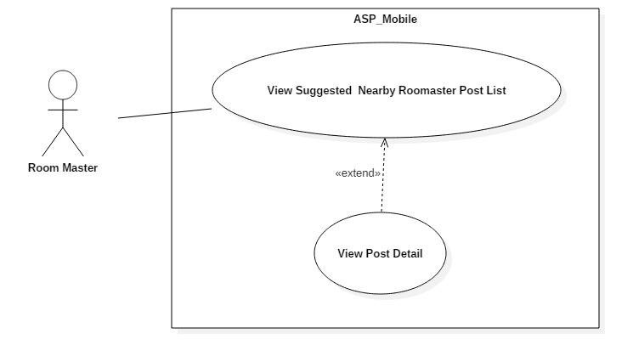

Figure 22: <Room Master> View Post Detail Use Case

|  |  |  |  |
| --- | --- | --- | --- |
| **USE CASE – UC_ ASP_15** | | | |
| **Use Case No.** | UC_ ASP_15 | **Use Case Version** | 0.2 |
| **Use Case Name** | View Post Detail | | |
| **Author** | Nguyễn Quang Nhật | | |
| **Date** | 17/10/2018 | **Priority** | High |
| **Actor:**   * Room Master   **Summary:**   * This use case allows room master to view post detail.   **Goal:**   * To get post’s detail.   **Triggers:**   * Press on any finding room post.   **Preconditions:**   * User logged in the system.   **Post conditions:**   * Success: User can view post’s details. * Fail: System shows error messages.   **Main Success Scenario:**   |  |  |  | | --- | --- | --- | | **Step** | **Actor Action** | **System Response** | | 1 | Actor presses on any finding rom post. | - System will navigate to this post screen with common detail.  - “Tài khoản”  - “Tên bài đăng”  - “Khoảng giá”  - “Số điện thoại”  - “Diện tích”  - “Mô tả”  - “Quận” |   **Alternative Scenario:** N/A  **Exceptions:** N/A  **Relationships:** extend **UC_ ASP_11**  **Business Rules:**   * User already logged in the system. * User must be room master role. | | | |

Table 22: <Room Master> View Post Detail Specification

#### <Member> Overview Use Case

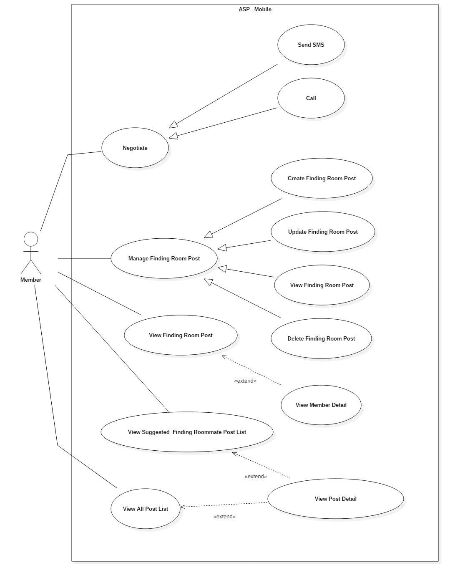

Figure 23: <Member> Overview Use Case

##### <Member> View Suggested Finding Roommate Post list

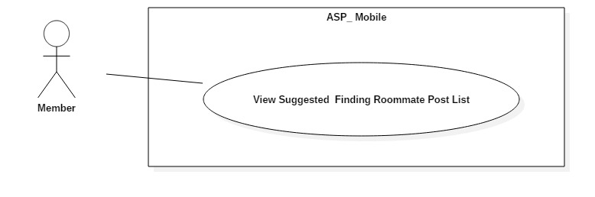

Figure 24: <Member> View Suggested Finding Roommate Posts List Use Case

|  |  |  |  |
| --- | --- | --- | --- |
| **USE CASE – UC_ ASP_16** | | | |
| **Use Case No.** | UC_ ASP_16 | **Use Case Version** | 0.2 |
| **Use Case Name** | View Suggested Finding Roommate Posts | | |
| **Author** | Nguyễn Quang Nhật | | |
| **Date** | 17/10/2018 | **Priority** | High |
| **Actor:**   * Member   **Summary:**   * This use case allows member to view suggested finding roommate posts.   **Goal:**   * To get suggested post list.   **Triggers:**   * User logged into system and goes to home screen.   **Preconditions:**   * User logged in the system.   **Post conditions:**   * Success: User can view suggested finding roommate posts. * Fail: System shows error messages.   **Main Success Scenario:**   |  |  |  | | --- | --- | --- | | **Step** | **Actor Action** | **System Response** | | 1 | Actor access application. | System displays home screen with:  - “Những bài gần bạn”: Horizontal scroll view. |   **Alternative Scenario:** N/A  **Exceptions:** N/A  **Relationships:** N/A  **Business Rules:**   * User already logged in the system. * User must accept location access request from the application. * At the time user access the application, system automatically calculate the distance based on the current location. * If user does not accept location access request from the application, display all newest accommodations in home screen. * If user has references suggest posts by references, otherwise suggest newest posts. | | | |

Table 23: <Member> View Suggested Finding Roommate Posts List Specification

##### <Member> Create Finding Room Post

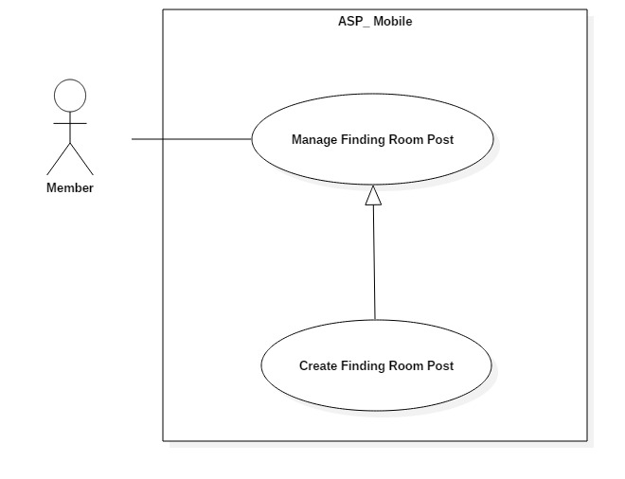

Figure 25:< Member> Create Finding Room Post Use Case

|  |  |  |  |
| --- | --- | --- | --- |
| **USE CASE – UC_ ASP_17** | | | |
| **Use Case No.** | UC_ ASP_17 | **Use Case Version** | 0.2 |
| **Use Case Name** | Create Finding Room Post | | |
| **Author** | Nguyễn Quang Nhật | | |
| **Date** | 17/10/2018 | **Priority** | High |
| **Actor:**   * Member   **Summary:**   * This use case allows member to create finding room post.   **Goal:**   * To create new finding room post.   **Triggers:**   * Actor sends create finding room post command.   **Preconditions:**   * User logged in the system.   **Post conditions:**   * Success: User can create new post. * Fail: System shows error messages.   **Main Success Scenario:**   |  |  |  | | --- | --- | --- | | **Step** | **Actor Action** | **System Response** | | 1 | Actor presses on create post button. | System displays create post screen with:  - “Tên bài”: Text input.  - “Khoảng Giá”: Slide choose.  - “Diện tích”  - “Quận”: Checkmark  - “Mô tả”: Text input.  - “Số điện thoại”: Text input  - “Giới tính” switch button  - “Đăng bài” button | | 2 | Actor fills form and presses on submit button. | [Exception no.1]  [Exception no.2]  System creates post successfully and navigate user back to home screen.  System will display latest information. |   **Alternative Scenario:** N/A  **Exceptions:**   |  |  |  | | --- | --- | --- | | **No** | **Cause** | **System Response** | | 1 | User input wrong information in some fields. | System notices that user need to re-input all these field:  - “Giá”: System displays warning message: “Không được sử dụng chữ hoặc ký tự đặc biệt !@#$%^&*()-=_+...”.  - “Diện tích”: System displays warning message: “Không được sử dụng chữ hoặc ký tự đặc biệt !@#$%^&*()-=_+...”. | | 2 | User does not input fields with requirement. | System notices that user need to re-input all these field:  - “Quận”: System displays warning message: “Bạn phải chọn ít nhất 1 quận.” .  - “Số điện thoại”: System displays warning message: “Số điện thoại không được để trống”. |   **Relationships:** N/A  **Business Rules:**   * User already logged in the system. * User must be member role. * District must not be empty. * Phone number must not be empty. * After member create finding rom post. System get user’s utilities and apply in account setting utilities. | | | |

Table 24: <Member> Create Finding Room Post specification

##### <Member> Update Finding Room Post

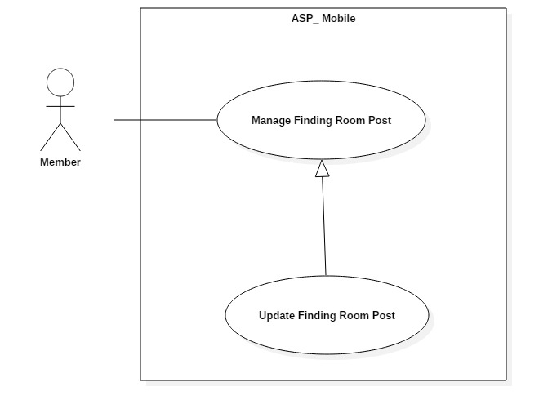

Figure 26:< Member> Update Finding Room Post Use Case

|  |  |  |  |
| --- | --- | --- | --- |
| **USE CASE – UC_ ASP_18** | | | |
| **Use Case No.** | UC_ ASP_18 | **Use Case Version** | 0.2 |
| **Use Case Name** | Update Finding Room Post | | |
| **Author** | Nguyễn Đỗ Minh Đức | | |
| **Date** | 17/10/2018 | **Priority** | High |
| **Actor:**   * Member   **Summary:**   * This use case allows member to update finding room post.   **Goal:**   * To update finding room post.   **Triggers:**   * Actor sends update finding room post command.   **Preconditions:**   * User logged in the system. * Post already uploaded.   **Post conditions:**   * Success: User can update finding room post. * Fail: System shows error messages.   **Main Success Scenario:**   |  |  |  | | --- | --- | --- | | **Step** | **Actor Action** | **System Response** | | 1 | Actor presses on edit post button. | Systems navigate to update finding room post screen.  System displays update screen with:  - “Tên bài đăng”  - “Khoảng giá”  - “Diện tích”  - “Mô tả”  - “Số điện thoại”  - “Quận”  - “Lưu” button | | 2 | Actor fills form and presses on save button. | [Exception no.1]  Room info is updated successfully and system refreshes the “Đã đăng” screen with new information. |   **Alternative Scenario:** N/A  **Exceptions:**   |  |  |  | | --- | --- | --- | | **No** | **Cause** | **System Response** | | 1 | User inputs wrong information in some fields. | System notices that user need to re-input all these field:  - “Diện tích”: System displays warning message: “Không được sử dụng chữ hoặc ký tự đặc biệt !@#$%^&*()-=_+...”. |   **Relationships:** N/A  **Business Rules:**   * User already logged in the system. * Information are updated must be matched the defined information structure in system. * User must be member role. * Finding room post already uploaded to the system. | | | |

Table 25: <Member> Update Finding Room Post specification

##### <Member> Delete Finding Room Post

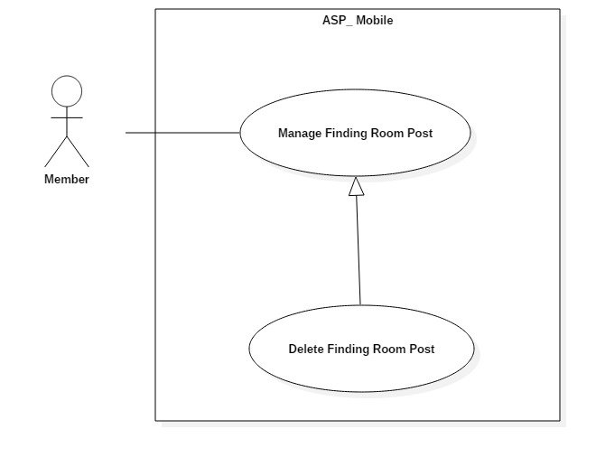

Figure 27: <Member> Delete Finding Room Post Use Case

|  |  |  |  |
| --- | --- | --- | --- |
| **USE CASE – UC_ ASP_19** | | | |
| **Use Case No.** | UC_ ASP_19 | **Use Case Version** | 0.2 |
| **Use Case Name** | Delete Finding Room Post | | |
| **Author** | Nguyễn Đỗ Minh Đức | | |
| **Date** | 17/10/2018 | **Priority** | High |
| **Actor:**   * Room Master   **Summary:**   * This use case allows room master to delete finding room post.   **Goal:**   * To delete post.   **Triggers:**   * Actor press on “Xoá” button in post view.   **Preconditions:**   * User logged in the system. * Post have been uploaded.   **Post conditions:**   * Success: User can delete finding room post. * Fail: System shows error messages.   **Main Success Scenario:**   |  |  |  | | --- | --- | --- | | **Step** | **Actor Action** | **System Response** | | 1 | Actor presses on certain post. | System will navigate to this post screen with common detail.  - “Tên bài đăng”  - “Khoảng giá”  - “Số điện thoại”  - “Diện tích”  - “Mô tả”  - “Quận”  - “Chỉnh sửa” button  - “Xóa” button | | 2 | Actor presses on “Xoá” button. | Post info is deleted successfully and system refreshes the “Đã đăng” screen with new information. |   **Alternative Scenario:** N/A  **Relationships:** N/A  **Business Rules:**   * User already logged in the system. * Finding room post already uploaded to the system. * User must be member role. | | | |

Table 26: <Member> Delete Finding Room Post specification

##### <Member> Negotiate

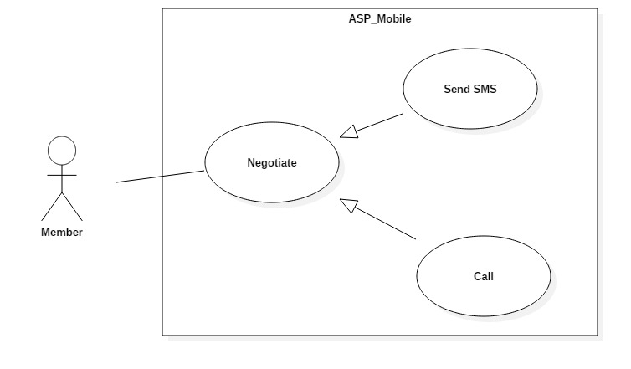

Figure 28: <Member> Negotiate Use Case

|  |  |  |  |
| --- | --- | --- | --- |
| **USE CASE – UC_ ASP_20** | | | |
| **Use Case No.** | UC_ ASP_20 | **Use Case Version** | 0.2 |
| **Use Case Name** | Negotiate | | |
| **Author** | Hồ Công Trình | | |
| **Date** | 17/10/2018 | **Priority** | High |
| **Actor:**   * Member   **Summary:**   * This use case allows member to contact with room master.   **Goal:**   * To make contact with other users.   **Triggers:**   * Actor press on SMS/Call button in single post.   **Preconditions:**   * User logged in the system.   **Post conditions:**   * Success: User can create new post. * Fail: System shows error messages.   **Main Success Scenario:**   |  |  |  | | --- | --- | --- | | **Step** | **Actor Action** | **System Response** | | 1 | Actor presses on any post in system | System displays details post screen with:  - “Tên bài”  - “Khoảng Giá”  - “Diện tích”  - “Quận”  - “Mô tả”  - “Giới tính”  - “SMS” button  - “Gọi điện” button | | 2 | Actor presses on “SMS” button | System open sms default application on mobile with filled phone number in send to box |   **Alternative Scenario:**   |  |  |  | | --- | --- | --- | | **No** | **Cause** | **System Response** |  |  |  |  | | --- | --- | --- | | 1 | Actor presses on “Call” button | System open call default application on mobile with phone number in dialog. |   **Exceptions:** N/A  **Relationships:** N/A  **Business Rules:**   * User already logged in the system. * User must accept phone, SMS request from the application. * System automatically display phone number in post to dialog. | | | |

Table 27: <Member> Negotiate specification

#### <Admin> Overview Use Case

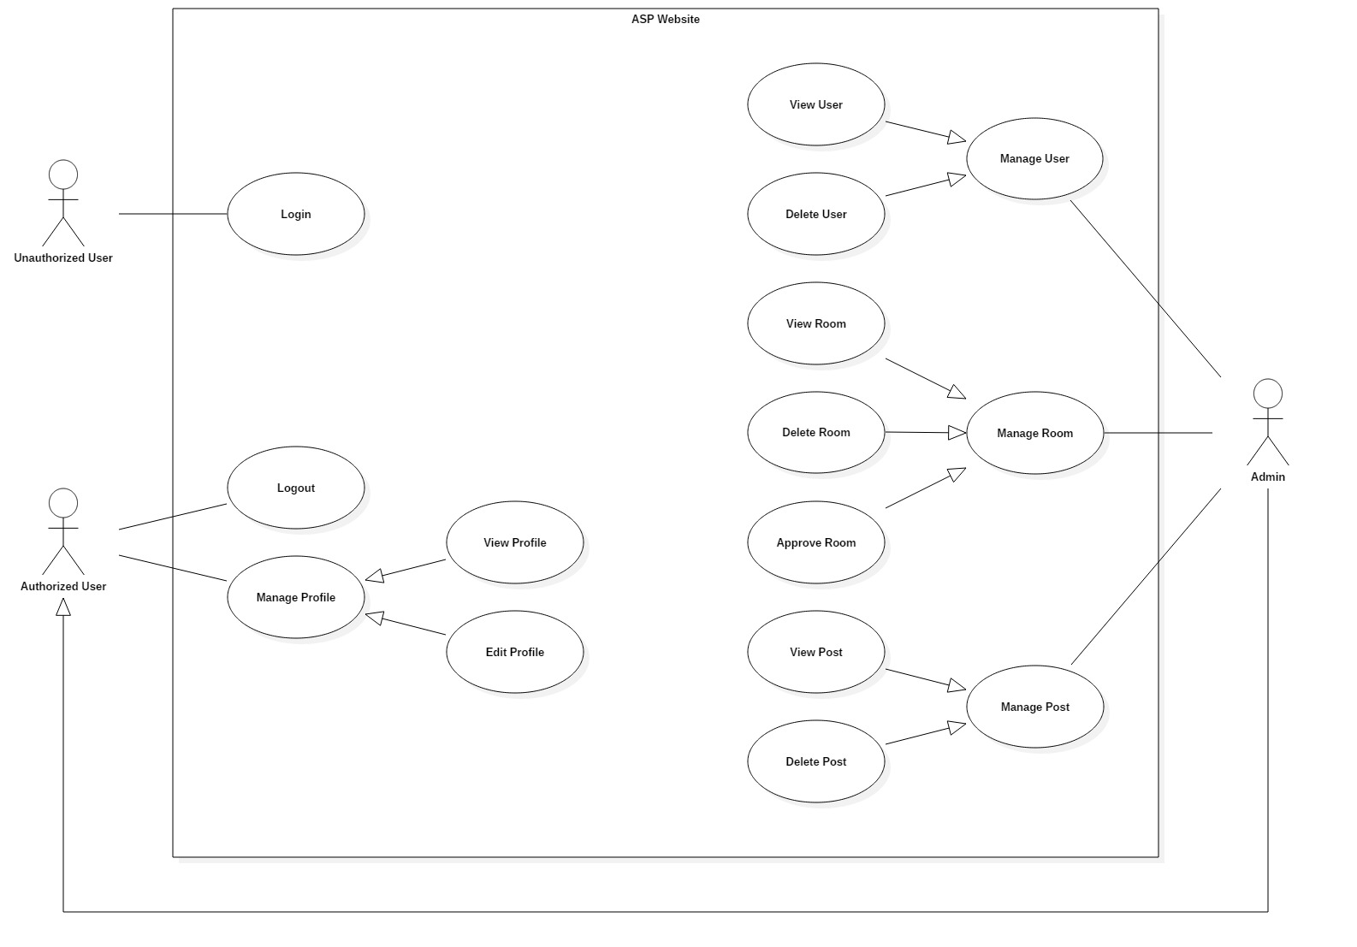

Figure 29: <Admin> Overview Use Case

##### <Admin> Approve Room

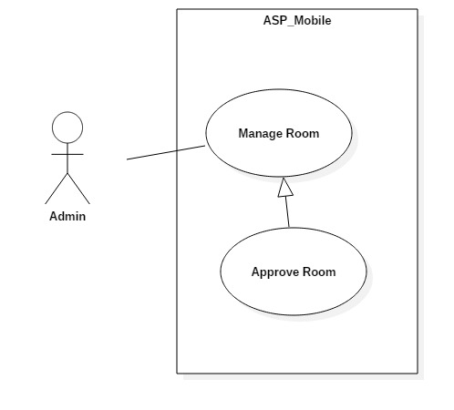

Figure 30: <Admin> Approve Room Use Case

|  |  |  |  |
| --- | --- | --- | --- |
| **USE CASE – UC_ ASP_23** | | | |
| **Use Case No.** | UC_ ASP_23 | **Use Case Version** | 0.2 |
| **Use Case Name** | Approve room | | |
| **Author** | Vương Minh Thông | | |
| **Date** | 17/10/2018 | **Priority** | High |
| **Actor:**   * Admin   **Summary:**   * This use case allows admin to approve room.   **Goal:**   * To approve room.   **Triggers:**   * Actor click “Approve” button.   **Preconditions:**   * User logged in the system.   **Post conditions:**   * Success: User can approve room. * Fail: System shows error messages.   **Main Success Scenario:**   |  |  |  | | --- | --- | --- | | **Step** | **Actor Action** | **System Response** | | 1 | Actor clicks “Approve” button. | System displays “Phòng” page with last informations.  - List of rooms.  - Manage buttons in each row of table room list. |   **Alternative Scenario:** N/A  **Exceptions:** N/A  **Relationships:** N/A  **Business Rules:**   * Admin already logged in the system. * House owner must upload their house’s license in their account setting. Depending on that, admin decide whether to confirm or not. * The approved rooms will appear on the mobile application. | | | |

Table 28: <Admin> Approve room specification

##### <Admin> View Users

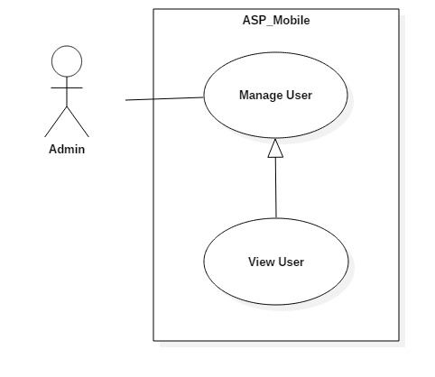

Figure 31: <Admin> View User Use Case

|  |  |  |  |
| --- | --- | --- | --- |
| **USE CASE – UC_ ASP_25** | | | |
| **Use Case No.** | UC_ ASP_25 | **Use Case Version** | 0.2 |
| **Use Case Name** | View User | | |
| **Author** | Nguyễn Quang Nhật | | |
| **Date** | 17/10/2018 | **Priority** | High |
| **Actor:**   * Admin   **Summary:**   * This use case allows admin to view user list.   **Goal:**   * To view user list.   **Triggers:**   * Actor click on users tab in web admin.   **Preconditions:**   * User logged in the system. * User must be admin.   **Post conditions:**   * Success: Admin can see all user information. * Fail: System shows error messages.   **Main Success Scenario:**   |  |  |  | | --- | --- | --- | | **Step** | **Actor Action** | **System Response** | | 1 | Actor clicks “Người dùng” tab. | System navigates to “Người dùng” page.  System displays “Người dùng” page with:  - List of users.  - “Quản lý” button.  - “Refresh” button. |   **Alternative Scenario:** N/A  **Exceptions:** N/A  **Relationships:** N/A  **Business Rules:**   * Admin already logged in the system. * Users exist in database. | | | |

Table 29: <Admin> View User specification

## Software System Attribute

### Usability

#### Graphic User Interface

* All the texts, labels, alerts and messages will be written in Vietnamese.
* GUI for mobile application is designed base on material design with Navigation Bar at the top contains the main functions of the application.

#### Usability

* The system usability is easy to use that users generally do not need to spend too much time looking around.
* Icons that indicate the actions should be easy to understand and users will not meet any troubles to recognize the feature of screen.

### Reliability

* The data should be backed up every day.

### Availability

* The IOS application must be available 24/7.
* System reply in maximum 3 seconds.

### Security

* Users is authentication/authorization for all users when they login to the system.

### Maintainability

* The system is divided into separated modules for easy maintain.

### Portability

* The software is a mobile application so it can be access anywhere with internet connection.
* User can use the mobile application running IOS 10 or above.
* Web application can be run on Chrome browser version 42 or later.

### Performance

* Requests from users are responded in less than 10 seconds at 5 Mbps bandwidth speed.
* System can handle 100 requests at one time.
* If the system crash, it shall ensure security less than 30 minutes and fixing hardware less than 2 days.

## Conceptual diagram

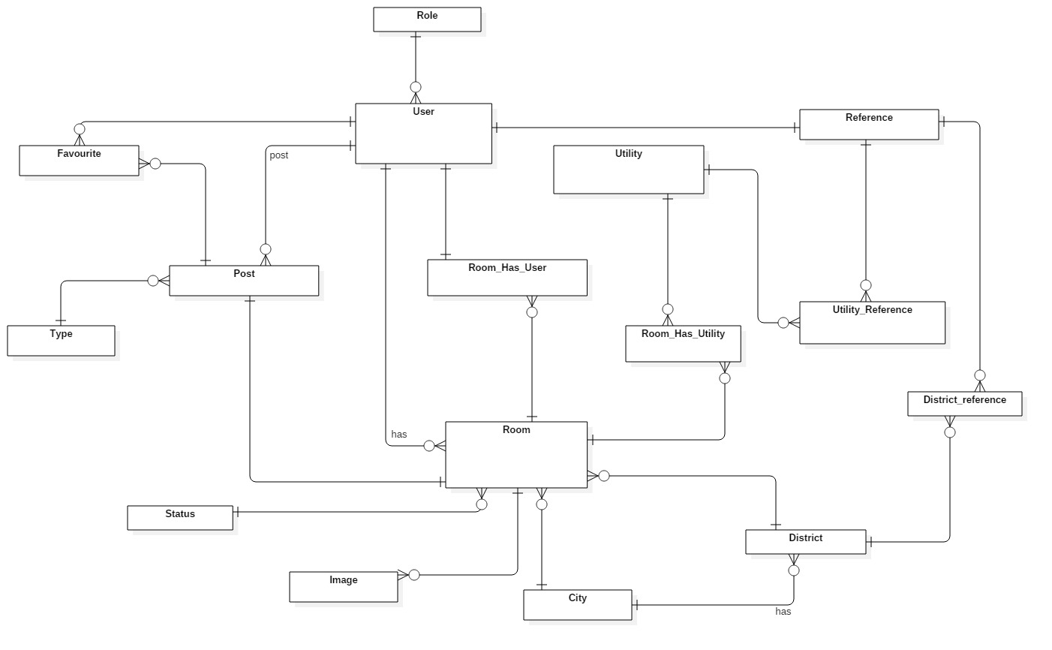

Figure 32: Conceptual Diagram

|  |  |
| --- | --- |
| Entity Data dictionary: describe content of all entities | |
| Entity Name | **Description** |
| User | Contains users information |
| Room | Contains rooms information |
| Post | Contains posts information |
| Role | Describe roles in system. |
| Favorites | Contains favorite information |
| Utilities | Contains utilities information |
| Reference | Contains references information |
| District | Contains districts information |
| City | Contains city information |
| Image | Contains images information |
| Type | Describe type of post in system. |
| Status | Describe status of room in system. |
| Room_Has_Utilities | Describe utilities of room in system |
| Utilities_Reference | Describe utilities of user in system |
| District_Reference | Describe districts that user prefer to search |
| Room_Has_User | Contains users in room information |

Table 30: Conceptual Entity dictionary

# D. Software Design Description

## Design Overview

* This document describes the technical and user interface design of **ASP**. It includes the architectural design, the detailed design of common functions and business functions and the design of database model.
* The architectural design describes the overall architecture of the system and the architecture of each main component and subsystem.
* The detailed design describes static and dynamic structure for each component and functions. It includes class diagrams, class explanations and sequence diagrams for each use cases.
* The database design describes the relationships between entities and details of each entity.
* Document overview:
* Section 2: gives an overall description of the system architecture design.
* Section 3: gives component diagrams that describe the connection and integration of the system.
* Section 4: gives the detail design description which includes class diagram, class explanation, and sequence diagram to details the application functions.
* Section 5: describe screens design.
* Section 6: describe a fully attributed ERD.

## System Architecture Design

### System Architecture Design

We choose REST API model as main model because of following advantages:

* **Separation between the client and the server**: the REST protocol totally separates the user interface from the server and the data storage. This has some advantages when making development.
* **Visibility, reliability and scalability**. The separation between client and server has one evident advantage, and that is that each development team can scale the product without too much problem.
* **The REST API is always independent of the type of platform or languages**: the REST API always adapts to the type of syntax or platforms being used, which gives considerable freedom when changing or testing new environments within the development.

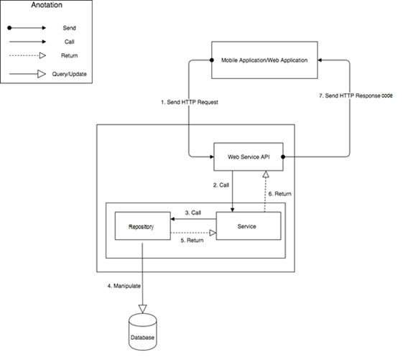

Figure 33: System Architecture Design (MVC)

## Component Diagram

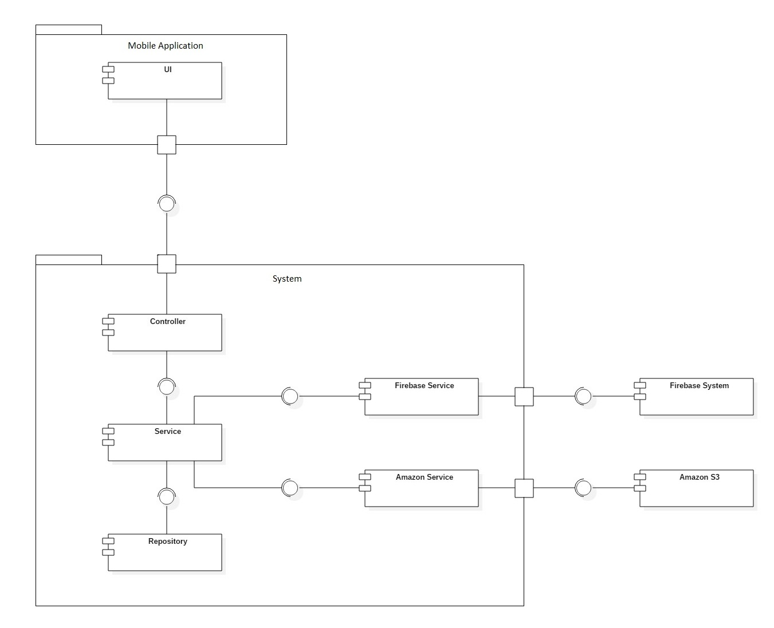

Figure 34: Component Diagram

|  |  |
| --- | --- |
| **COMPONENT DICTIONARY: DESCRIBES COMPONENT** | |
| **Component Name** | **Description** |
| UI | Mobile application package: View, Controller |
| Controller | Component to handle HTTP request |
| Service | Component to handle business logic |
| Repository | Component to handle data |
| Firebase Service | Component to handle push notification |
| Amazon Service | Component to handle upload image |
| Firebase System | Component to handle access to real time database |
| Amazon S3 | Component to handle image storage |

Table 31: Component Diagram Explanation

## Detail Description

### Class Diagram

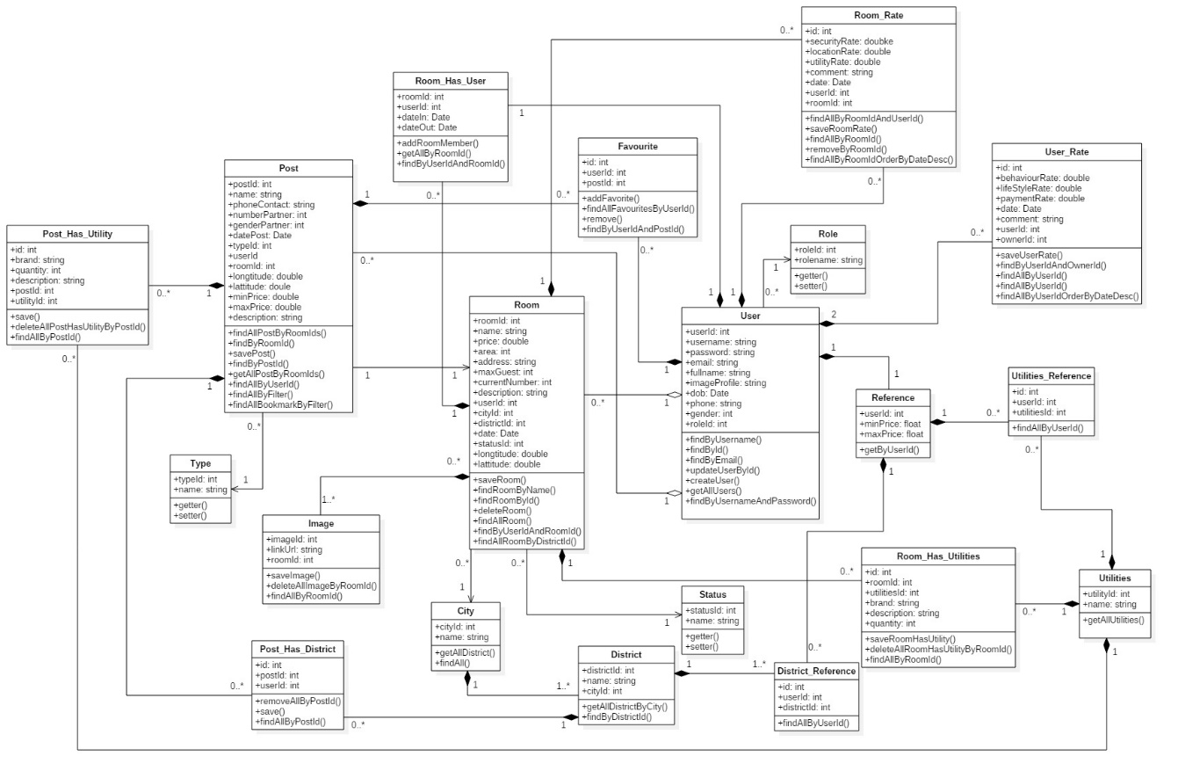

Figure 35: Class Diagram

|  |  |  |
| --- | --- | --- |
| **CLASS DICTIONARY: DESCRIBE CLASS** | | |
| **Class Name** | **Mapping column with Conceptual diagram** | **Description** |
| User | User | Contain the user information |
| Room | Room | Contain the room information |
| Post | Post | Contain the post information |
| Role | Role | Contain the role information |
| Favourites | Favourites | Contain the bookmark information |
| Utilities | Utilities | Contain the utilities information |
| Reference | Reference | Contain the reference profile information |
| District | District | Contain the district information |
| City | City | Contain the city information |
| Image | Image | Contain the image information |
| Type | Type | Contain the type information |
| Status | Status | Contain the status information |
| Room_Has_Utilities | Room_Has_Utilities | Contain the room’s utilities information |
| Utilities_Reference | Utilities_Reference | Contain the user’s utilities information |
| District_Reference | District_Reference | Contain districts that user prefer to search |
| Room_Has_User | Room_Has_User | Contains users in room information |
| Room_Rate | N/A | Contain the room rate information |
| User_Rate | N/A | Contain the user rate information |
| Post_Has_Utility | N/A | Contain the post’s utilities |
| Post_Has_District | N/A | Contain the post’s districts |

Table 32: Class Diagram Explanation

### Class Diagram Explanation

#### User

|  |  |  |  |
| --- | --- | --- | --- |
| **Attribute** | **Type** | **Visibility** | **Description** |
| userId | Integer | private | Unique identifier of user |
| username | String | private | Username of user |
| password | String | private | Password of user |
| email | String | private | Email of user |
| fullname | String | private | Full name of user |
| imageProfile | String | private | Image profile of user |
| dob | Date | private | Date of birth of user |
| phone | String | private | Phone number of user |
| gender | Integer | private | Gender of user |
| roleId | Integer | private | Role of user |

Table 33: User Attributes

#### Room

|  |  |  |  |
| --- | --- | --- | --- |
| **Attribute** | **Type** | **Visibility** | **Description** |
| roomId | Integer | private | Unique identifier of room |
| name | String | private | Name of room |
| price | Double | private | Price of room |
| area | Integer | private | Area of room |
| address | String | private | Address of room |
| maxGuest | Integer | private | Maximum number of guest in room |
| currentNumber | Integer | private | Current number of guest in room |
| description | String | private | Description of room |
| userId | Integer | private | Identifier of user in room |
| cityId | Integer | private | City’s identify of room |
| districtId | Integer | private | District’s identify of room |
| date | Date | private | Created date of room |
| statusId | Integer | private | Status of room that be approved or declined |
| longtitude | Double | private | Longitude of room |
| lattitude | Double | private | Latitude of room |

Table 34: Room Attributes

#### Post

|  |  |  |  |
| --- | --- | --- | --- |
| **Attribute** | **Type** | **Visibility** | **Description** |
| postId | Integer | private | Unique identifier of post |
| name | String | private | Name of post |
| phoneContact | String | private | Phone number of room master |
| numberPartner | Integer | private | Number of partner wanted in post |
| genderPartner | Integer | private | Gender of partner wanted in post |
| datePost | Date | private | Created date of post |
| typeId | Integer | private | Type of post, define finding room post or finding roommate post. |
| userId | Integer | private | Identifier of user in room |
| roomId | Integer | private | Room’s identifier of post |
| longtitude | Double | private | Longitude of post |
| lattitude | Double | private | Latitude of post |
| minPrice | Double | private | Min price of post |
| maxPrice | Double | private | Max price of post |
| description | String | private | Description of post |

Table 35: Post Attributes

#### Role

|  |  |  |  |
| --- | --- | --- | --- |
| **Attribute** | **Type** | **Visibility** | **Description** |
| roleId | Integer | private | Unique identifier of role |
| rolename | String | private | Name of role |

Table 36: Role Attributes

#### Favourite

|  |  |  |  |
| --- | --- | --- | --- |
| **Attribute** | **Type** | **Visibility** | **Description** |
| id | Integer | private | Unique identifier of favourite |
| userId | Integer | private | User’s identifier of favourite |
| postId | Integer | private | Post’s identifier of favourite |

Table 37: Favourite Attributes

#### Utilities

|  |  |  |  |
| --- | --- | --- | --- |
| **Attribute** | **Type** | **Visibility** | **Description** |
| utilitiesId | Integer | private | Unique identifier of utilities |
| name | String | private | Name of Utilities |

Table 38: Utility Attributes

#### Reference

|  |  |  |  |
| --- | --- | --- | --- |
| **Attribute** | **Type** | **Visibility** | **Description** |
| userId | Integer | private | User’s identifier of reference |
| minPrice | Double | private | Min price is chosen by user |
| maxPrice | Double | private | Max price is chosen by user |

Table 39: Reference Attributes

#### District

|  |  |  |  |
| --- | --- | --- | --- |
| **Attribute** | **Type** | **Visibility** | **Description** |
| districtId | Integer | private | Unique identifier of district |
| name | String | private | Name of district |
| cityId | Integer | private | City’s identifier of district |

Table 40: District Attributes

#### City

|  |  |  |  |
| --- | --- | --- | --- |
| **Attribute** | **Type** | **Visibility** | **Description** |
| cityId | Integer | private | Unique identifier of city |
| name | String | private | Name of city |

Table 41: City Attributes

#### Image

|  |  |  |  |
| --- | --- | --- | --- |
| **Attribute** | **Type** | **Visibility** | **Description** |
| imageId | Integer | private | Unique identifier of image |
| linkUrl | String | private | Url of image |
| roomid | Integer | private | Room’s identifier of image |

Table 42: Image Attributes

#### Type

|  |  |  |  |
| --- | --- | --- | --- |
| **Attribute** | **Type** | **Visibility** | **Description** |
| typeId | Integer | private | Unique identifier of type. |
| name | String | private | Name of type |

Table 43: Type Attributes

#### Status

|  |  |  |  |
| --- | --- | --- | --- |
| **Attribute** | **Type** | **Visibility** | **Description** |
| statusId | Integer | private | Unique identifier of status |
| name | String | private | Name of status |

Table 44: Status Attributes

#### Room_Has_Utilities

|  |  |  |  |
| --- | --- | --- | --- |
| **Attribute** | **Type** | **Visibility** | **Description** |
| Id | Integer | private | Unique identifier of room’s utilities |
| roomId | Integer | private | Room’s identifier in room has utilities field |
| utilitiesId | Integer | private | Utility’s identifier relate to room |
| brand | String | private | Brand of utilities are selected |
| description | String | private | Description of utilities are selected |
| quantity | Integer | private | Describe how many utilities |

Table 45: Room Has Utilities Attributes

#### Utilities_Reference

|  |  |  |  |
| --- | --- | --- | --- |
| **Attribute** | **Type** | **Visibility** | **Description** |
| id | Integer | private | Unique identifier of reference |
| userId | Integer | private | User’s identifier of reference |
| utilitiesId | Integer | private | Utility’s identifier of reference |

Table 46: Utilities Reference Attributes

#### District_Reference

|  |  |  |  |
| --- | --- | --- | --- |
| **Attribute** | **Type** | **Visibility** | **Description** |
| id | Integer | private | Unique identifier of district’s reference |
| userId | Integer | private | User’s identifier of reference |
| districtId | Integer | private | District’s identifier of reference |

Table 47: District Reference Attributes

#### Room_Has_User

|  |  |  |  |
| --- | --- | --- | --- |
| **Attribute** | **Type** | **Visibility** | **Description** |
| roomId | Integer | private | Room’s identifier has user |
| userId | Integer | private | User’s identifier in room |
| dateIn | Date | private | Date user move in |
| dateOut | Date | private | Date user move out |

Table 48: Room Has User Attributes

#### Post_Has_Utilities

|  |  |  |  |
| --- | --- | --- | --- |
| **Attribute** | **Type** | **Visibility** | **Description** |
| Id | Integer | private | Unique identifier of room’s utilities |
| postId | Integer | private | Post’s identifier in post has utilities field |
| utilitiesId | Integer | private | Utility’s identifier relate to room |
| brand | String | private | Brand of utilities are selected |
| description | String | private | Description of utilities are selected |
| quantity | Integer | private | Describe how many utilities |

Table 49: Post Has Utilities

#### Post_Has_District

|  |  |  |  |
| --- | --- | --- | --- |
| **Attribute** | **Type** | **Visibility** | **Description** |
| Id | Integer | private | Unique identifier of post’s utilities |
| postId | Integer | private | Post’s identifier in post has utilities field |
| disctrictId | Integer | private | Disctrict’s identifier relate to post |

Table 50: Post Has Districts

#### Room_Rate

|  |  |  |  |
| --- | --- | --- | --- |
| **Attribute** | **Type** | **Visibility** | **Description** |
| Id | Integer | private | Identifier of rate room |
| security_rate | Double | private | Security rate of room |
| location_rate | Double | private | Location rate of room |
| utility_rate | Double | private | Utility rate of room |
| comment | String | private | Comment for room |
| date | Date | private | Date of rate |
| userId | Integer | private | User’s identifier rate room |
| roomId | Integer | private | Room’s identifier get rated |

Table 51: Room Rate

#### User_Rate

|  |  |  |  |
| --- | --- | --- | --- |
| **Attribute** | **Type** | **Visibility** | **Description** |
| id | Integer | private | Identifier of rate user |
| behaviourrate | Double | private | Behaviour rate of user |
| lifestylerate | Double | private | Life style rate of user |
| paymentrate | Double | private | Payment rate of user |
| comment | String | private | Comment for user |
| date | Date | private | Date of rate |
| user_id | Integer | private | User’s identifier get rated |
| owner_id | Integer | private | User’s identifier rate with role house owner |

Table 52: User Rate

### Interactive diagram

#### Sequence Diagram

##### Register

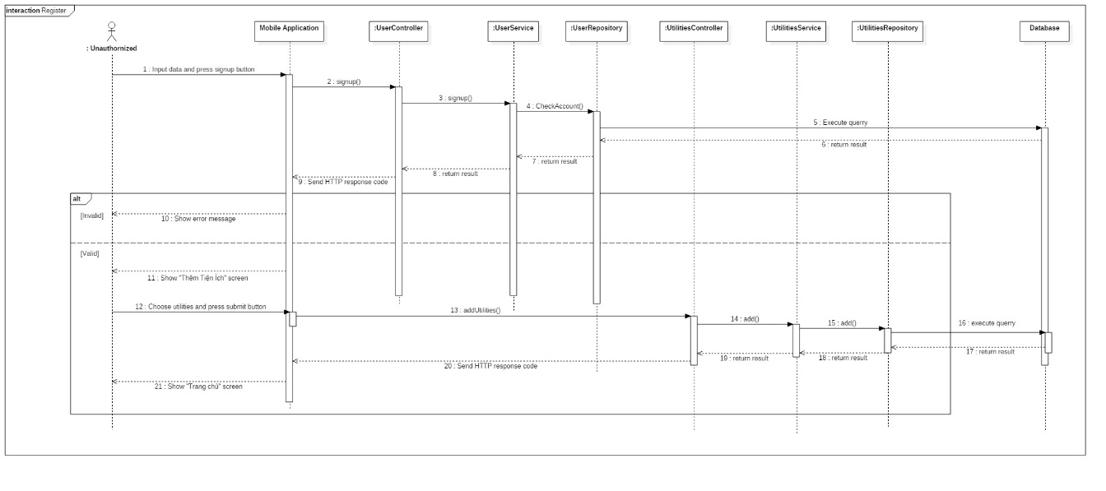

Figure 36: Sequence Diagram - <Unauthorized> Register

##### Login

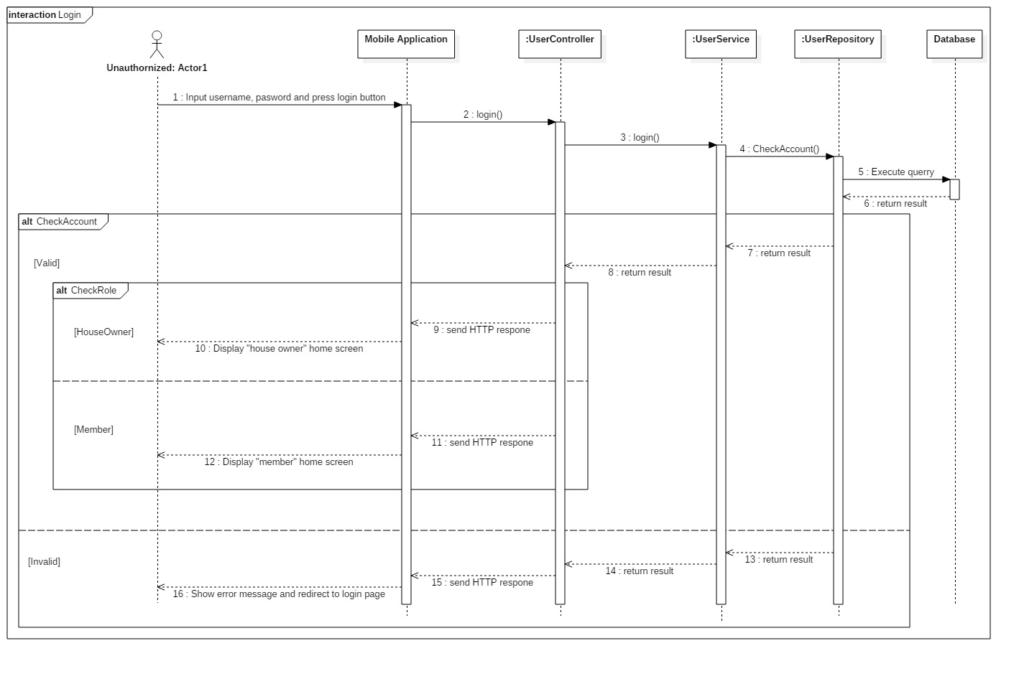

Figure 37: Sequence Diagram - <Unauthorized> Login

##### Create Room

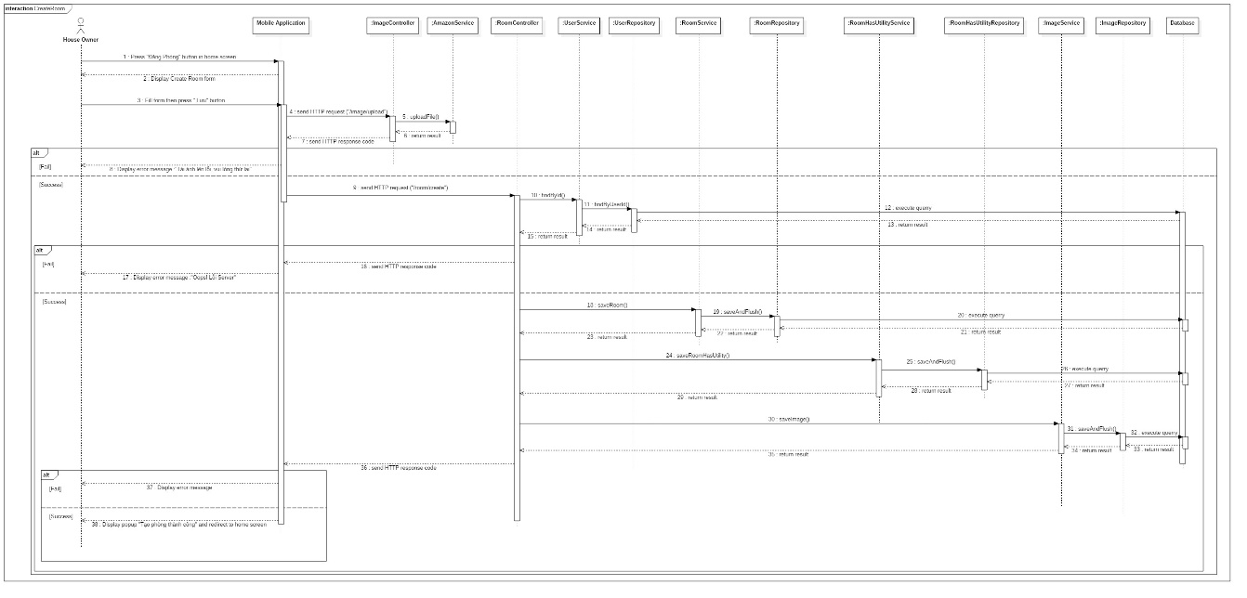

Figure 38: Sequence Diagram - <House owner> Create Room

##### Update Room

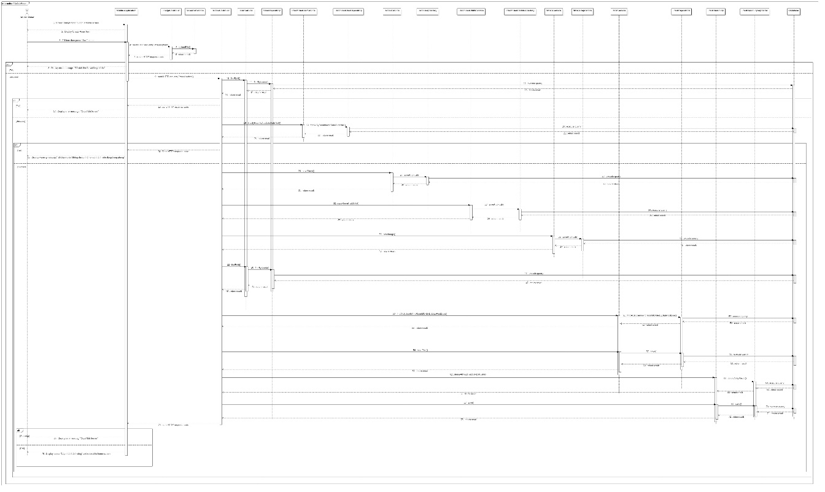

Figure 39: Sequence Diagram - <House owner> Update Room

##### Delete Room

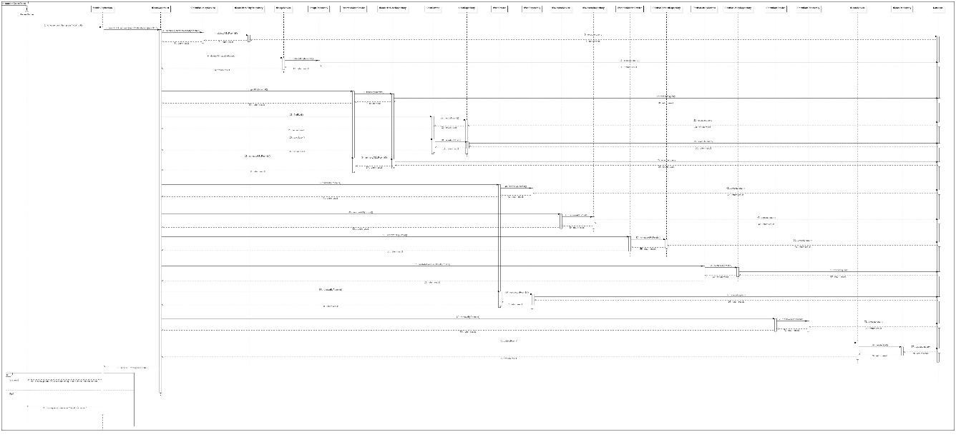

Figure 40: Sequence Diagram - <House owner> Delete Room

##### View Single Room

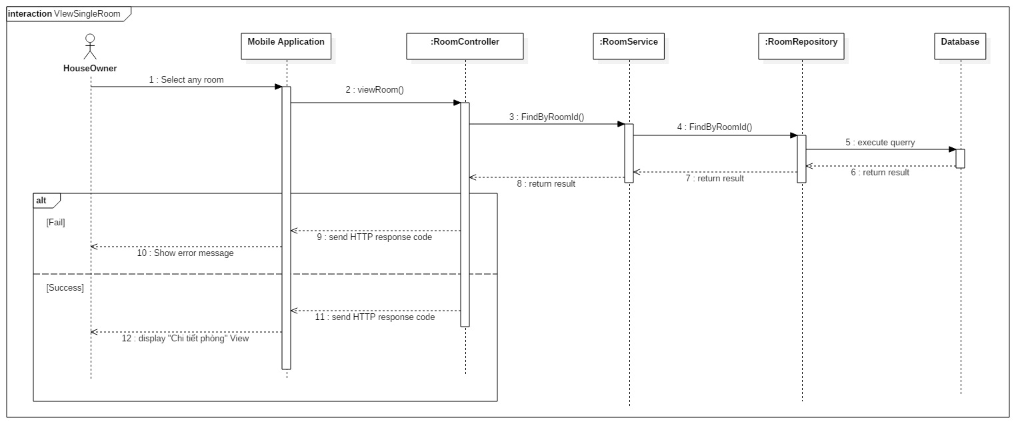

Figure 41: Sequence Diagram - <House owner> View Single Room

##### Add Member into Room

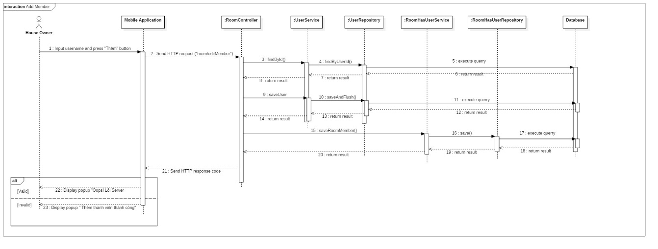

Figure 42: Sequence Diagram - <House owner> Add Member into Room

##### Delete Member of Room

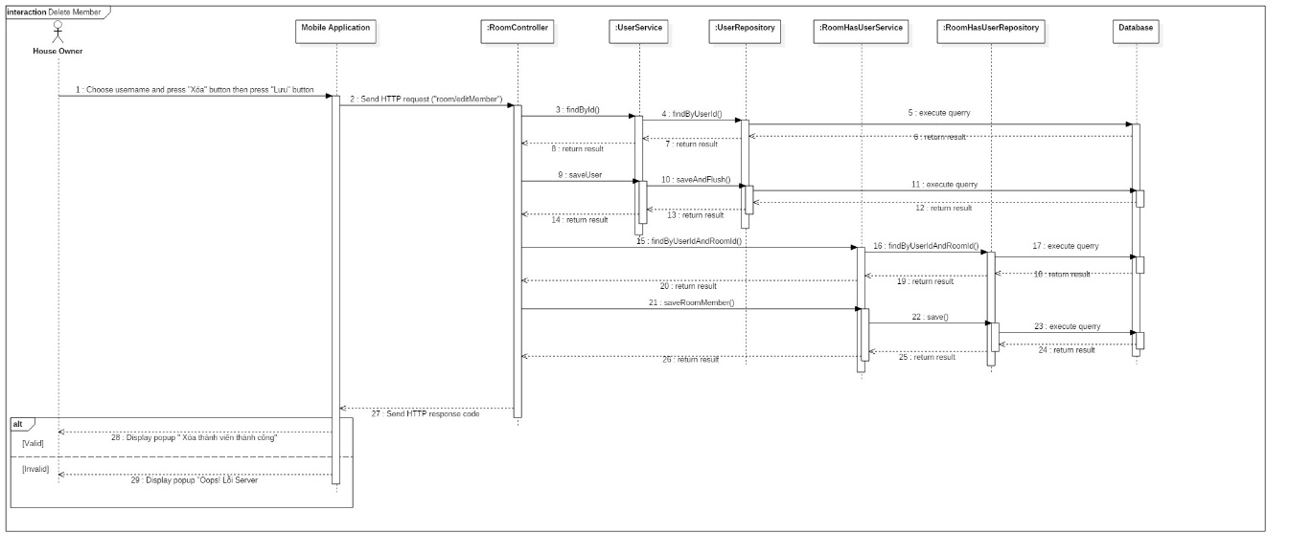

Figure 43: Sequence Diagram - <House owner> Delete Members of Room

##### Create Finding Roommate Post

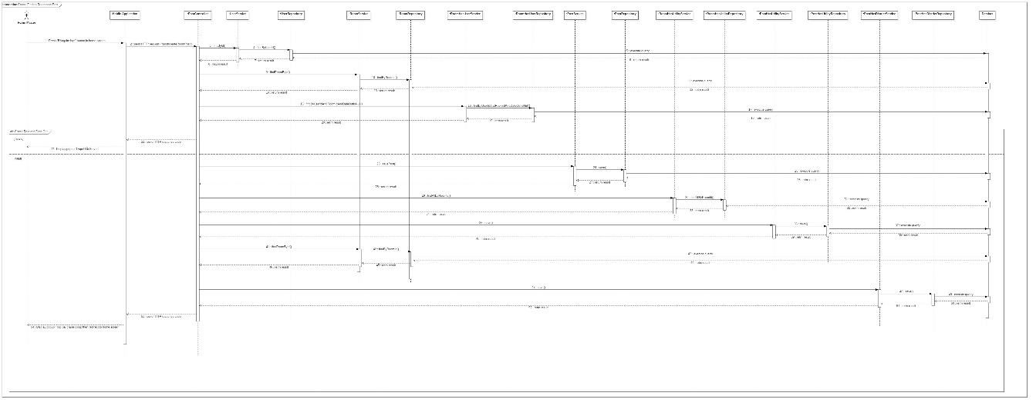

Figure 44: Sequence Diagram - <Room Master> Create Finding Roommate Post

##### Delete Finding Roommate Post

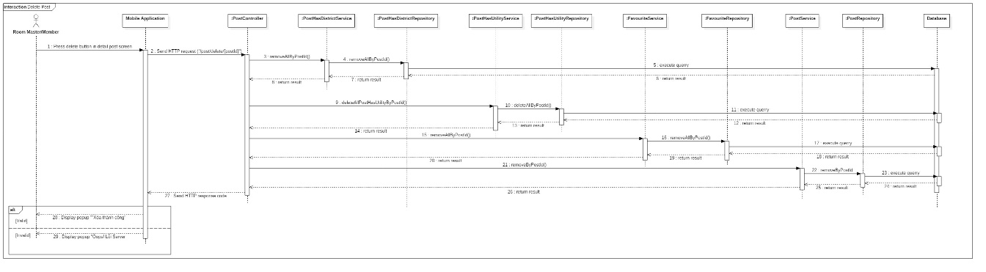

Figure 45: Sequence Diagram - <Room Master> Delete Finding Roommate Post



##### Update Finding Roommate Post

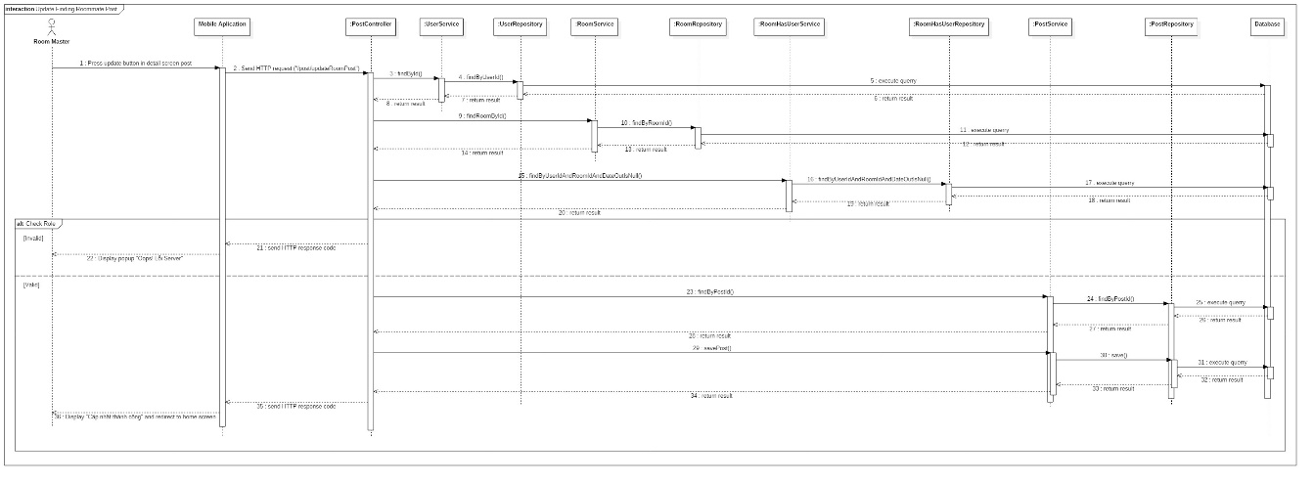

Figure 46: Sequence Diagram - <Room Master> Update Finding Roommate Post



##### View Suggest List Overview

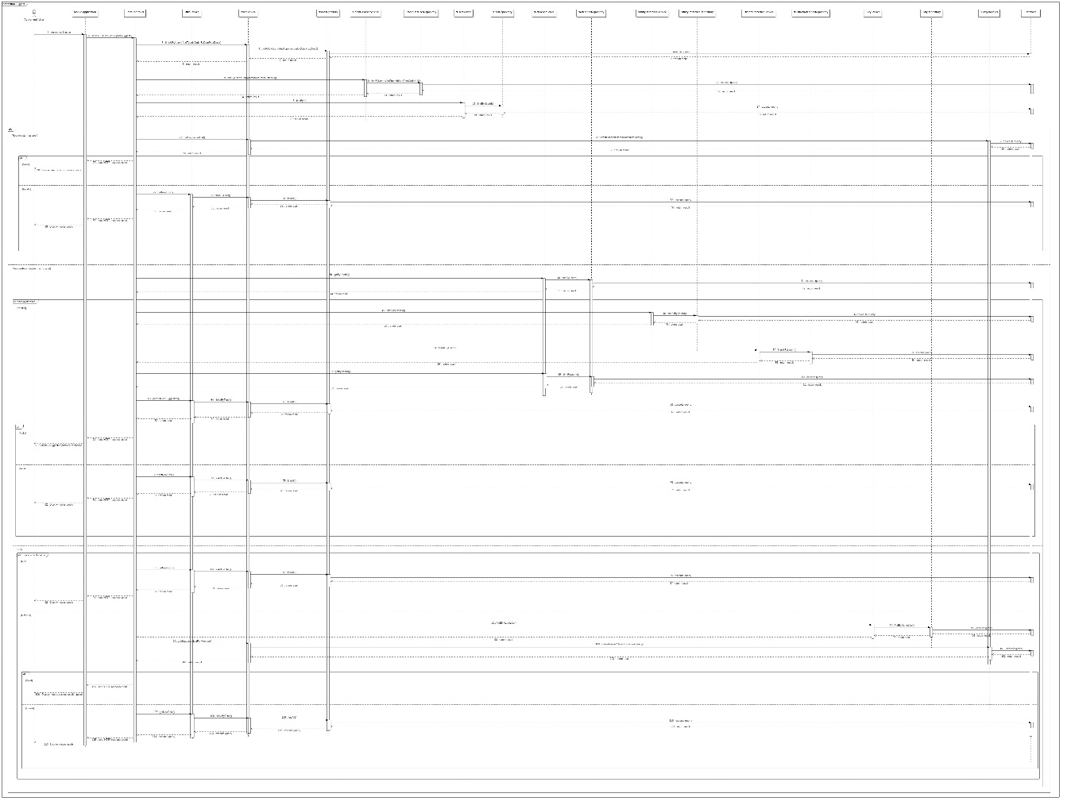

Figure 47: Sequence Diagram - <Member/Room Master> View Suggest List

##### <Suggest> Member/Room Master has reference and has no posts.

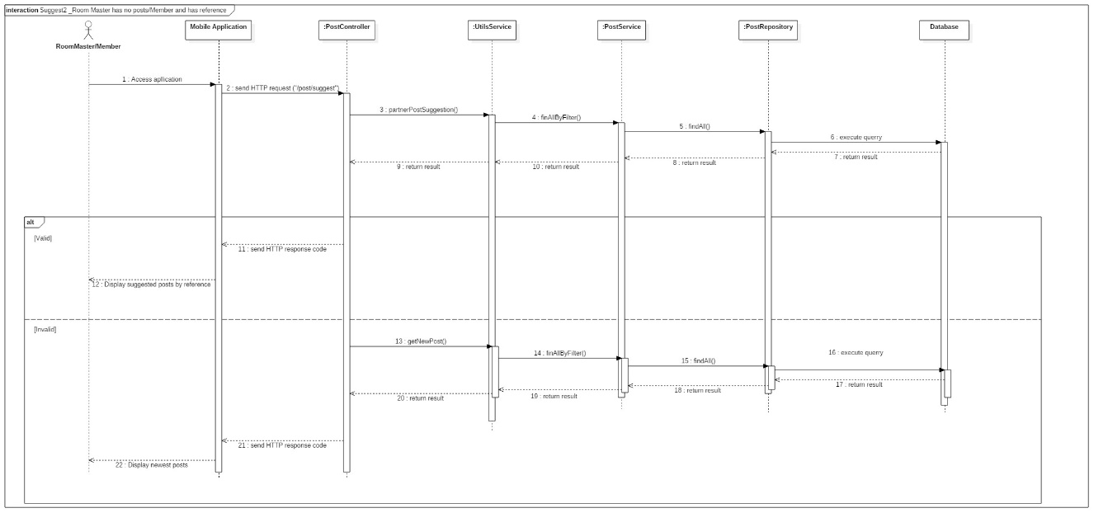

Figure 48: Sequence Diagram - <Member/Room Master> Has reference and has no posts.

##### <Suggest> Room Master has posts

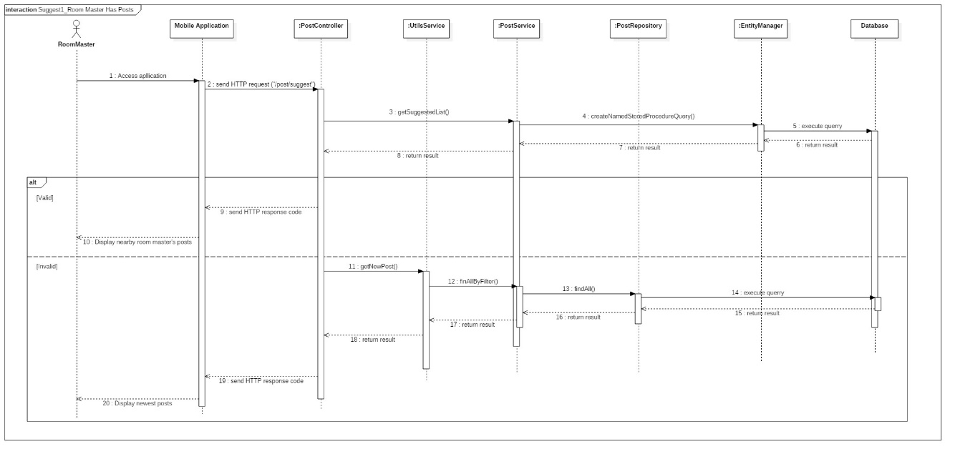

Figure 49: Sequence Diagram - <Room Master> Room Master has posts

##### <Suggest>Member/Room Master has no reference but allow access current location

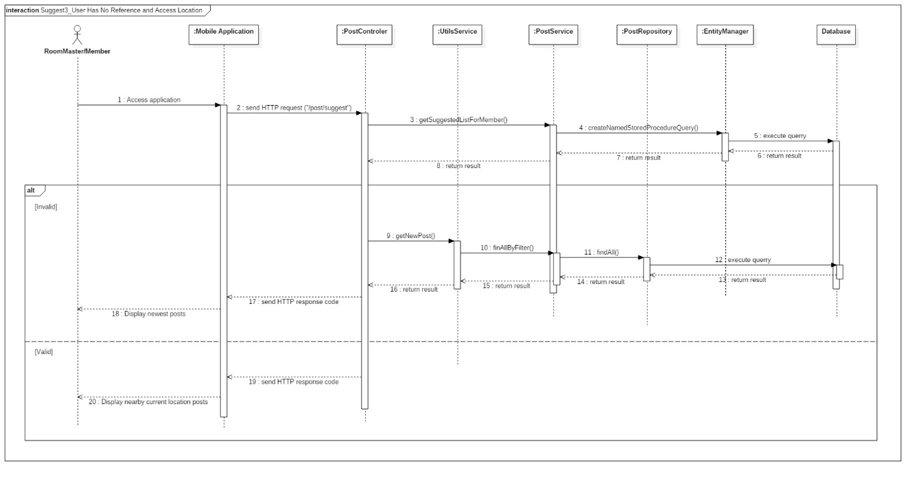

Figure 50: Sequence Diagram - <Member/Room Master> Member/Room Master has no reference but allow access current location.

##### <Suggest> Member/Room Master has no reference and not allow access current location

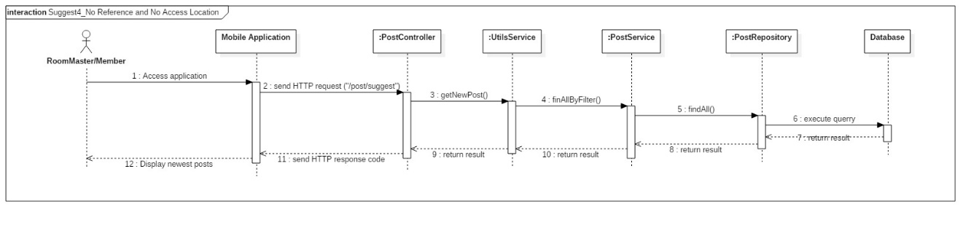

Figure 51: Sequence Diagram - <Member/Room Master> Member/Room Master has no reference and not allow access current location.

##### Create Finding Room Post

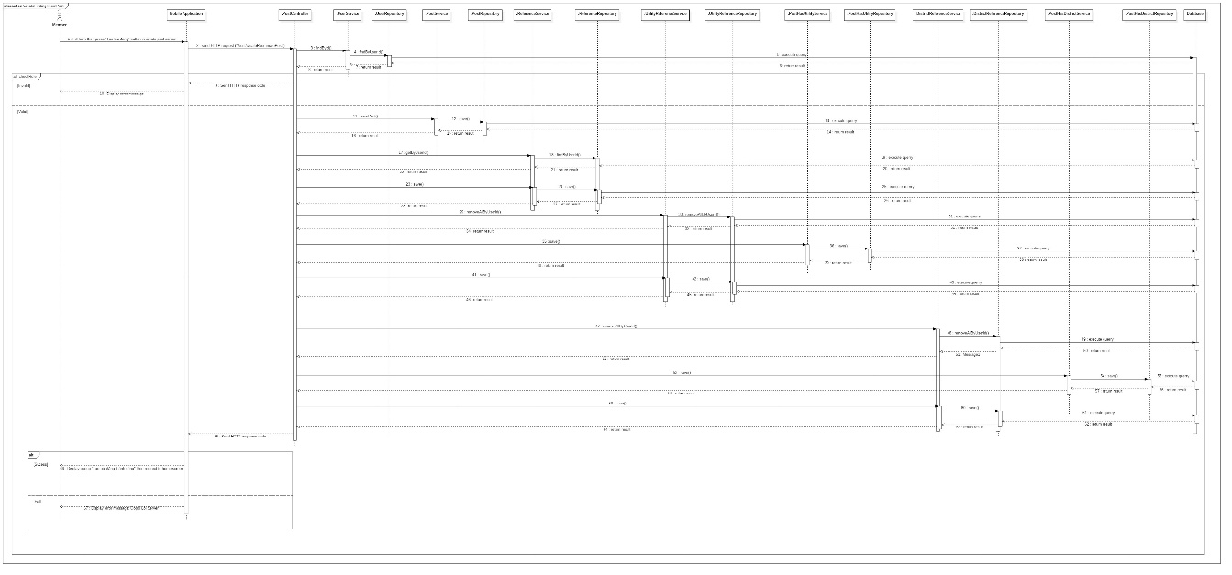

Figure 52: Sequence Diagram - <Member> Create Finding Room Post

##### Update Finding Room Post

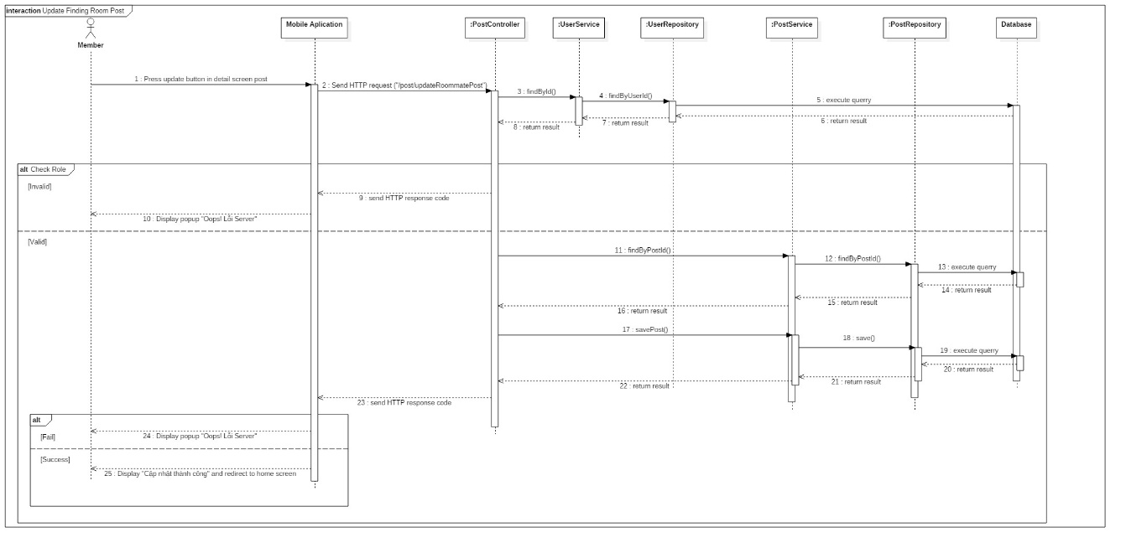

Figure 53: Sequence Diagram - <Member> Update Finding Room Post

##### Delete Finding Room Post



Figure 54: Sequence Diagram - <Member> Delete Finding Room Post

##### Filter

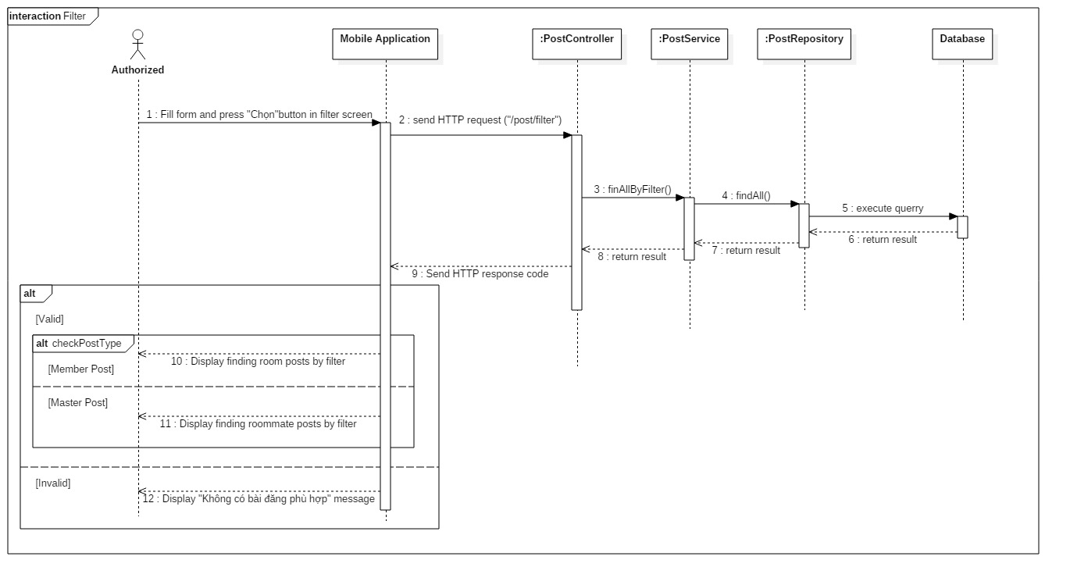

Figure 55: Sequence Diagram - <Authorized User> Filter

## Interface

### Admin Interface Design

#### Login

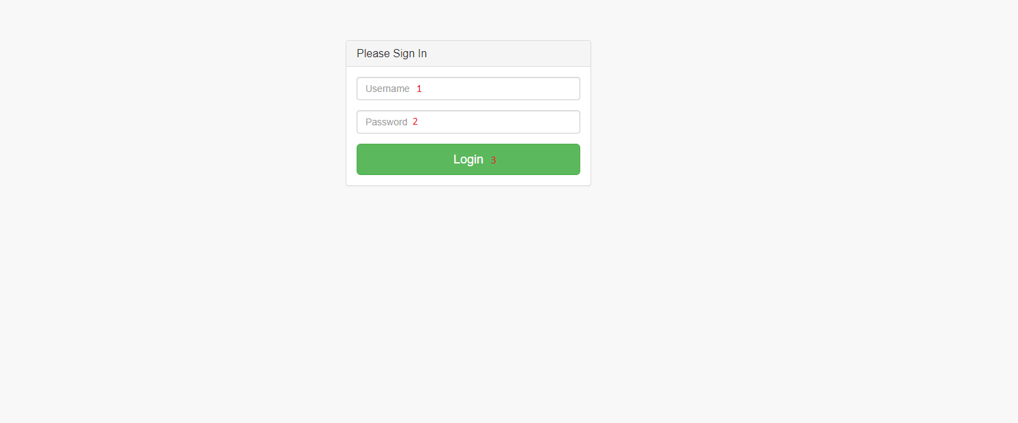

Figure 56: <Admin> Login Interface

|  |  |  |  |  |  |  |
| --- | --- | --- | --- | --- | --- | --- |
| **FIELDS** | | | | | | |
| **No** | **Field Name** | **Description** | **Read Only** | **Mandatory** | **Control Type** | **Data Type** |
| **1** | Username | Fill user name | No | Yes | Textfield | String |
| **2** | Password | Fill password | No | Yes | Textfield | String |
| **BUTTONS/HYPERLINKS** | | | | | | |
| **No** | **Function** | **Description** | | **Validation** | **Outcome** | |
| **3** | login | Admin accesses dashboard to manage room, user | | Yes | Display list pending rooms, list of users. | |

Table 53: Admin login - Field, Buttons

#### Manage User

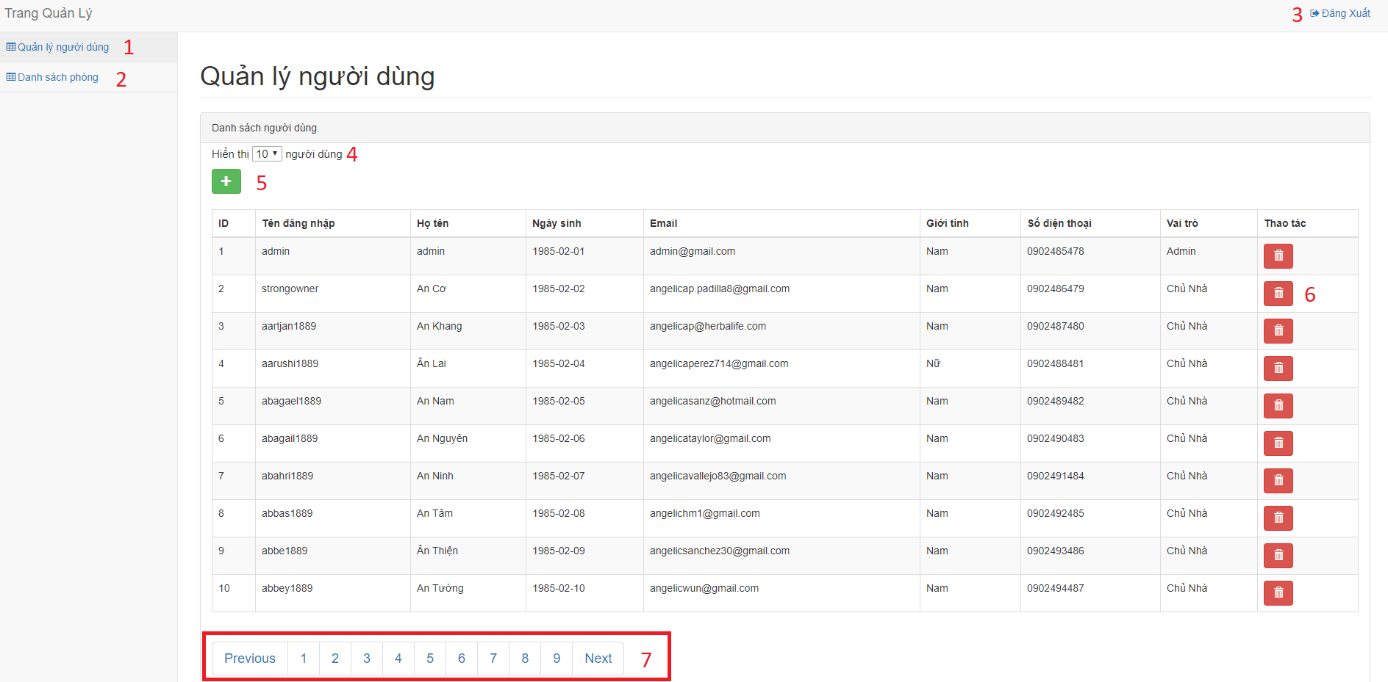

Figure 57: <Admin> Manage User Interface

|  |  |  |  |  |  |  |
| --- | --- | --- | --- | --- | --- | --- |
| **FIELDS** | | | | | | |
| **No** | **Field Name** | **Description** | **Read Only** | **Mandatory** | **Control Type** | **Data Type** |
| **4** | Number of users per page | Select number of users per page (10, 20, 50) | No | No | Dropdowlist | String |
| **BUTTONS/HYPERLINKS** | | | | | | |
| **No** | **Function** | **Description** | | **Validation** | **Outcome** | |
| **1** | userPage | Redirect to manage user page | | N/A | Display all users lists | |
| **2** | roomPage | Redirect to manage room page | | N/A | Display all pending rooms. | |
| **3** | logout | Log out | | N/A | Redirect to login page | |
| **5** | createUser | Admin add manager to manage user. | | All fields required before summit | Redirect to manage user page. | |
| **6** | deleteUser | Remove user from system | | N/A | Remove user from system | |
| **7** | roomPage | Pagination | | N/A | Change page. | |

Table 54: Admin Manage User - Field, Buttons, Hyperlinks

#### Manage Room

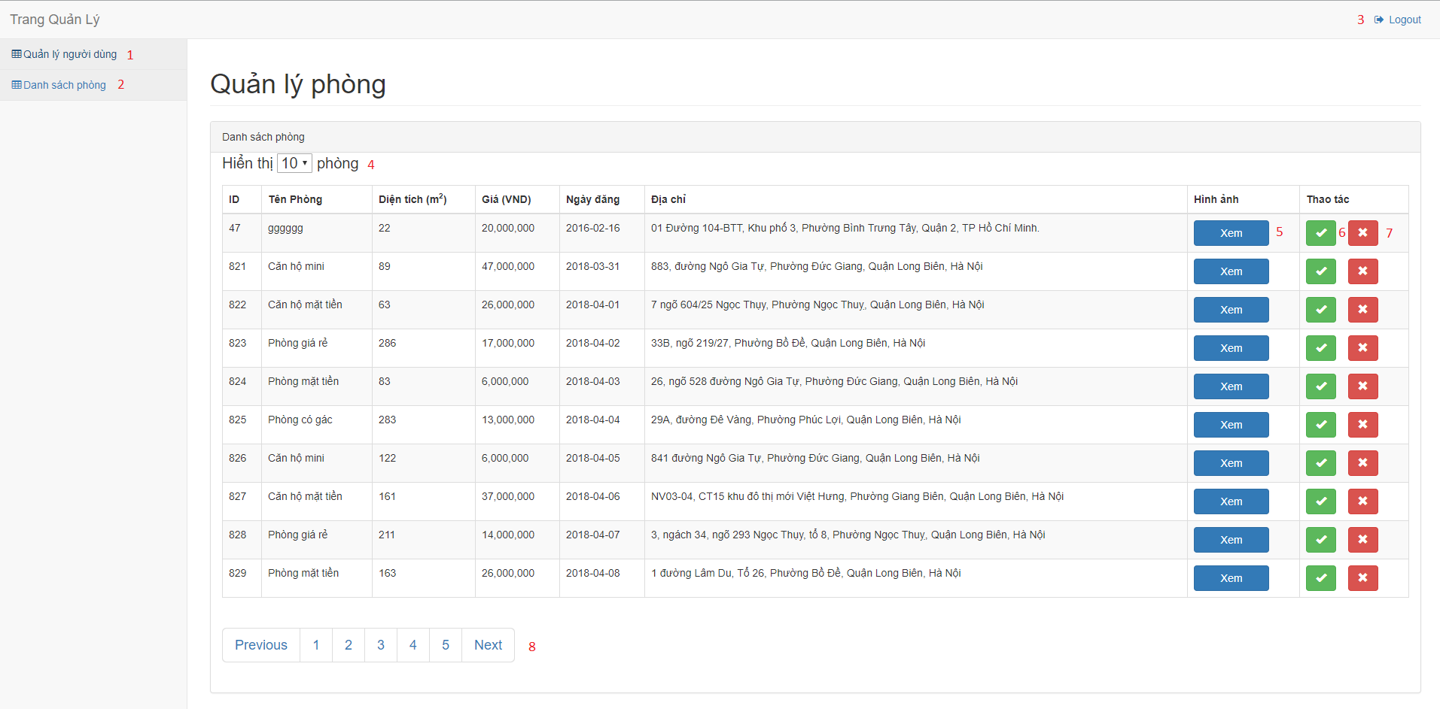

Figure 58: <Admin> Manage Room Interface

|  |  |  |  |  |  |  |
| --- | --- | --- | --- | --- | --- | --- |
| **FIELDS** | | | | | | |
| **No** | **Field Name** | **Description** | **Read Only** | **Mandatory** | **Control Type** | **Data Type** |
| **4** | Number of users per page | Select number of users per page (10, 20, 50) | No | No | Dropdowlist | String |
| **BUTTONS/HYPERLINKS** | | | | | | |
| **No** | **Function** | **Description** | | **Validation** | **Outcome** | |
| **1** | userPage | Redirect to manage user page | | N/A | Display all users lists | |
| **2** | roomPage | Redirect to manage room page | | N/A | Display all pending rooms. | |
| **3** | logout | Log out | | N/A | Redirect to login page | |
| **5** | btnImagelist | Show images list of room | | All fields required before summit | Redirect to manage user page. | |
| **6** | approveRoom | Approve room with pending status. | | N/A | Approve room that house owner can manipulation on it. | |
| **7** | declineRoom | Decline room if room has wrong information. | | N/A | Declined room has wrong information. | |
| **8** | roomPage | Pagination | | N/A | Change page. | |

Table 55: Admin Manage Room - Field, Buttons, Hyperlinks

#### Approve Room



Figure 59: <Admin> Approve Room Interface

|  |  |  |  |  |
| --- | --- | --- | --- | --- |
| **BUTTONS/HYPERLINKS** | | | | |
| **No** | **Function** | **Description** | **Validation** | **Outcome** |
| **1** | btnImagelist | Show images list of room | All fields required before summit | Redirect to manage user page. |
| **2** | approveRoom | Approve room with pending status. | N/A | Approve room that house owner can manipulation on it. |
| **3** | declineRoom | Decline room if room has wrong information. | N/A | Declined room has wrong information. |

Table 56: Admin Approve Room - Field, Buttons, Hyperlinks

### Unauthorized User Interface Design

#### Launch Screen

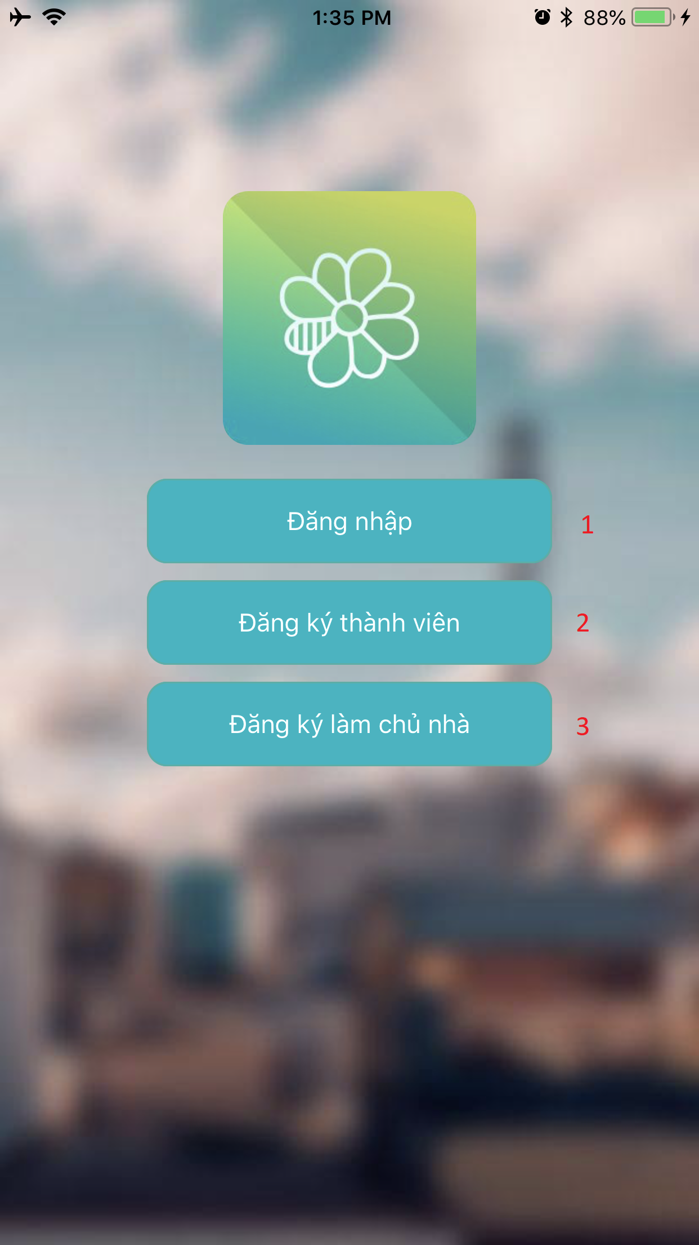

Figure 60: <Unauthorized User> Launch Screen Interface

|  |  |  |  |  |
| --- | --- | --- | --- | --- |
| **BUTTONS/HYPERLINKS** | | | | |
| **No** | **Function** | **Description** | **Validation** | **Outcome** |
| **1** | login | Sign in to system | N/A | Go to home screen |
| **2** | createUser | Create new member account | N/A | Go to Member Sign Up screen |
| **3** | createUser | Create new house owner account. | N/A | Go to House Owner Sign Up screen. |

Table 57: Launch Screen - Buttons

#### Sign Up

##### <Member> Sign Up

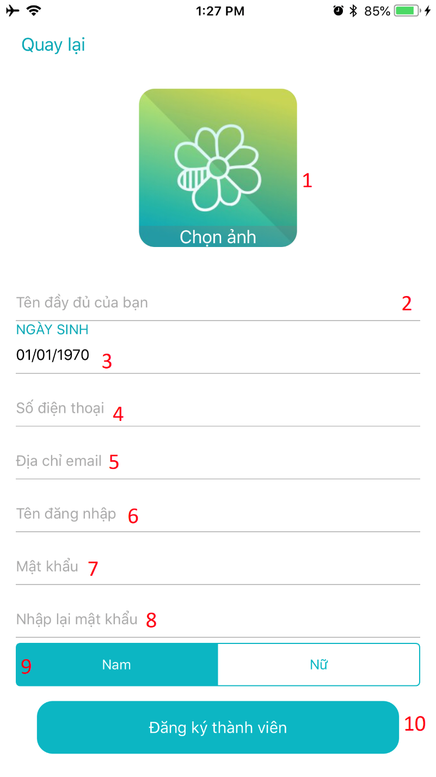

Figure 61: <Member >Sign Up Interface

|  |  |  |  |  |  |  |
| --- | --- | --- | --- | --- | --- | --- |
| **FIELDS** | | | | | | |
| **No** | **Field Name** | **Description** | **Read Only** | **Mandatory** | **Control Type** | **Data Type** |
| **2** | Full name | Fill user name | No | Yes | Textfield | String |
| **3** | Date of birth | Date of birth of user | No | Yes | DatePicker | DateTimePicker |
| **4** | Phone | Fill phone number | No | Yes | Textfield | String |
| **5** | Email | Fill Email | No | Yes | Textfield | String |
| **6** | Username | Fill username | No | Yes | Textfield | String |
| **7** | Password | Fill password | No | Yes | Textfield | String |
| **8** | Repeat Password | Fill repeat password | No | Yes | Textfield | String |
| **9** | Gender | Select gender | No | Yes | Textbox | String |
| **BUTTONS/HYPERLINKS** | | | | | | |
| **No** | **Function** | **Description** | | **Validation** | **Outcome** | |
| **1** | uploadRoomImage | Choose image to set profile image | | Image must be less than 10Mb | Upload profile image | |
| **10** | createUser | Create new account | | All fields required before summit | Redirect to home screen | |

Table 58:<Member> Sign Up – Buttons, Field

##### <House Owner> Sign Up

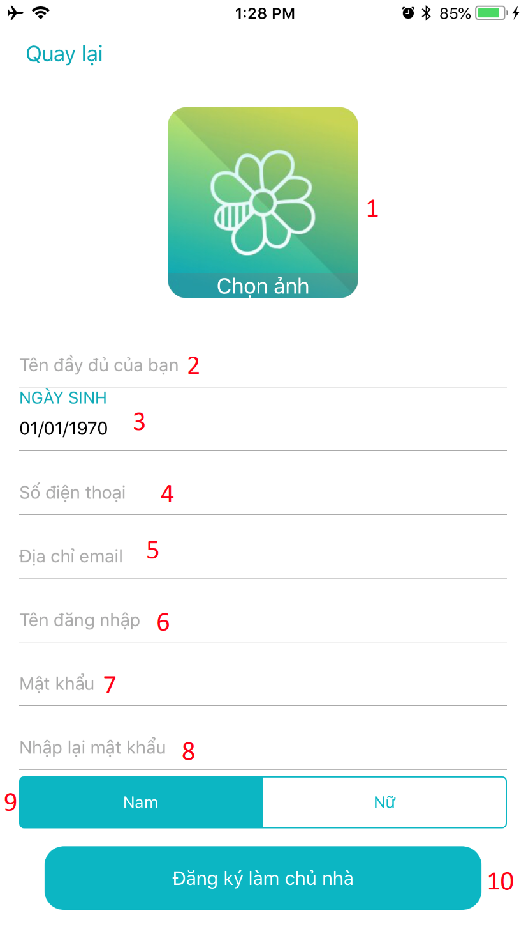

Figure 62: <House Owner > Sign Up Interface

|  |  |  |  |  |  |  |
| --- | --- | --- | --- | --- | --- | --- |
| **FIELDS** | | | | | | |
| **No** | **Field Name** | **Description** | **Read Only** | **Mandatory** | **Control Type** | **Data Type** |
| **2** | Full name | Fill user name | No | Yes | Textfield | String |
| **3** | Date of birth | Date of birth of user | No | Yes | DatePicker | DateTimePicker |
| **4** | Phone | Fill phone number | No | Yes | Textfield | String |
| **5** | Email | Fill Email | No | Yes | Textfield | String |
| **6** | Username | Fill username | No | Yes | Textfield | String |
| **7** | Password | Fill password | No | Yes | Textfield | String |
| **8** | Repeat Password | Fill repeat password | No | Yes | Textfield | String |
| **9** | Gender | Select gender | No | Yes | Textbox | String |
| **BUTTONS/HYPERLINKS** | | | | | | |
| **No** | **Function** | **Description** | | **Validation** | **Outcome** | |
| **1** | uploadRoomImage | Choose image to set profile image | | Image must be less than 10Mb | Upload profile image | |
| **10** | createUser | Create new account | | All fields required before summit | Redirect to home screen | |

Table 59: <House Owner> Sign Up – Buttons, Field

#### Sign In

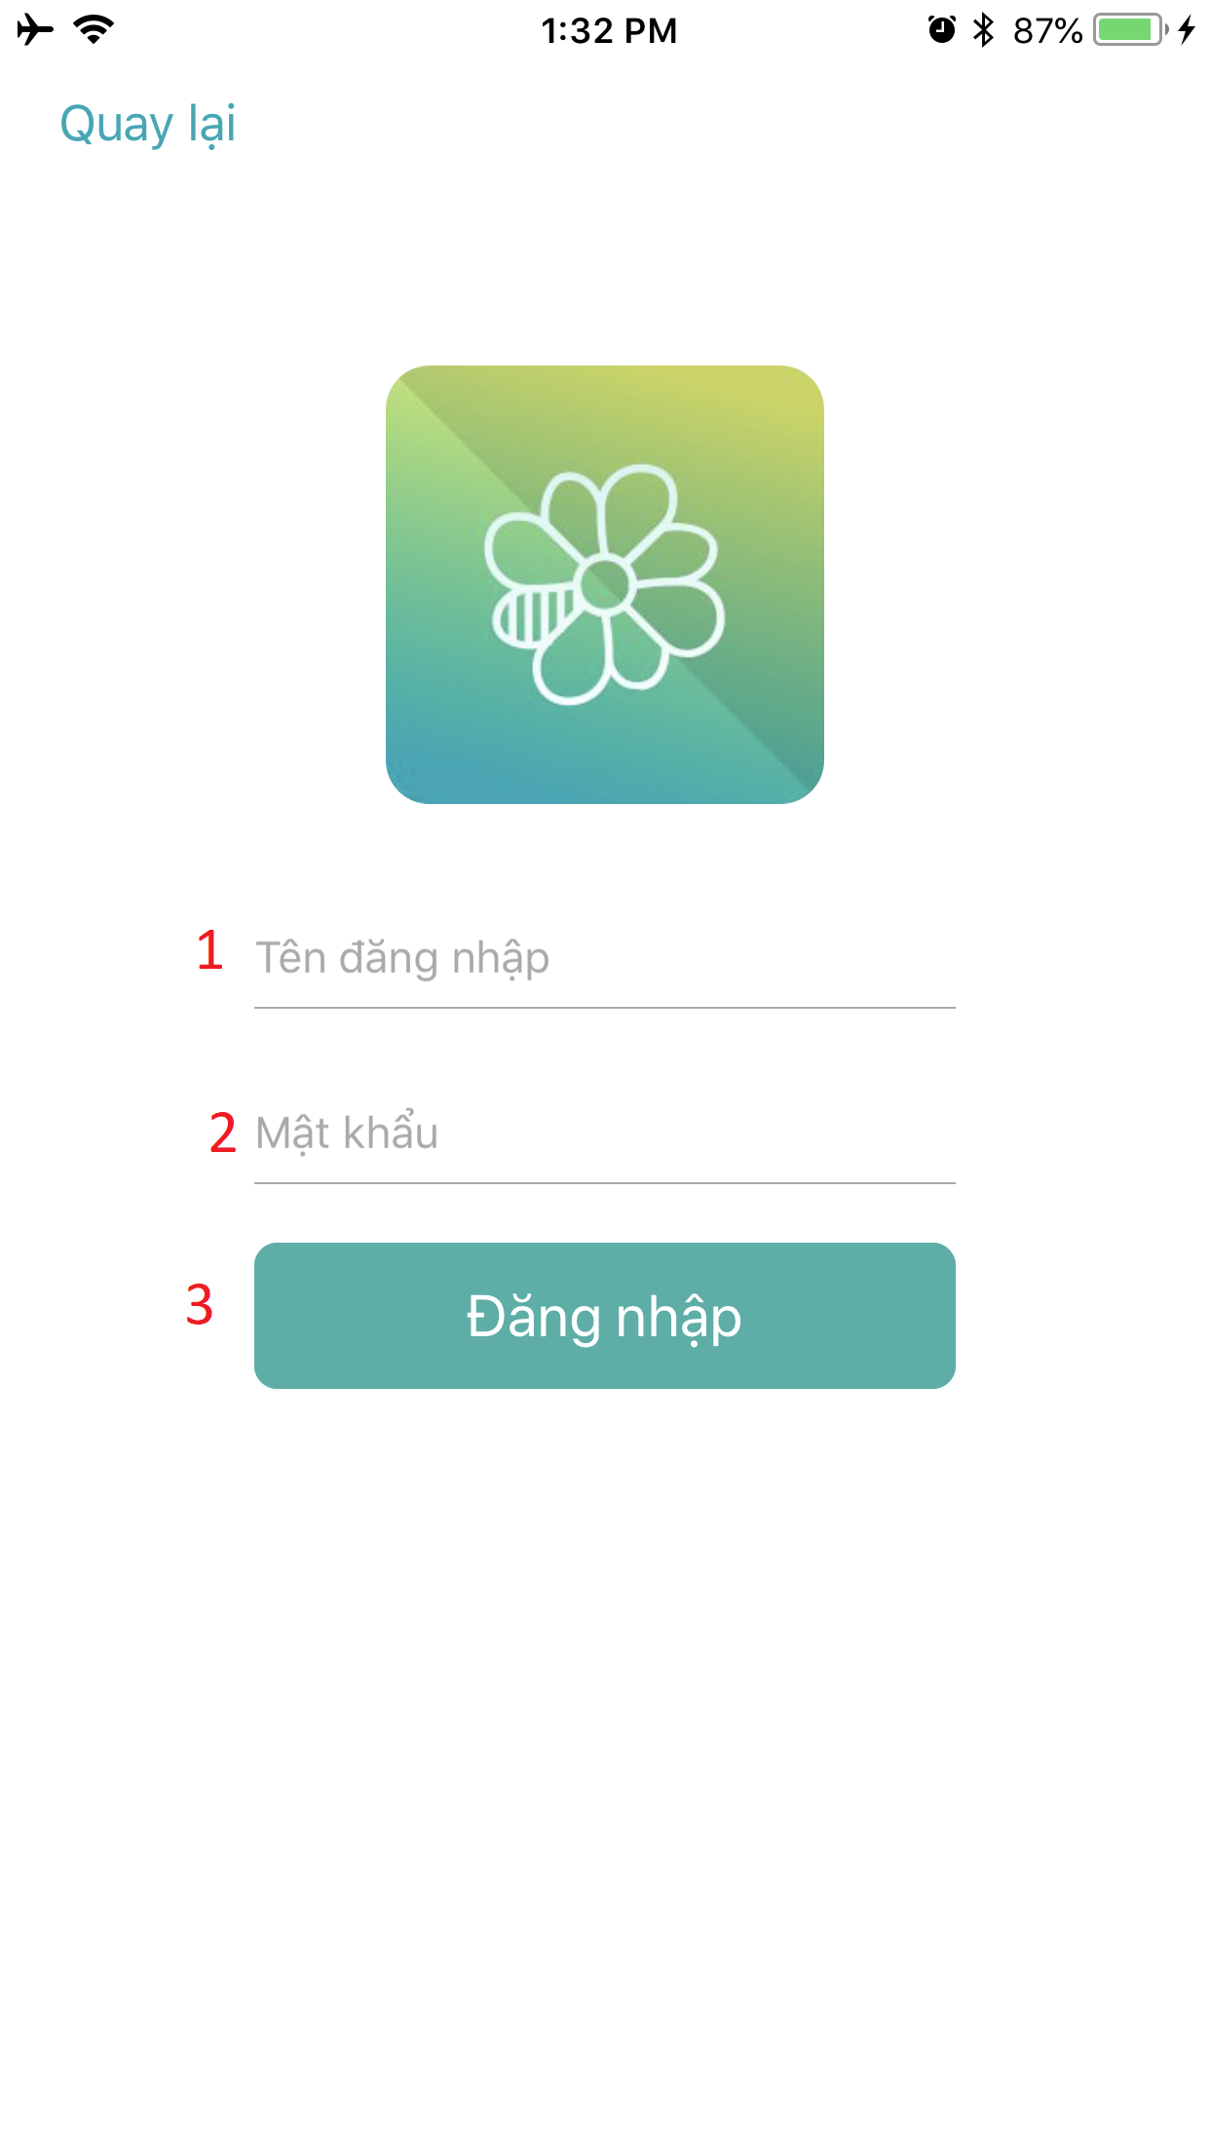

Figure 63: <Unauthorized User> Sign In Interface

|  |  |  |  |  |  |  |
| --- | --- | --- | --- | --- | --- | --- |
| **FIELDS** | | | | | | |
| **No** | **Field Name** | **Description** | **Read Only** | **Mandatory** | **Control Type** | **Data Type** |
| **1** | Username | Fill username | No | Yes | Textbox | String |
| **2** | Password | Fill password | No | Yes | Textbox | String |
| **BUTTONS/HYPERLINKS** | | | | | | |
| **No** | **Function** | **Description** | | **Validation** | **Outcome** | |
| **3** | login | Login to system | | N/A | Go to home screen | |

Table 60: Sign In - Field, Buttons

### Authorized User Interface Design

#### View Setting

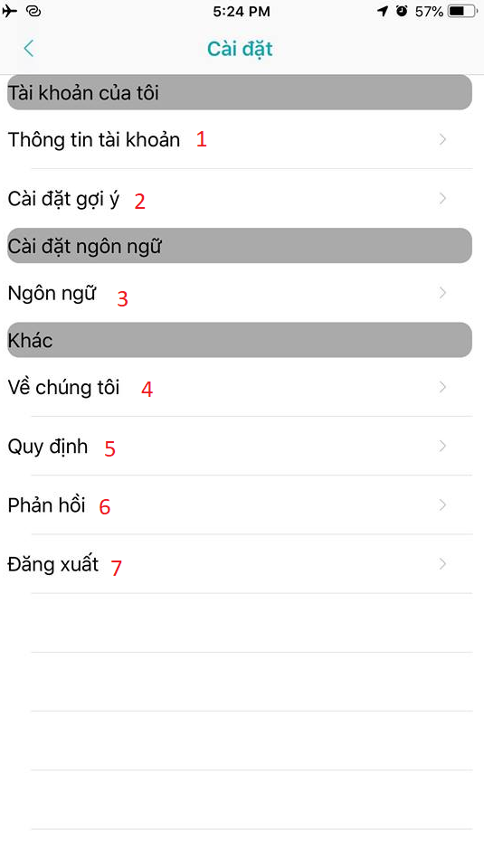

Figure 64: <Authorized User> View Setting Interface

|  |  |  |  |  |
| --- | --- | --- | --- | --- |
| **BUTTONS/HYPERLINKS** | | | | |
| **No** | **Function** | **Description** | **Validation** | **Outcome** |
| **1** | findById | Display setting profile screen | N/A | Go to setting profile screen |
| **2** | createReference | Display setting reference screen | N/A | Go to setting reference screen |
| **3** | language | Change language | N/A | Change application language |
| **4** | N/A | Display about us screen | N/A | Go to about us screen |
| **5** | N/A | Display privacy screen | N/A | Go to privacy screen |
| **6** | N/A | Display feedback screen | N/A | Go to feedback screen |
| **7** | logOut | Log user out of system | N/A | Log user out of system |

Table 61: View Setting - Field, Buttons, Hyperlinks

#### Update User Information

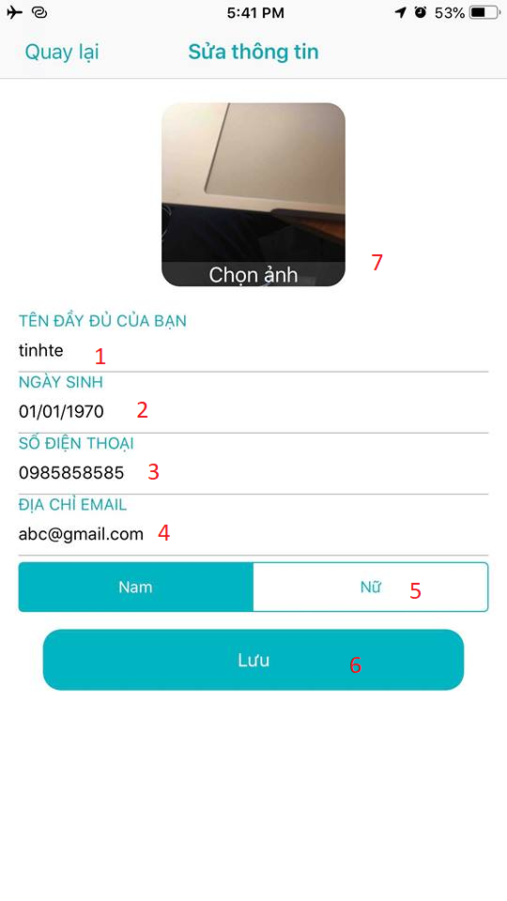

Figure 65: <Authorized User> Update Information Interface

|  |  |  |  |  |  |  |
| --- | --- | --- | --- | --- | --- | --- |
| **FIELDS** | | | | | | |
| **No** | **Field Name** | **Description** | **Read Only** | **Mandatory** | **Control Type** | **Data Type** |
| **1** | Full name | Fill user name | No | Yes | Textfield | String |
| **2** | Date of birth | Date of birth of user | No | Yes | DatePicker | DateTimePicker |
| **3** | Phone | Fill phone number | No | Yes | Textfield | String |
| **4** | Email | Fill Email | No | Yes | Textfield | String |
| **5** | Gender | Select gender | No | Yes | Textbox | String |
| **BUTTONS/HYPERLINKS** | | | | | | |
| **No** | **Function** | **Description** | | **Validation** | **Outcome** | |
| **7** | uploadRoomImage | Choose image to set profile image | | Image must be less than 10Mb | Upload profile image | |
| **6** | updateUser | Update account | | All fields required before summit | Redirect to home screen | |

Table 62: Update User Information - Field, Buttons, Hyperlinks

#### View Profile

##### <House Owner> View Profile

Figure 66: <Authorized User> View Profile Interface

Table 63: View Profile - Field, Buttons, Hyperlinks

##### <Member/Room Master> View Profile

Figure 67: <Authorized User> View Profile Interface

Table 64: View Profile - Field, Buttons, Hyperlinks

#### View Notification



Figure 68: <Authorized User> View Notification Interface

Table 65: View Notification - Field

#### View Bookmark

##### <Room Post> View Bookmark

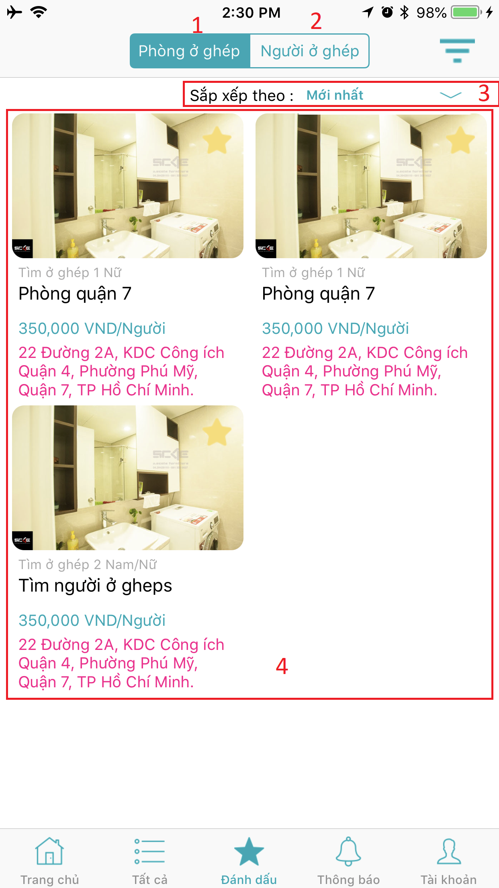

Figure 69: <Room Post> View Bookmark

|  |  |  |  |  |  |  |  |  |  |  |
| --- | --- | --- | --- | --- | --- | --- | --- | --- | --- | --- |
| **FIELDS** | | | | | | | | | | |
| **No** | **Field Name** | | **Description** | | **Read Only** | | **Mandatory** | | **Control Type** | **Data Type** |
| **4** | Bookmarked posts list | | Display bookmarked posts | | Yes | | Yes | | Panel | N/A |
| **BUTTONS/HYPERLINKS** | | | | | | | | | | |
| **No** | | **Function** | | **Description** | | **Validation** | | **Outcome** | | |
| **1** | | getFavouriteByFilter | | Find all bookmarked finding roommate posts | | N/A | | Display list of bookmarked finding roommate posts | | |
| **2** | | getFavouriteByFilter | | Find all bookmarked finding room posts | | N/A | | Display list of bookmarked finding room posts | | |
| **3** | | getFavouriteByFilter | | Select order by price/date | | N/A | | Display list of bookmarked posts by order. | | |

Table 66: View Bookmark - Field, Buttons, Hyperlinks

##### <Roommate Post> View Bookmark

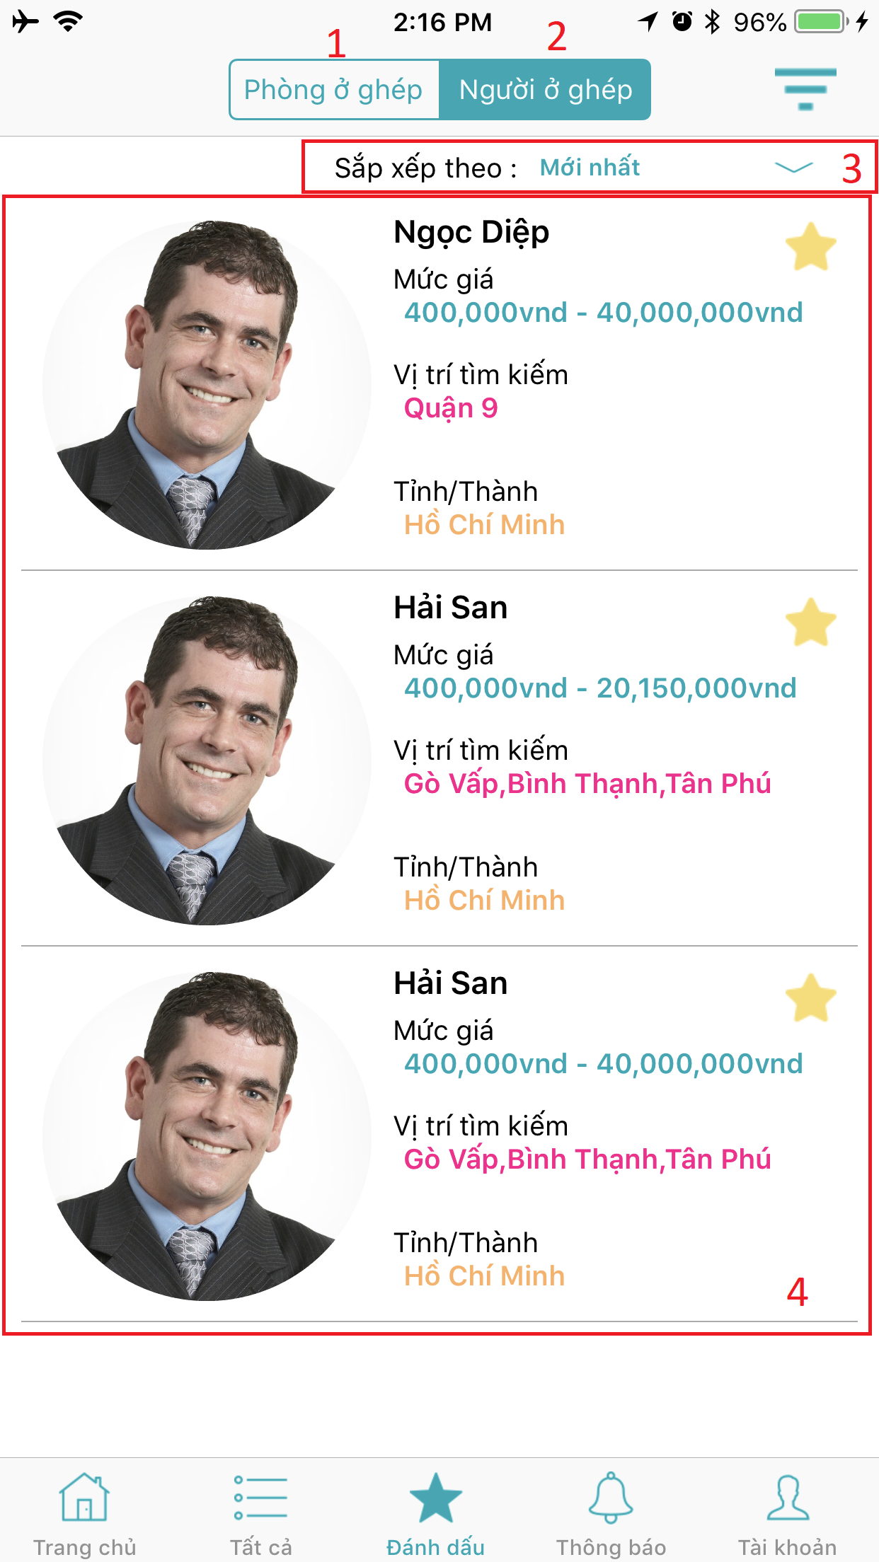

Figure 70: <Roommate Post > View Bookmark

|  |  |  |  |  |  |  |  |  |  |  |  |  |  |  |  |
| --- | --- | --- | --- | --- | --- | --- | --- | --- | --- | --- | --- | --- | --- | --- | --- |
| **FIELDS** | | | | | | | | | | | | | | | |
| **No** | **Field Name** | | **Description** | | | **Read Only** | | | **Mandatory** | | | **Control Type** | | **Data Type** | |
| **4** | Bookmarked posts list | | | Display bookmarked posts | | | Yes | | | Yes | | | Panel | | N/A |
| **BUTTONS/HYPERLINKS** | | | | | | | | | | | | | | | |
| **No** | | **Function** | | | **Description** | | | **Validation** | | | **Outcome** | | | | |
| **1** | | getFavouriteByFilter | | | Find all bookmarked finding roommate posts | | | N/A | | | Display list of bookmarked finding roommate posts | | | | |
| **2** | | getFavouriteByFilter | | | Find all bookmarked finding room posts | | | N/A | | | Display list of bookmarked finding room posts | | | | |
| **3** | | getFavouriteByFilter | | | Select order by price/date | | | N/A | | | Display list of bookmarked posts by order. | | | | |

Table 67: View Bookmark - Field, Buttons, Hyperlinks

#### Request Location Popup Screen

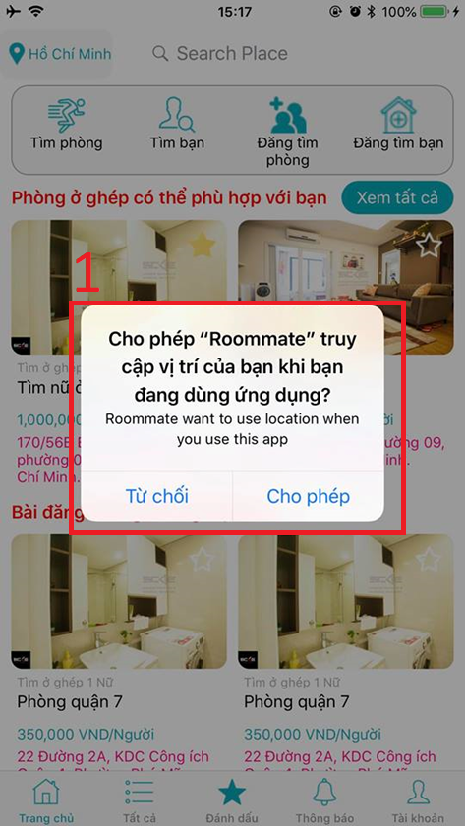

Figure 71: <Authorized User> Request Location Interface

|  |  |  |  |  |  |  |  |  |  |  |  |
| --- | --- | --- | --- | --- | --- | --- | --- | --- | --- | --- | --- |
| **FIELDS** | | | | | | | | | | | |
| **No** | **Field Name** | **Description** | | **Read Only** | | **Mandatory** | | **Control Type** | | **Data Type** | |
| **1** | Location request popup | | Request access current location | | Yes | | No | | Popup | | N/A |

Table 68: Request Location - Fields

#### View All

##### <Room Post> View All

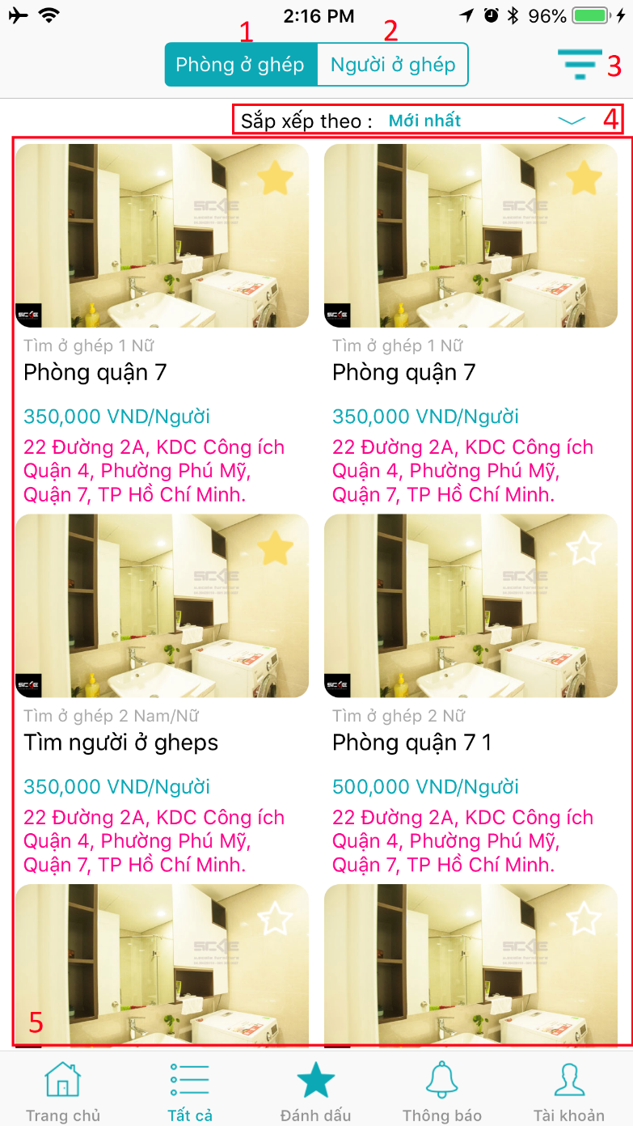

Figure 72: <Room Post> View All

|  |  |  |  |  |  |  |  |  |  |  |  |  |  |  |  |
| --- | --- | --- | --- | --- | --- | --- | --- | --- | --- | --- | --- | --- | --- | --- | --- |
| **FIELDS** | | | | | | | | | | | | | | | |
| **No** | **Field Name** | | **Description** | | | **Read Only** | | | **Mandatory** | | | **Control Type** | | **Data Type** | |
| **5** | Room posts list | | | Display newest room posts | | | No | | | Yes | | | Panel | | N/A |
| **BUTTONS/HYPERLINKS** | | | | | | | | | | | | | | | |
| **No** | | **Function** | | | **Description** | | | **Validation** | | | **Outcome** | | | | |
| **1** | | getPostByFilter | | | Find all finding roommate posts | | | N/A | | | Display all finding roommate posts | | | | |
| **2** | | getPostByFilter | | | Find all finding room posts | | | N/A | | | Display all finding room posts | | | | |
| **3** | | getPostByFilter | | | Filter post by options | | | N/A | | | Display all posts are filtered by reference | | | | |
| **4** | | getPostByFilter | | | Select order by price/date | | | N/A | | | Display list of room posts by order. | | | | |

Table 69: <Room Post> View All- Fields, Buttons

##### <Roommate Post> View All

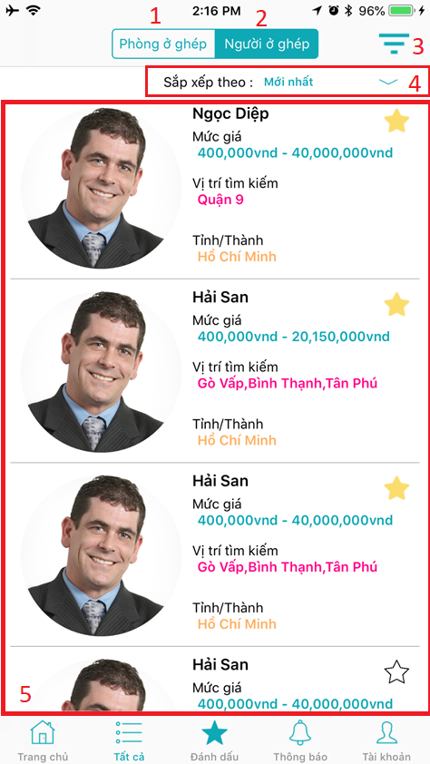

Figure 73: <Roommate Post> View All

|  |  |  |  |  |  |  |  |  |  |  |  |  |  |  |  |
| --- | --- | --- | --- | --- | --- | --- | --- | --- | --- | --- | --- | --- | --- | --- | --- |
| **FIELDS** | | | | | | | | | | | | | | | |
| **No** | **Field Name** | | **Description** | | | **Read Only** | | | **Mandatory** | | | **Control Type** | | **Data Type** | |
| **5** | Roommate posts list | | | Display newest room posts | | | No | | | Yes | | | Panel | | N/A |
| **BUTTONS/HYPERLINKS** | | | | | | | | | | | | | | | |
| **No** | | **Function** | | | **Description** | | | **Validation** | | | **Outcome** | | | | |
| **1** | | getPostByFilter | | | Find all finding roommate posts | | | N/A | | | Display all finding roommate posts | | | | |
| **2** | | getPostByFilter | | | Find all finding room posts | | | N/A | | | Display all finding room posts | | | | |
| **3** | | getPostByFilter | | | Filter posts by references | | | N/A | | | Display all posts are filtered by references | | | | |
| **4** | | getPostByFilter | | | Select order by price/date | | | N/A | | | Display list of room posts by order. | | | | |

Table 70: <Roommate Post> View All- Fields, Buttons

#### Filter

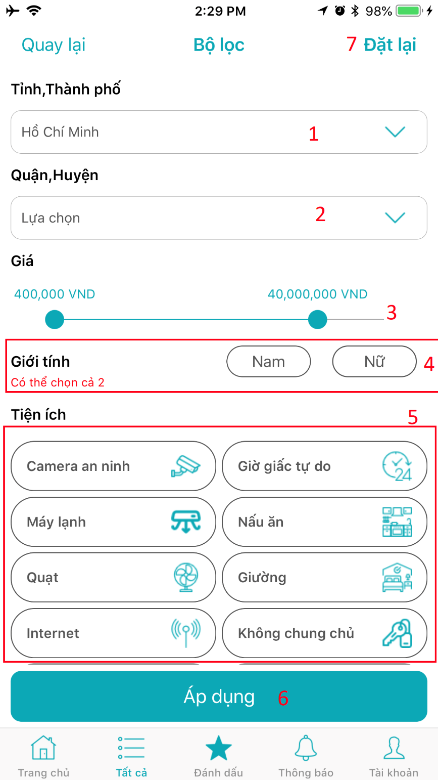

Figure 74: <Authorized User> Filter

|  |  |  |  |  |  |  |  |  |  |  |  |  |  |  |  |
| --- | --- | --- | --- | --- | --- | --- | --- | --- | --- | --- | --- | --- | --- | --- | --- |
| **FIELDS** | | | | | | | | | | | | | | | |
| **No** | **Field Name** | | **Description** | | | **Read Only** | | | **Mandatory** | | | **Control Type** | | **Data Type** | |
| **1** | City | | | Select city to filter | | | Yes | | | Yes | | | Dropdown list | | N/A |
| **2** | District | | | Select district to filter | | | Yes | | | Yes | | | Dropdown list | | N/A |
| **3** | Price range | | | Apply price rage to filter | | | Yes | | | Yes | | | Slider | | N/A |
| **4** | Gender | | | Select gender to filter | | | Yes | | | Yes | | | Button | | N/A |
| **5** | Utilities | | | Select utilities to filter | | | Yes | | | Yes | | | Buttons | | N/A |
| **BUTTONS/HYPERLINKS** | | | | | | | | | | | | | | | |
| **No** | | **Function** | | | **Description** | | | **Validation** | | | **Outcome** | | | | |
| **6** | | getPostByFilter | | | Filter posts by references | | | N/A | | | Display all posts are filtered by references. | | | | |

Table 71: <Authorized User> Filter - Fields, Buttons

### House owner Interface Design

#### Create Room

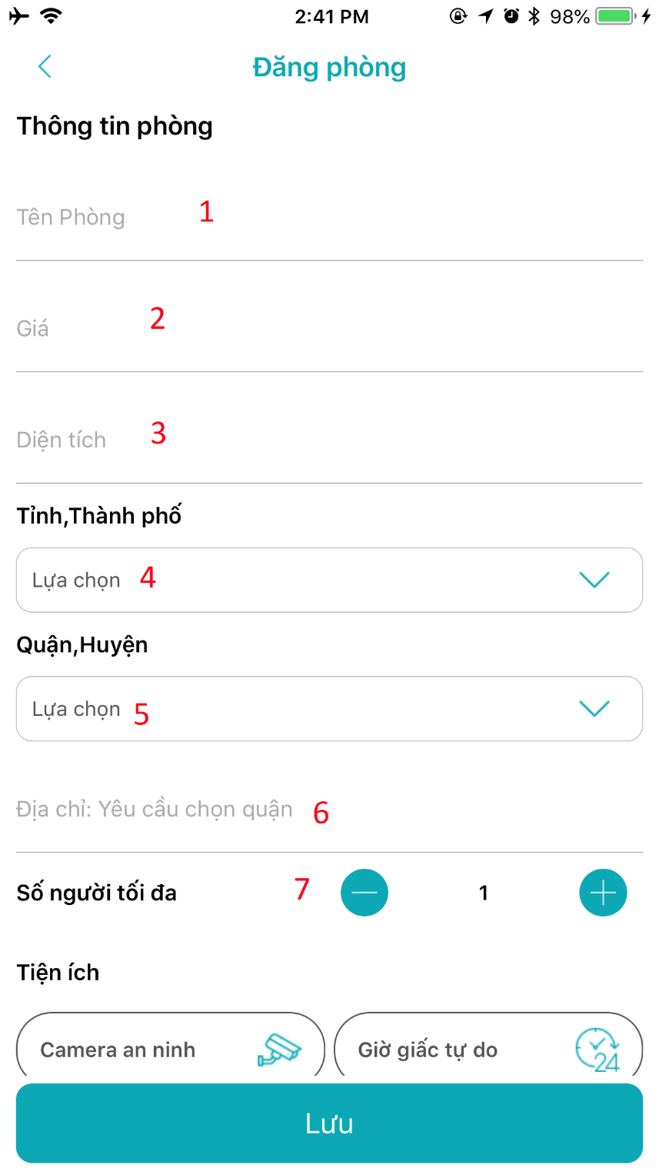

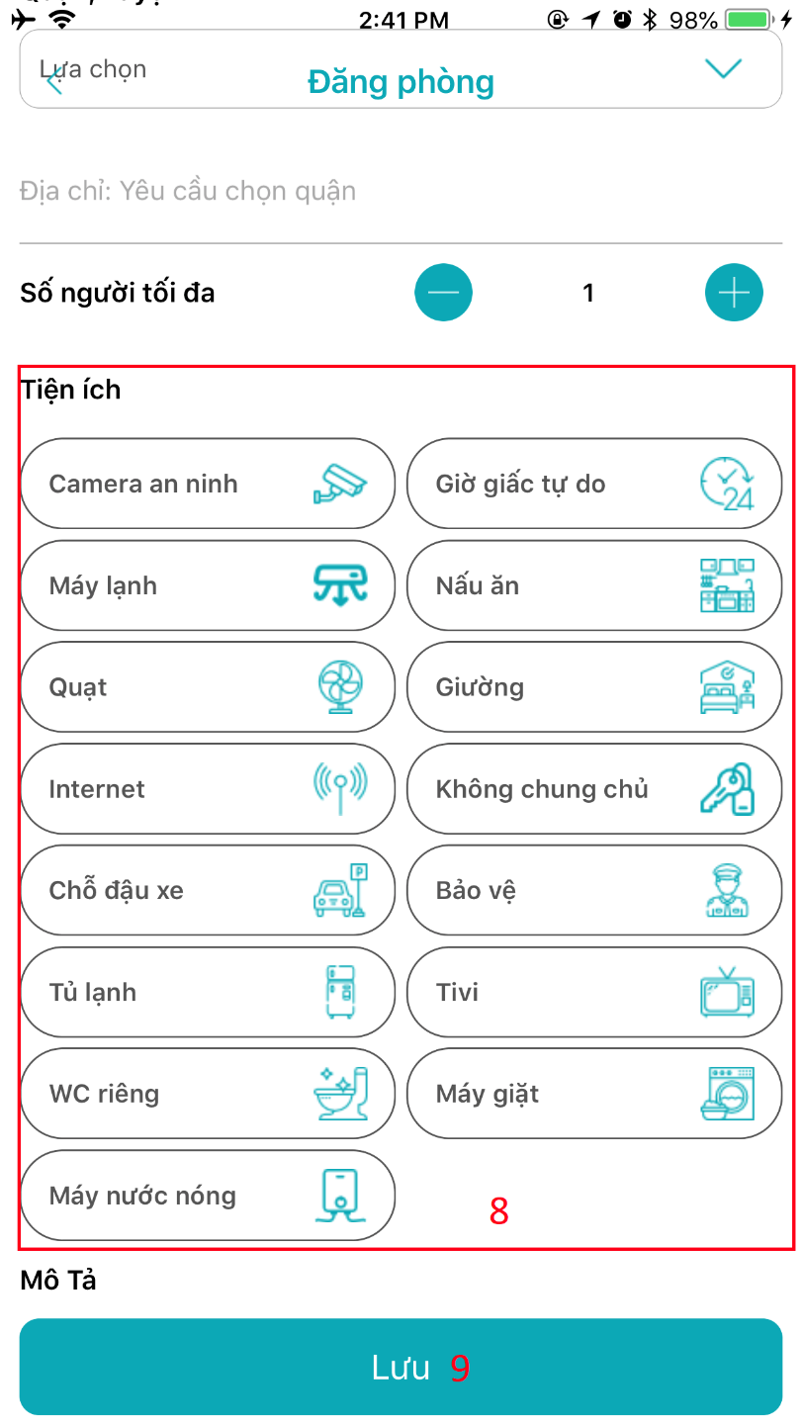

Figure 75: <House owner> Create Room Interface

|  |  |  |  |  |  |  |  |  |  |  |  |  |  |  |  |
| --- | --- | --- | --- | --- | --- | --- | --- | --- | --- | --- | --- | --- | --- | --- | --- |
| **FIELDS** | | | | | | | | | | | | | | | |
| **No** | **Field Name** | | **Description** | | | **Read Only** | | | **Mandatory** | | | **Control Type** | | **Data Type** | |
| **1** | Room name | | | Fill room name | | | No | | | Yes | | | Textfield | | String |
| **2** | Room price | | | Fill room price | | | No | | | Yes | | | Textfield | | String |
| **3** | Room area | | | Fill room area | | | No | | | Yes | | | Textfield | | String |
| **4** | City | | | Select city | | | No | | | Yes | | | Dropdownlist | | N/A |
| **5** | District | | | Select district | | | No | | | Yes | | | Dropdownlist | | N/A |
| **6** | Address | | | Fill address | | | No | | | Yes | | | Textfield | | String |
| **7** | Max member | | | Select max member | | | No | | | Yes | | | Button | | N/A |
| **8** | Utilities | | | Select utilities | | | No | | | Yes | | | Buttons | | N/A |
| **BUTTONS/HYPERLINKS** | | | | | | | | | | | | | | | |
| **No** | | **Function** | | | **Description** | | | **Validation** | | | **Outcome** | | | | |
| **9** | | createRoom | | | House owner create room | | | All fields required before summit | | | Room will be created with status is pending. | | | | |

Table 72: Create Room - Field, Buttons, Hyperlinks

#### Update Room

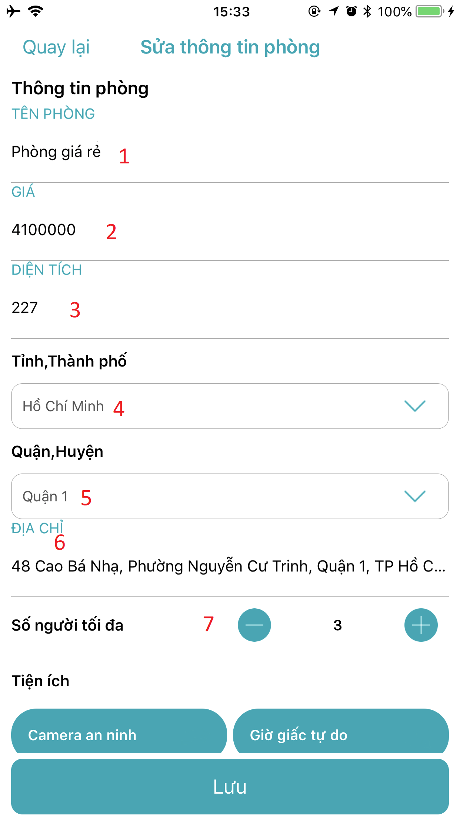

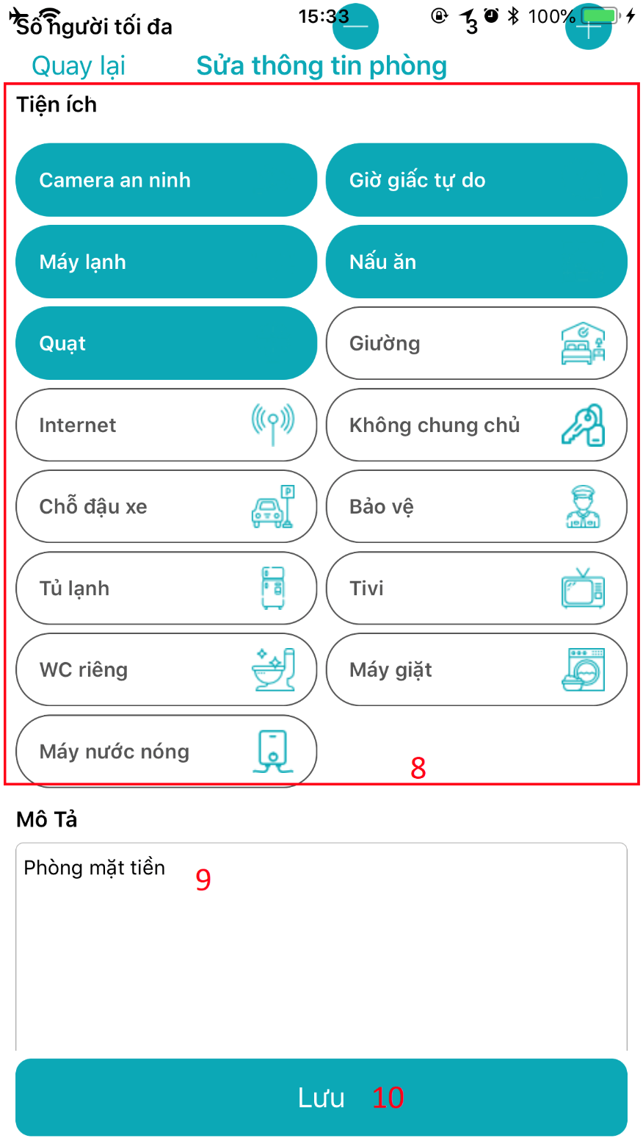

Figure 76: < House owner > Update Room Interface

|  |  |  |  |  |  |  |  |  |  |  |  |  |  |  |  |
| --- | --- | --- | --- | --- | --- | --- | --- | --- | --- | --- | --- | --- | --- | --- | --- |
| **FIELDS** | | | | | | | | | | | | | | | |
| **No** | **Field Name** | | **Description** | | | **Read Only** | | | **Mandatory** | | | **Control Type** | | **Data Type** | |
| **1** | Room name | | | Fill room name | | | No | | | Yes | | | Textfield | | String |
| **2** | Room price | | | Fill room price | | | No | | | Yes | | | Textfield | | String |
| **3** | Room area | | | Fill room area | | | No | | | Yes | | | Textfield | | String |
| **4** | City | | | Select city | | | No | | | Yes | | | Dropdownlist | | N/A |
| **5** | District | | | Select district | | | No | | | Yes | | | Dropdownlist | | N/A |
| **6** | Address | | | Fill address | | | No | | | Yes | | | Textfield | | String |
| **7** | Max member | | | Select max member | | | No | | | Yes | | | Button | | N/A |
| **8** | Utilities | | | Select utilities | | | No | | | Yes | | | Buttons | | N/A |
| **9** | Description | | | Fill Description | | | No | | | Yes | | | Textfield | | String |
| **BUTTONS/HYPERLINKS** | | | | | | | | | | | | | | | |
| **No** | | **Function** | | | **Description** | | | **Validation** | | | **Outcome** | | | | |
| **10** | | updateRoom | | | House owner updates room | | | All fields required before summit | | | Room will be updated and status change to pending after update. | | | | |

Table 73: Update Room - Field, Buttons, Hyperlinks

#### View Room

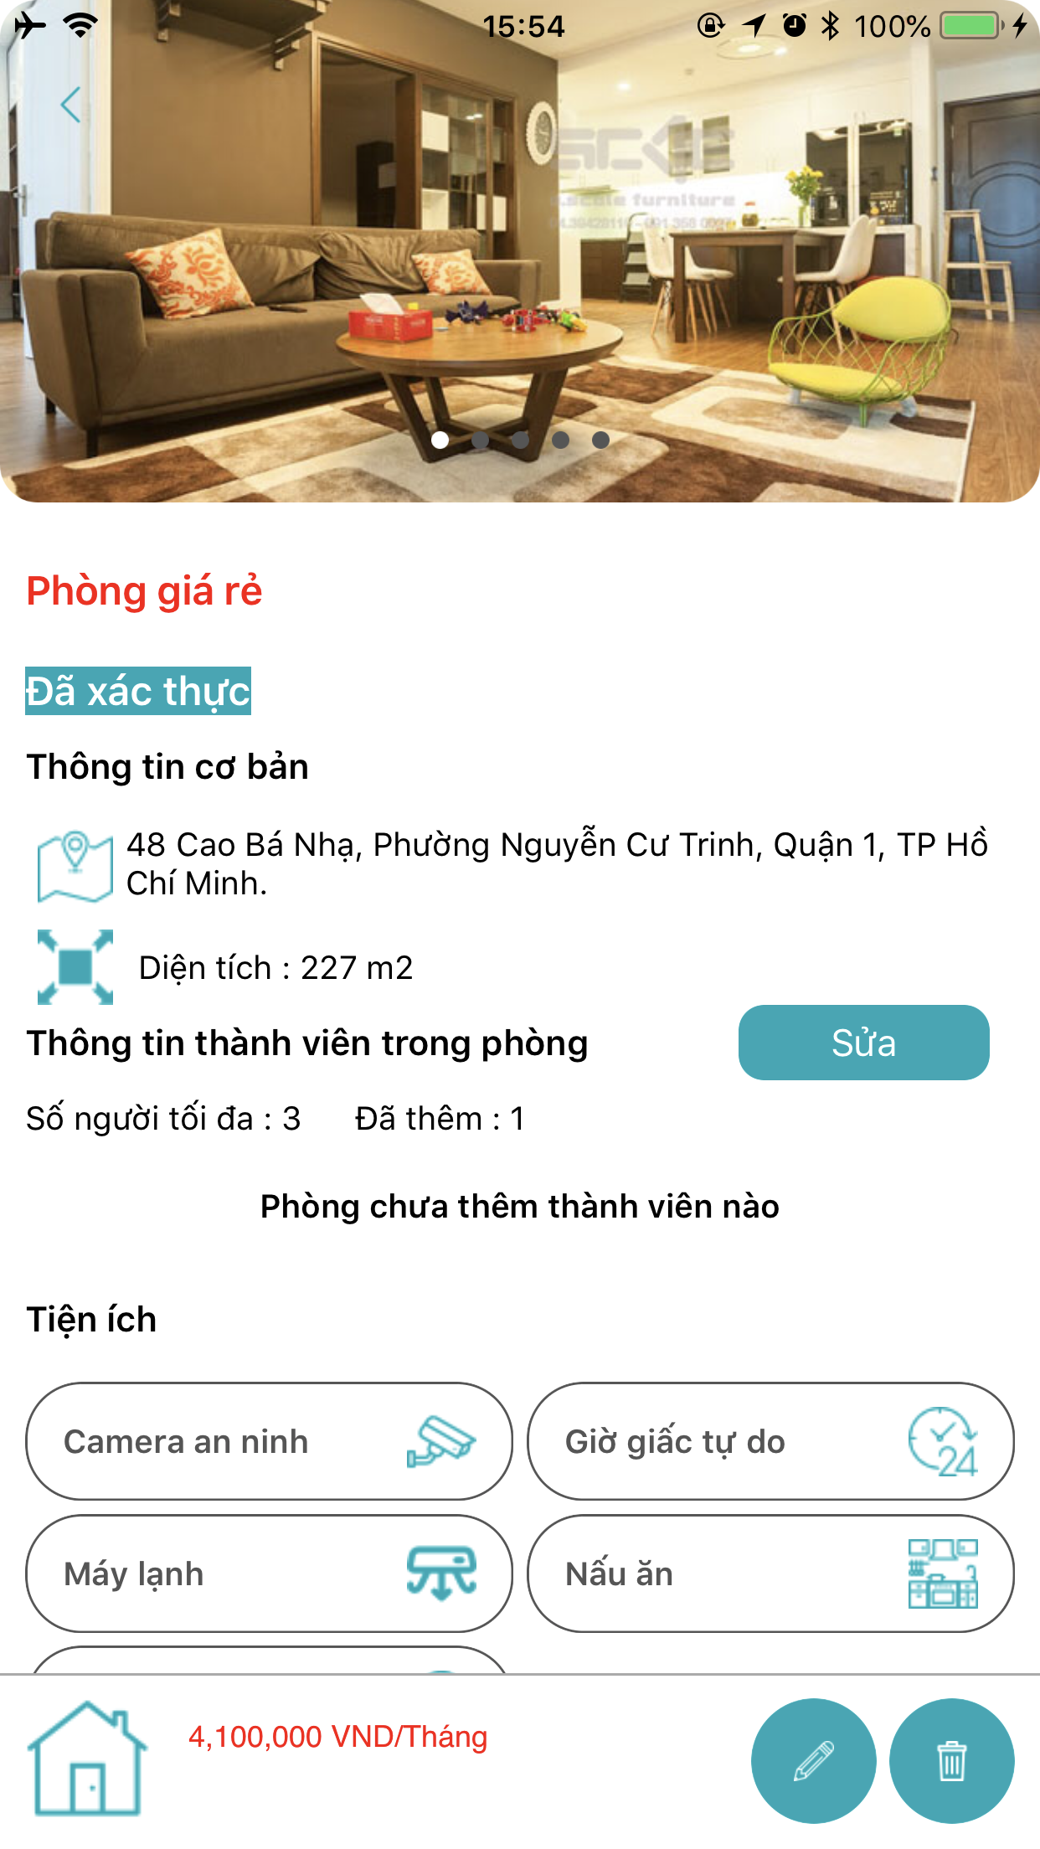

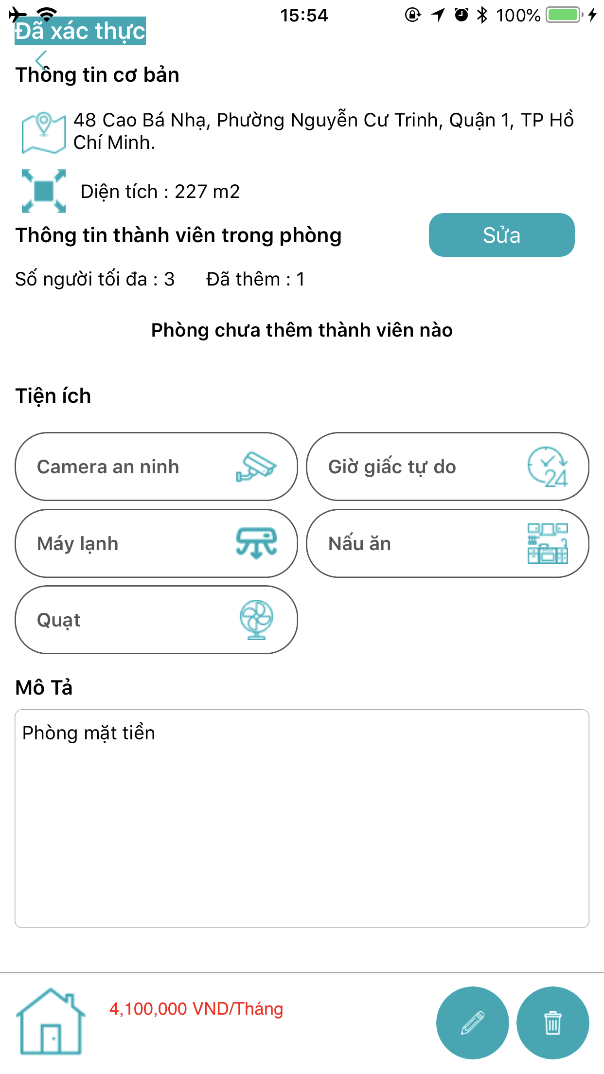

Figure 77: < House owner > View Room Interface

Table 74: View Room - Field, Buttons, Hyperlinks

#### Delete Room

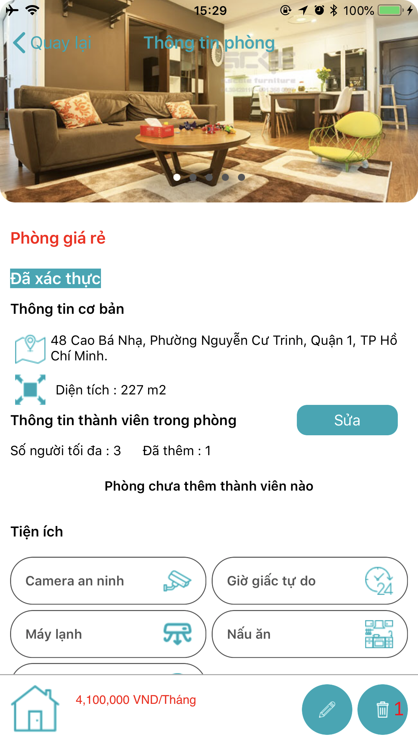

Figure 78: < House owner > Delete Room Interface

|  |  |  |  |  |
| --- | --- | --- | --- | --- |
| **BUTTONS/HYPERLINKS** | | | | |
| **No** | **Function** | **Description** | **Validation** | **Outcome** |
| **1** | deleteRoom | House owner deletes room | N/A | Room will be deleted |

Table 75: Delete Room - Field, Buttons, Hyperlinks

#### Add member into Room

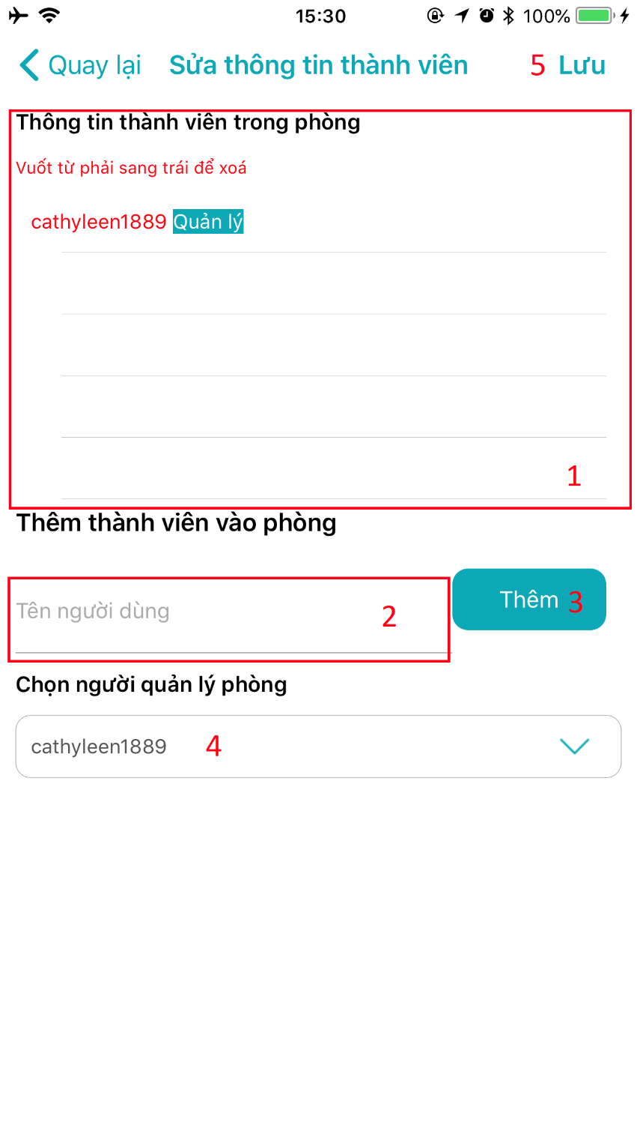

Figure 79: < House owner > Add member into Room Interface

|  |  |  |  |  |  |  |  |  |  |  |  |  |  |  |  |
| --- | --- | --- | --- | --- | --- | --- | --- | --- | --- | --- | --- | --- | --- | --- | --- |
| **FIELDS** | | | | | | | | | | | | | | | |
| **No** | **Field Name** | | **Description** | | | **Read Only** | | | **Mandatory** | | | **Control Type** | | **Data Type** | |
| **1** | Member list in room | | | Display all members in room | | | Yes | | | No | | | Panel | | N/A |
| **2** | Member username | | | House owner fill username of member want to add. | | | No | | | Yes | | | Textfield | | String |
| **3** | Add button | | | Update panel display all members in room | | | No | | | Yes | | | Button | | N/A |
| **4** | Choosing room master | | | House owner chooses one member to become room master | | | No | | | Yes | | | Dropdownlist | | N/A |
| **BUTTONS/HYPERLINKS** | | | | | | | | | | | | | | | |
| **No** | | **Function** | | | **Description** | | | **Validation** | | | **Outcome** | | | | |
| **5** | | editMember | | | Add member into room | | | All fields required before summit | | | Member added into room | | | | |

Table 76: Add member into Room - Field, Buttons, Hyperlinks

#### Delete member of Room

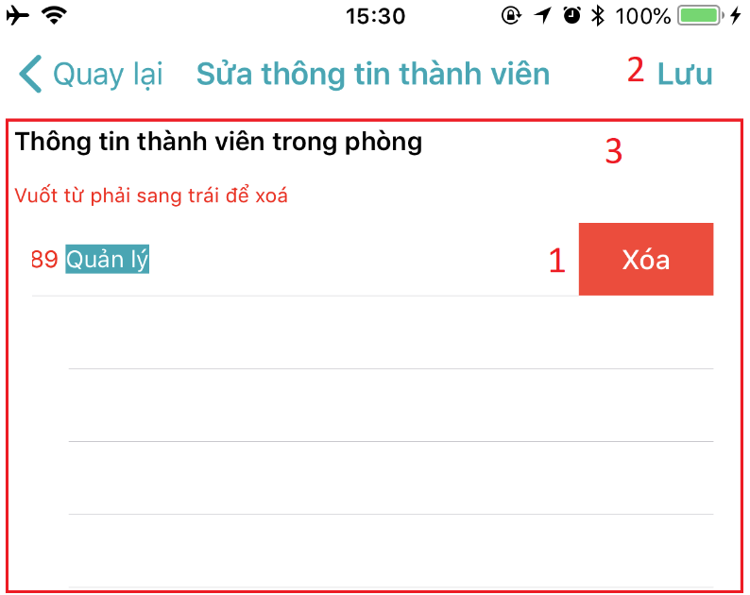

Figure 80: < House owner > Delete member of Room Interface

|  |  |  |  |  |  |  |  |  |  |  |
| --- | --- | --- | --- | --- | --- | --- | --- | --- | --- | --- |
| **FIELDS** | | | | | | | | | | |
| **No** | **Field Name** | | **Description** | | **Read Only** | **Mandatory** | | **Control Type** | | **Data Type** |
| **1** | Delete button | | Update panel display all members in room | | No | Yes | | Button | | N/A |
| **3** | Member list in room | | Display all members in room | | Yes | No | | Panel | | N/A |
| **BUTTONS/HYPERLINKS** | | | | | | | | | | |
| **No** | | **Function** | | **Description** | | | **Validation** | | **Outcome** | |
| **2** | | editMember | | Delete member of room | | | N/A | | Delete member out | |

Table 77: Delete member of Room - Field, Buttons, Hyperlinks

### Room Master

#### View suggested room master list

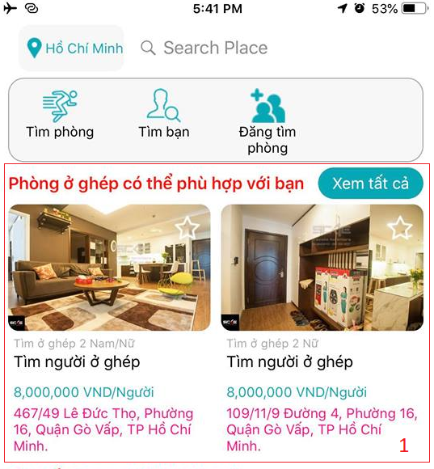

#### Create Post

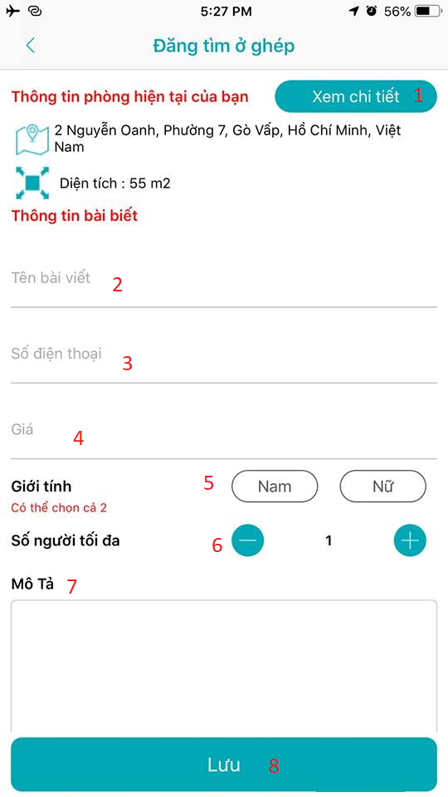

#### Update post

#### View Post

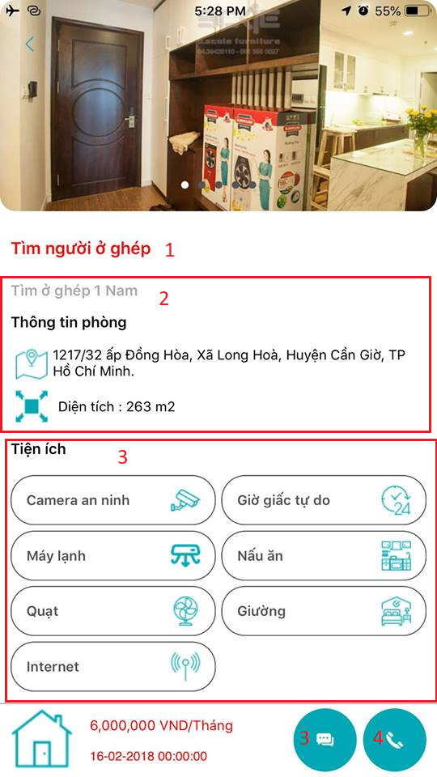

#### Delete Post

### Member

#### View suggested room master list

#### Create Post

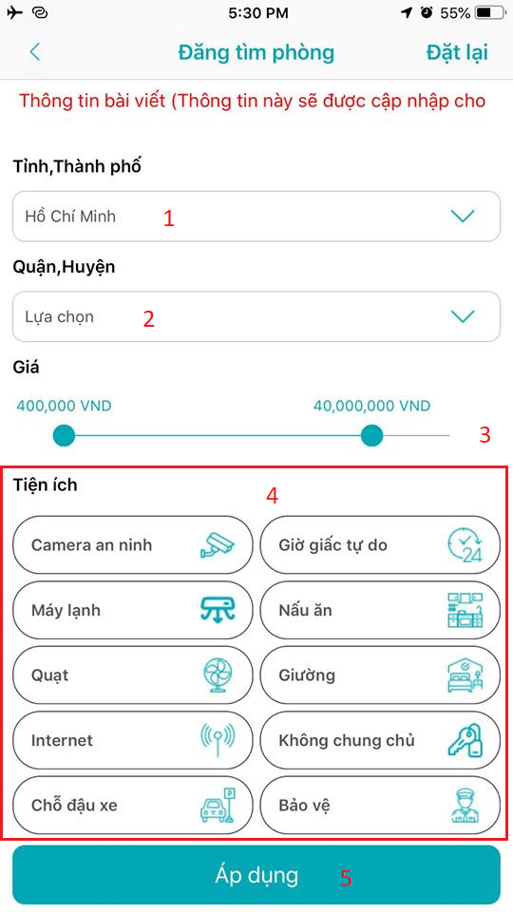

#### Update Post

#### Delete Post

#### View Post

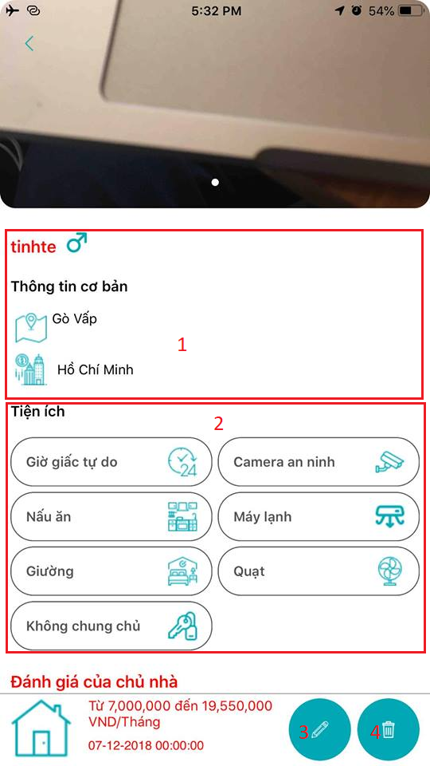

## Database Design

### Entity relationship diagram (ERD)

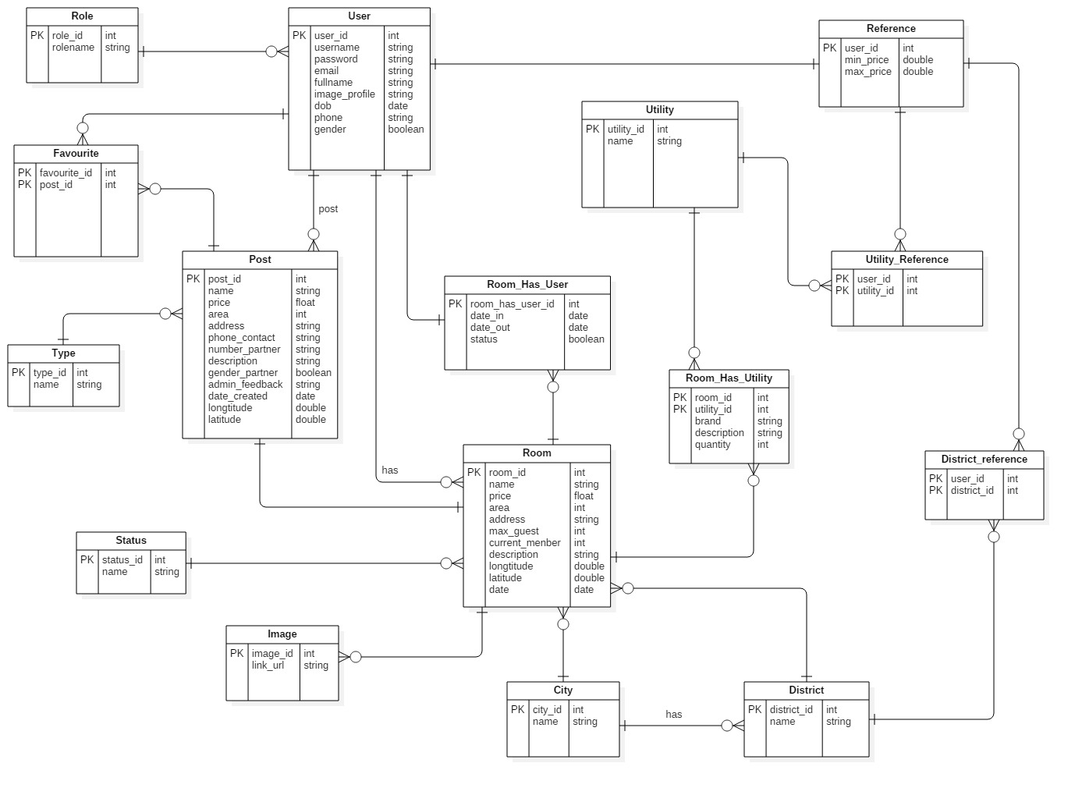

Figure 81: Entity Relationship diagram

### Entity dictionary

|  |  |
| --- | --- |
| **ENTITY DATA DICTIONARY: DESCRIBE CONTENT OF ALL ENTITIES** | |
| **Entity Name** | **Description** |
| **User** | Contains users information |
| **Room** | Contains rooms information |
| **Post** | Contains posts information |
| **Role** | Describe roles in system. |
| **Favorites** | Contains favorite information |
| **Utilities** | Contains utilities information |
| **Reference** | Contains references information |
| **District** | Contains districts information |
| **City** | Contains city information |
| **Image** | Contains images information |
| **Type** | Describe type of post in system. |
| **Status** | Describe status of room in system. |
| **Room_Has_Utilities** | Describe utilities of room in system |
| **Utilities_Reference** | Describe utilities of user in system |
| **District_Reference** | Describe districts that user prefer to search |
| **Room_Has_User** | Contains users in room information |

Table 78: Entity Data dictionary

## Algorithms

### Definition

In ASP system, suggest nearby posts function is a main scope.

As a room master who has room post, this function will suggest nearby other room master's posts.

As a member who does not have a reference and allows to access location, this function will suggest room posts around.

### Define Problem

When room master posts a post or member allows accessing location, the system will calculate the distance based on longitude and latitude. Because the earth is a spherical shape, so we need an algorithm to do this.

### Solution

View the Earth as a spherical shape with center is O. City S is located 11° latitude, 106°30' longitude.

City P is located 49° latitude, 2°30' longitude.

With Spherical Law of Cosines, the system can calculate the angle of $\hat{POS}$

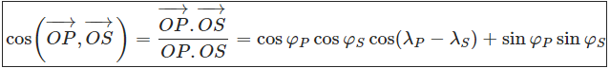

Where φ is latitude (positive when the point is in the Northern Hemisphere, negative in Southern Hemisphere), λ is the longitude (positive sign in the Eastern Hemisphere, negative sign in the Western Hemisphere)

cos($\vec{OP},\vec{OS}$) = cos49°cos11°cos104°+sin11°sin49° ≈ −0,01179

So that, $\hat{POS}$  ≈ 90°40'32"

A nautical mile is based on the circumference of the planet Earth. If you were to cut the Earth in half at the equator, you could pick up one of the halves and look at the equator as a circle. You could divide that circle into 360 degrees. You could then divide a degree into 60 minutes. A minute of arc on the planet Earth is 1 nautical mile.

So that, we convert distances from degrees to nautical miles by multiply by 60.

The system converts nautical mile to statute mile by multiply by 1.1515.

Finally, the system converts statute mile to kilometer by multiply by 1.609344.

Base on the result above, the system takes 90°40'32" multiply by 60, multiply by 1.1515 and multiply by 1.609344, and get the result is 10082.8746 km.

# E. System Implementation & Test

## Introduction

### Overview

This section describes the approach and methodologies used by group to plan, organize and manage the testing of ASP system. It provides in the detail all necessary information about the implementation and testing procedure of the system included test plans, test cases, test result, test environments, pass/fail criteria and risks estimations as well as a checklist to cover all possible cases.

### Test approach

We use system test approach to estimate our keeping track of children system quality, tester to aware of what ASP should do but does not have the knowledge of how because it does it. If tester had knowledge about the technical inside it, testing process won’t be objectivity.

## Database Relationship Diagram

### Physical Diagram

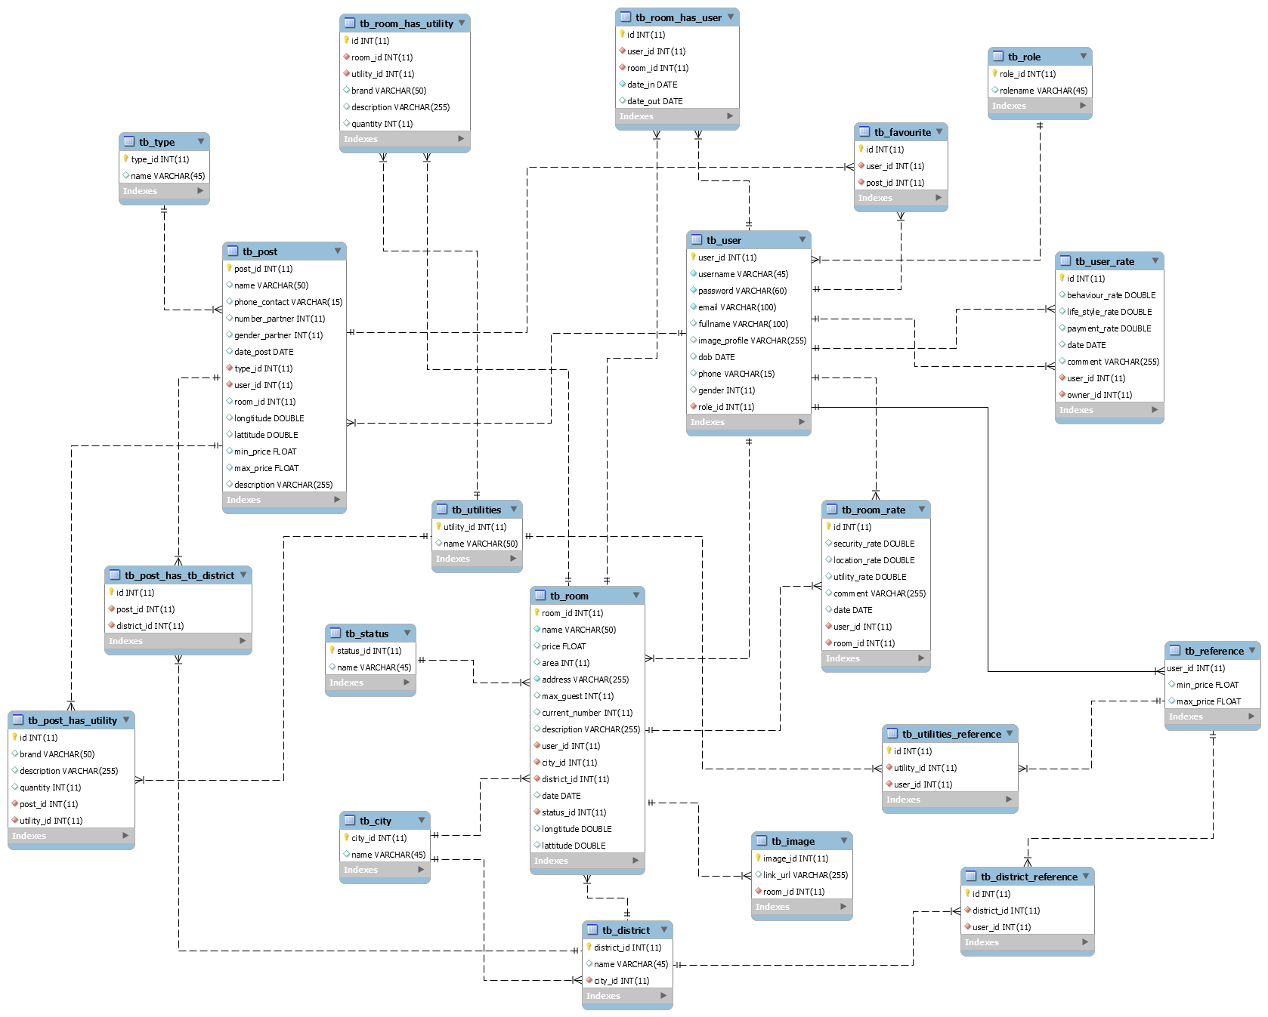

Figure 82: Physical diagram

### Data dictionary

|  |  |
| --- | --- |
| **DATA DICTIONARY: DESCRIBE CONTENT OF ALL TABLES** | |
| **Table name** | **Description** |
| **User** | Contains users information |
| **Room** | Contains rooms information |
| **Post** | Contains posts information |
| **Role** | Describe roles in system. |
| **Favorites** | Contains favorite information |
| **Utilities** | Contains utilities information |
| **Reference** | Contains references information |
| **District** | Contains districts information |
| **City** | Contains city information |
| **Image** | Contains images information |
| **Type** | Describe type of post in system |
| **Status** | Describe status of room in system |
| **User_Rate** | Contains user rate information |
| **Room_Rate** | Contains room rate information |
| **Room_Has_Utilities** | Describe utilities of room in system |
| **Utilities_Reference** | Describe utilities of user in system |
| **District_Reference** | Describe districts that user prefer to search |
| **Room_Has_User** | Contains users in room information |
| **Post_Has_Utility** | Describe utilities of post in system |
| **Post_Has_District** | Describe districts of post in system |

Table 79: Data dictionary

|  |  |  |  |  |
| --- | --- | --- | --- | --- |
| **Table Name** | **Attributes** | **Description** | **Domain** | **NULL** |
| **User** | user_id | Unique identifier of user | INT(11) | NO |
| username | Username of user | VARCHAR(45) | NO |
| password | Password of user | VARCHAR(60) | NO |
| email | Email of user | VARCHAR(100) | NO |
| fullname | Full name of user | VARCHAR(100) | YES |
| image_profile | Image profile of user | VARCHAR(255) | YES |
| dob | Date of birth of user | DATE | YES |
| phone | Phone number of user | VARCHAR(15) | YES |
| gender | Gender of user | INT(11) | YES |
| role_id | Role of user | INT(11) | NO |
| **Room** | room_id | Unique identifier of room | INT(11) | NO |
| name | Name of room | VARCHAR(50) | NO |
| price | Price of room | FLOAT | NO |
| area | Area of room | INT(11) | YES |
| address | Address of room | VARCHAR(255) | NO |
| max_guest | Maximum number of guest in room | INT(11) | YES |
| current_number | Current number of guest in room | INT(11) | YES |
| description | Description of room | VARCHAR(255) | YES |
| user_id | Identifier of user in room | INT(11) | NO |
| city_id | City’s identify of room | INT(11) | NO |
| district_id | District’s identify of room | INT(11) | NO |
| date | Created date of room | DATE | YES |
| status_id | Status of room that be approved or declined | INT(11) | NO |
| longtitude | Longitude of room | DOUBLE | YES |
| lattitude | Latitude of room | DOUBLE | YES |
| **Post** | post_id | Unique identifier of post | INT(11) | NO |
| name | Name of post | VARCHAR(50) | YES |
| phone_contact | Phone number of room master | VARCHAR(15) | YES |
| number_partner | Number of partner wanted in post | INT(11) | YES |
| gener_partner | Gender of partner wanted in post | INT(11) | YES |
| date_post | Created date of post | DATE | YES |
| type_id | Type of post, define finding room post or finding roommate post. | INT(11) | NO |
| user_id | Identifier of user in room | INT(11) | NO |
| room_id | Room’s identifier of post | INT(11) | YES |
| longtitude | Longitude of post | DOUBLE | YES |
| lattitude | Latitude of post | DOUBLE | YES |
| min_price | Min price of post | FLOAT | YES |
| maxprice | Max price of post | FLOAT | YES |
| description | Description of post | VARCHAR(255) | YES |
| **Role** | role_id | Unique identifier of role | INT(11) | NO |
| rolename | Name of role | VARCHAR(45) | YES |
| **Favourite** | id | Unique identifier of favourite | INT(11) | NO |
| user_id | User’s identifier of favourite | INT(11) | NO |
| post_id | Post’s identifier of favourite | INT(11) | NO |
| **Utilities** | utilitiy_id | Unique identifier of utility | INT(11) | NO |
| name | Name of utility | VARCHAR(50) | YES |
| **Reference** | user_id | User’s identifier of reference | INT(11) | NO |
| min_price | Min price is chosen by user | FLOAT | YES |
| max_price | Max price is chosen by user | FLOAT | YES |
| **District** | district_id | Unique identifier of district | INT(11) | NO |
| name | Name of district | VARCHAR(45) | YES |
| city_id | City’s identifier relate to district | INT(11) | NO |
| **City** | city_id | Unique identifier of city | INT(11) | NO |
| name | Name of city | VARCHAR(45) | YES |
| **Image** | image_id | Unique identifier of image | INT(11) | NO |
| link_url | Url of image | VARCHAR(255) | YES |
| room_id | Room’s identifier of image | INT(11) | NO |
| **Type** | type_id | Unique identifier of type. | INT(11) | NO |
| name | Name of type | VARCHAR(45) | YES |
| **Status** | status_id | Unique identifier of status. | INT(11) | NO |
| name | Name of status | VARCHAR(45) | YES |
| **Room_Has_Utilities** | id | Unique identifier of room’s utilities | INT(11) | NO |
| room_id | Room’s identifier in room has utilities field | INT(11) | NO |
| utilitiy_id | Utility’s identifier relate to room | INT(11) | NO |
| brand | Brand of utilities are selected | VARCHAR(50) | YES |
| description | Description of utilities are selected | VARCHAR(255) | YES |
| quantity | Describe how many utilities | INT(11) | YES |
| **Utilities_Reference** | id | Unique identifier of reference | INT(11) | NO |
| user_id | User’s identifier of reference | INT(11) | NO |
| utilitiy_id | Utility’s identifier of reference | INT(11) | NO |
| **District_Reference** | id | Unique identifier of district’s reference | INT(11) | NO |
| user_id | User’s identifier of reference | INT(11) | NO |
| district_id | District’s identifier of reference | INT(11) | NO |
| **Room_Rate** | id | Identifier of rate room | INT(11) | NO |
| security_rate | Security rate of room | DOUBLE | YES |
| location_rate | Location rate of room | DOUBLE | YES |
| utility_rate | Utility rate of room | DOUBLE | YES |
| comment | Comment for room | VARCHAR(255) | YES |
| date | Date of rate | DATE | YES |
| user_id | User’s identifier rate room | INT(11) | NO |
| room_id | Room’s identifier get rated | INT(11) | NO |
| **User_Rate** | id | Identifier of rate user | INT(11) | NO |
| behaviour_rate | Behaviour rate of user | DOUBLE | YES |
| life_style_rate | Life style rate of user | DOUBLE | YES |
| payment_rate | Payment rate of user | DOUBLE | YES |
| comment | Comment for user | VARCHAR(255) | YES |
| date | Date of rate | DATE | YES |
| user_id | User’s identifier get rated | INT(11) | NO |
| owner_id | User’s identifier rate with role house owner | INT(11) | NO |
| **Post_Has_Utility** | id | Unique identifier of post’s utilities | INT(11) | NO |
| post_id | Post’s identifier in post has utilities field | INT(11) | NO |
| utilitiy_id | Utility’s identifier relate to post | INT(11) | NO |
| brand | Brand of utilities are selected | VARCHAR(50) | YES |
| description | Description of utilities are selected | VARCHAR(255) | YES |
| quantity | Describe how many utilities | INT(11) | YES |
| **Post_Has_District** | id | Post’s identifier has district | INT(11) | NO |
| post_id | Post’s identifier | INT(11) | NO |
| district_id | District’s identifier | INT(11) | NO |
| **Room_Has_User** | room_id | Room’s identifier has user | INT(11) | NO |
| user_id | User’s identifier in room | INT(11) | NO |
| date_in | Date user move in | DATE | NO |
| date_out | Date user move out | DATE | NO |

Table 80: Data Table Description

## Performance Measure

### Show list result of finding room post performance

In general, when user open application, show list take less than 3 second to perform.

### Show list result of finding roommate post performance

In general, when user open application, show list take less than 1 second to perform.

### Show list result of all post performance

In general, when user open application, show list take less than 1 second to perform.

### Show list result of suggested post performance

In general, when user open application, show list take less than 1 second to perform.

### Add new room performance

New room will be shown at room list after user added new room completely take less than 1 second.

### Update room performance

Updated room will be shown at room list after user update room completely take less than 1 second.

### Add new post performance

New post will be shown at post list after user added new post completely take less than 1 second.

### Update post performance

Updated post will be shown at room list after user update post completely take less than 1 second

## Test Plan

The overall purpose of testing is to ensure ASP meets its entire technical, functional and business requirement. The purpose of this document is to describe the overall test plan and strategy for testing the ASP. The approach described in this document provides the framework for all testing related to this application. Individual test cases will be written for each version of the application that is released. This document will also be updated as required for each release

### Features to be tested

* + - Unauthorized User: Login, Register.
    - Authorized User: Update user info, view notification, book mark post.
    - House Owner: Create room, update room, add member into room, remove member of room.
    - Room Master: Create finding roommate post, update finding roommate post, view suggested nearby room master’s posts.
    - Member: Create finding room post, update finding room post, view suggested list.

### Features not to be tested

## System Testing Test Case

### Test case

#### 5.1.1 <Unauthorized User> Login

|  |  |  |  |  |  |
| --- | --- | --- | --- | --- | --- |
| **ID** | **Test Case Description** | **Test Case Procedure** | **Expected Output** | **Result** | **Test Date** |
| **L_1** | Test user logins successfully | 1. User inputs “Tên Đăng Nhập” field.  2. User inputs “Mật khẩu” field.  3. User clicks “Đăng nhập” button. | 1. System shows message “Đang đăng nhập”.  2. System navigates to main page. | Pass | 1/12/2018 |
| **L_2** | Test user logins with wrong “Tên Đăng Nhập” format. | 1. User inputs “Tên Đăng Nhập” field with wrong format.  2. User inputs “Mật khẩu” field.  2. User clicks “Đăng nhập” button. | 1. System shows message “Tên đăng nhập hoặc mật khẩu không đúng”. | Pass | 1/12/2018 |
| **L_3** | Test user logins with wrong “Mật khẩu” fields. | 1. User inputs “Tên Đăng Nhập” field.  2. User inputs wrong “Mật khẩu” field.  3. User clicks “Đăng nhập” button. | 1. System shows message “Tên đăng nhập hoặc mật khẩu không đúng”. | Pass | 1/12/2018 |
| **L_4** | Test user logins with blank requirement fields. | 1. User clicks “Đăng nhập” button. | 1. System shows message “Tên đăng nhập hoặc mật khẩu không đúng”. | Pass | 1/12/2018 |
| **L_5** | Test user logins with no internet connection. | 1. User inputs requirement fields.  2. User clicks “Đăng nhập” button. | 1. System shows message “Không thể kết nối mạng, vui lòng kiểm tra lại” | Pass | 1/12/2018 |

Table 81: Test case <Unauthorized User> Login

#### 5.1.2 <Unauthorized User> Register

|  |  |  |  |  |  |
| --- | --- | --- | --- | --- | --- |
| **ID** | **Test Case Description** | **Test Case Procedure** | **Expected Output** | **Result** | **Test Date** |
| **R_1** | Test user register successfully. | 1. User inputs “Tên đầy đủ của bạn” field.  2. User inputs “Ngày sinh” field.  3. User inputs “Số điện thoại” field.  4. User inputs “Địa chỉ email” field.  5. User inputs “Tên đăng nhập” field.  6. User inputs “Mật khẩu” field.  7. User inputs “Nhập lại mật khẩu” field.  8. User choose “Nam” or “Nữ” button.  9. User click “Đăng ký thành viên” button. | 1. System redirect to home screen. | Pass | 1/12/2018 |
| **R_2** | Test user register with wrong fields. | 1. User inputs wrong “Tên đầy đủ của bạn” field.  2. User inputs wrong “Ngày sinh” field.  3. User inputs wrong “Số điện thoại” field.  4. User inputs wrong “Địa chỉ email” field.  5. User inputs wrong “Tên đăng nhập” field.  6. User inputs wrong “Mật khẩu” field.  7. User inputs wrong “Nhập lại mật khẩu” field.  8. User choose “Nam” or “Nữ” button.  9. User click “Đăng ký thành viên” button. | 1. System display message “Tên đầy đủ của bạn: Tên từ 6 đến 50 ký tự. Số điện thoại: Định dạng số điện thoại sai.  Địa chỉ email: Địa chỉ email không đúng.  Tên đăng nhập: Tên đăng nhập từ 6-50 ký tự.  Mật khẩu: Mật khẩu từ 6-50 ký tự.  Ảnh đại diện: Yêu cầu chọn ảnh” | Pass | 1/12/2018 |
| **R_3** | Test user register with blank requirement fields. | 1. User click “Đăng ký thành viên” button. | 1. System display message “Tên đầy đủ của bạn: Tên từ 6 đến 50 ký tự. Số điện thoại: Định dạng số điện thoại sai.  Địa chỉ email: Địa chỉ email không đúng.  Tên đăng nhập: Tên đăng nhập từ 6-50 ký tự.  Mật khẩu: Mật khẩu từ 6-50 ký tự.  Ảnh đại diện: Yêu cầu chọn ảnh” | Pass | 1/12/2018 |
| **R_4** | Test user register with no internet connection. | 1. User inputs “Tên đầy đủ của bạn” field.  2. User inputs “Ngày sinh” field.  3. User inputs “Số điện thoại” field.  4. User inputs “Địa chỉ email” field.  5. User inputs “Tên đăng nhập” field.  6. User inputs “Mật khẩu” field.  7. User inputs “Nhập lại mật khẩu” field.  8. User choose “Nam” or “Nữ” button.  9. User click “Đăng ký thành viên” button. | 1. System shows message “Không thể kết nối mạng, vui lòng kiểm tra lại” | Pass | 1/12/2018 |

Table 82: Test case <Unauthorized User> Register

#### 5.1.3 <House Owner> Manage Room

|  |  |  |  |  |  |
| --- | --- | --- | --- | --- | --- |
| **ID** | **Test Case Description** | **Test Case Procedure** | **Expected Output** | **Result** | **Test Date** |
| **MR_1** | Test house owner create room successfully. | 1. User inputs “Tên Phòng” field.  2. User inputs “Giá” field.  3. User inputs “Diện tích” field.  4. User choose city “Tỉnh, Thành Phố” dropdown lits.  5. User choose district “Quận” dropdown list.  6. User inputs “Địa chỉ” field.  7. User choose amount of number “Số người tối đa” button.  8. User chose utilities “Tiện ích” button.  9. User clicks “Lưu” button. | 1. System shows message “Tạo phòng thành công”.  2. System navigates to main page. | Pass | 1/12/2018 |
| **MR_2** | Test house owner create room with blank requirement fields. | 1. User clicks “Lưu” button. | 1. System display message “ Tên phòng: Tên từ 6 đến 50 ký tự.  Giá : Giá từ 300000 đến 50000000.  Diện tích: Diện tích từ 10 – 1000 m2.  Địa chỉ: Địa chỉ phải chọn từ gợi ý.  Tiện ích: Chọn tối thiểu 5 tiện ích.  Đăn ảnh: Tải tối thiểu 2 và tối đa 12 ảnh dụng lượng max: 5MB” | Pass | 1/12/2018 |
| **MR_3** | Test house owner create room with wrong fields. | 1. User inputs wrong “Tên Phòng” field.  2. User inputs wrong “Giá” field.  3. User inputs wrong “Diện tích” field.  4. User choose city “Tỉnh, Thành Phố” dropdown lits.  5. User choose district “Quận” dropdown list.  6. User inputs wrong “Địa chỉ” field.  7. User choose amount of number “Số người tối đa” button.  8. User chose utilities “Tiện ích” button.  9. User clicks “Lưu” button. | 1. System display message “ Tên phòng: Tên từ 6 đến 50 ký tự.  Giá : Giá từ 300000 đến 50000000.  Diện tích: Diện tích từ 10 – 1000 m2.  Địa chỉ: Địa chỉ phải chọn từ gợi ý.  Tiện ích: Chọn tối thiểu 5 tiện ích.  Đăn ảnh: Tải tối thiểu 2 và tối đa 12 ảnh dụng lượng max: 5MB” | Pass | 1/12/2018 |
| **MR_4** | Test house owner create room with no internet connection. | 1. User inputs “Tên Phòng” field.  2. User inputs “Giá” field.  3. User inputs “Diện tích” field.  4. User choose city “Tỉnh, Thành Phố” dropdown lits.  5. User choose district “Quận” dropdown list.  6. User inputs “Địa chỉ” field.  7. User choose amount of number “Số người tối đa” button.  8. User chose utilities “Tiện ích” button.  9. User clicks “Lưu” button. | 1. System shows message “Không thể kết nối mạng, vui lòng kiểm tra lại” | Pass | 1/12/2018 |
| **MR_5** | Test house owner update room successfully. | 1. User inputs “Tên Phòng” field.  2. User inputs “Giá” field.  3. User inputs “Diện tích” field.  4. User choose city “Tỉnh, Thành Phố” dropdown lits.  5. User choose district “Quận” dropdown list.  6. User inputs “Địa chỉ” field.  7. User choose amount of number “Số người tối đa” button.  8. User chose utilities “Tiện ích” button.  9. User clicks “Lưu” button. | 1. System display message “Cập nhật phòng thành công”.  2. System redirect to updated room’s detail screen. | Pass | 1/12/2018 |
| **MR_6** | Test house owner update room with wrong requirement fields. | 1. User inputs wrong “Tên Phòng” field.  2. User inputs wrong “Giá” field.  3. User inputs wrong “Diện tích” field.  4. User choose city “Tỉnh, Thành Phố” dropdown lits.  5. User choose district “Quận” dropdown list.  6. User inputs wrong “Địa chỉ” field.  7. User choose amount of number “Số người tối đa” button.  8. User chose utilities “Tiện ích” button.  9. User clicks “Lưu” button. | 1. System display message “ Tên phòng: Tên từ 6 đến 50 ký tự.  Giá : Giá từ 300000 đến 50000000.  Diện tích: Diện tích từ 10 – 1000 m2.  Địa chỉ: Địa chỉ phải chọn từ gợi ý.  Tiện ích: Chọn tối thiểu 5 tiện ích.  Đăn ảnh: Tải tối thiểu 2 và tối đa 12 ảnh dụng lượng max: 5MB” | Pass | 1/12/2018 |
| **MR_7** | Test house owner update room with blank requirement fields. | 1. User clicks “Lưu” button in update room screen. | 1. System display message “ Tên phòng: Tên từ 6 đến 50 ký tự.  Giá : Giá từ 300000 đến 50000000.  Diện tích: Diện tích từ 10 – 1000 m2.  Địa chỉ: Địa chỉ phải chọn từ gợi ý.  Tiện ích: Chọn tối thiểu 5 tiện ích.  Đăn ảnh: Tải tối thiểu 2 và tối đa 12 ảnh dụng lượng max: 5MB” | Pass | 1/12/2018 |
| **MR_8** | Test house owner update room with no internet connection. | 1. User inputs “Tên Phòng” field.  2. User inputs “Giá” field.  3. User inputs “Diện tích” field.  4. User choose city “Tỉnh, Thành Phố” dropdown lits.  5. User choose district “Quận” dropdown list.  6. User inputs “Địa chỉ” field.  7. User choose amount of number “Số người tối đa” button.  8. User chose utilities “Tiện ích” button.  9. User clicks “Lưu” button. | 1. System shows message “Không thể kết nối mạng, vui lòng kiểm tra lại” | Pass | 1/12/2018 |
| **MR_9** | Test house owner delete room | 1. User chooses room in account screen.  2. User chooses delete button in room’s details screen.  3. User clicks “Đồng ý”. | 1. System shows message “Xóa phòng thành công”  2. System redirect to account screen. | Pass | 1/12/2018 |
| **MR_10** | Test house owner add member successfully. | 1. User inputs member username.  2. User clicks “Thêm” button.  3. User clicks “Lưu” button. | 1. System displays message “Thêm thành viên thành công”. | Pass | 1/12/2018 |
| **MR_11** | Test house owner add member and inputs wrong field. | 1. User inputs wrong member username.  2. User clicks “Thêm” button. | 1. System displays message “Tên thành viên không tòn tại”. | Pass | 1/12/2018 |
| **MR_12** | Test house owner delete member successfully | 3. User swipe member name.  4. User click “Xóa” button. | 1. System displays message “Xóa thành viên thành công”. | Pass | 1/12/2018 |

Table 83: Test case <House Owner > Manage Room

#### 5.1.4 <Room Master> Manage Finding Roommate Post

|  |  |  |  |  |  |
| --- | --- | --- | --- | --- | --- |
| **ID** | **Test Case Description** | **Test Case Procedure** | **Expected Output** | **Result** | **Test Date** |
| **MP1_1** | Test room master create finding roommate post |  |  | Pass | 1/12/2018 |
| **MP1_2** | Test room master create finding roommate post with blank requirement fields. |  |  | Pass | 1/12/2018 |
| **MP1_3** | Test room master create finding roommate post with no internet connection. |  |  |  |  |
| **MP1_4** | Test room master update finding roommate post |  |  |  |  |
| **MP1_5** | Test room master update finding roommate post with blank requirement fields. |  |  |  |  |
| **MP1_6** | Test room master update finding roommate post with no internet connection. |  |  |  |  |
| **MP1_7** | Test room master delete finding roommate. |  |  |  |  |

Table 84: Test case <Room Master> Manage Finding Roommate Post

#### 5.1.5 <Member> Manage Finding Room Post

|  |  |  |  |  |  |
| --- | --- | --- | --- | --- | --- |
| **ID** | **Test Case Description** | **Test Case Procedure** | **Expected Output** | **Result** | **Test Date** |
| **MP2_1** | Test member create finding room post. |  |  | Pass | 1/12/2018 |
| **MP2_2** | Test member create finding room post with blanks field. |  |  |  |  |
| **MP2_3** | Test member create finding room post with no internet connection. |  |  |  |  |
| **MP2_4** | Test member update finding room post. |  |  |  |  |
| **MP2_5** | Test member update finding room post with blanks field. |  |  |  |  |
| **MP2_6** | Test member update finding room post with no internet connection. |  |  |  |  |
| **MP2_7** | Test member delete finding room post. |  |  |  |  |

Table 85: Test case <Member> Manage Finding Room Post

#### 5.1.6 <Member/Room Master> Suggestion

|  |  |  |  |  |  |
| --- | --- | --- | --- | --- | --- |
| **ID** | **Test Case Description** | **Test Case Procedure** | **Expected Output** | **Result** | **Test Date** |
| **S_1** | Test member/room master access application with no location and no reference | 1. User access application. | 1. System display newest finding roommate posts. | Pass | 1/12/2018 |
| **S_2** | Test member/room master access application with location but no reference | 1. User access application. | 1. System display nearby finding roommate posts. | Pass | 1/12/2018 |
| **S_3** | Test room master has post. | 1. User access application. | 1. System display nearby finding roommate posts. | Pass | 1/12/2018 |
| **S_4** | Test member/room master access application has reference but no post | 1. User access application. | 1. System display posts with same references. | Pass | 1/12/2018 |

Table 86: Test case <Member/Room Master> Suggest

# F. Software User’s Manual

## Installation Guide

### 1.1 Setting up environment at server side

#### Hardware Requirement

#### Software Requirement

### Deployment at server side

#### Check Environment

#### Import Database

#### Build Project

#### Deploy Project to IIS

## 2. User Manual

### 2.1 Unauthorized User

#### 2.1.1 Login

### 2.2 Authorized User

### 2.3 Admin

### 2.4 House Owner

### 2.5 Room Master

### 2.3 Member

# G. Appendix

## 1. A nautical mile

<https://science.howstuffworks.com/innovation/science-questions/question79.htm>

Accessed on: Oct. 2018.

## 2. Spherical law of cosines

<https://en.wikipedia.org/wiki/Spherical_law_of_cosines>

Accessed on: Oct. 2018.